**DIFFERENTIATED TB CARE**

Miss Elizabeth Murmu/Hasda ,40 Years Female ,C/O Jem Kumar Hasda of village Grahampur ,Gossaigaon Has started DOTs from Gossaigaon Civil Hospital Vide Nikshay ID- 21012044 from 01/10/2021 as Pulmonary TB , but during Mega covid -19 vaccination drive of Govt.of India the patient is dropped out from the vaccination. As part of duty of NTEP Kokrajhar has taken special drive of covid vaccination among the TB patients to protect the lives of TB patients from Covid -19.

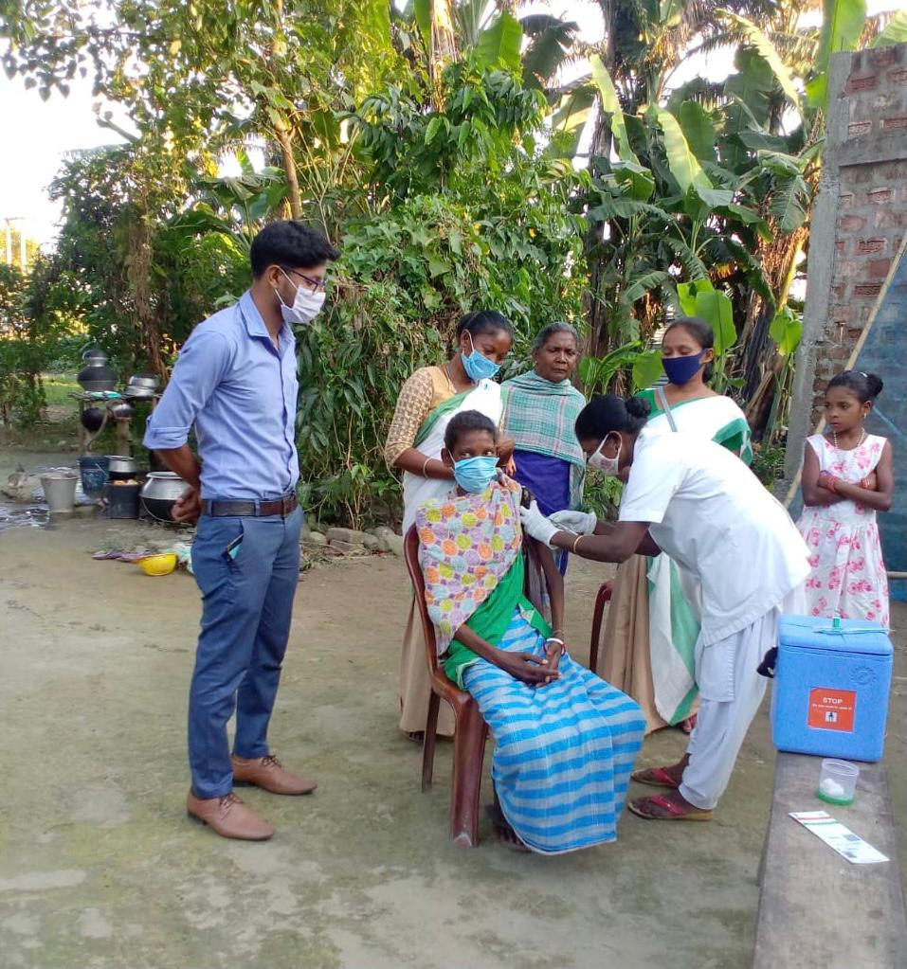During home visit by STS, she is found very much reluctant to vaccinate herself due to miss information and rumors .As a part of “Hare Ghar Dastak” the Deputy Commissioner Kokrajhar Smt. Varnali Deka, IAS has taken special drive to overcome hesitancy the mobile vaccination team successfully inoculated covid -19 vaccine to Elizabeth Murmu/Hasda on 18/11/2021. This will go long way in addressing the dual challenges of TB & Covid -19.