**Best Practice on Social Support to TB Patients of Bankura District**

Tuberculosis is an infectious disease that is a major cause of ill health and among the top ten cause of death worldwide. India bears the highest burden of world’s TB patient (27%) and targets to eliminate TB by 2025 with multi-sectoral approach.

In Tuberculosis as in many other infectious diseases, there is a bidirectional interaction between nutritional status and active disease. Under nutrition is a risk factor for Tuberculosis which tern worsens the nutritional status. This interaction is particularly important in the Indian context where food insecurity and under-nutrition coexist with a large burden of Tuberculosis. The Central TB Division (CTD), Ministry of Health and Family Welfare, Government of India, wishes to acknowledge the support of the line departments, development partners and numerous individuals who have worked with the Ministry or want to work to END TB.

Majority of Tuberculosis (TB) cases of resource-poor settings experience food insecurity, which impacts treatment adherence and outcomes. So in **District TB Forum meeting** ,DTO Bankura ,emphasis on linkages for extra nutritional support for TB patients with existing Government Schemes like West Bengal public distribution system(PDS) ,give priority to TB patients for easy access to different livelihood opportunities and vocational training from line department, prioritize of TB patients for availing Govt. housing facilities like **Bangla Awas Yojana ,Pradhan Mantri Awas Yojana etc.** District Magistrate , Bankura support this & instructed to all SDOs & BDOs for support TB patients. Every Block in Bankura District are ensured & roll out Social support Scheme to TB patients. This is fruitful after DTO Bankura conducted **DIE (District Internal Evaluation)** where DTO & his team ,WHO Consultant ,BMOH participated in this evaluation.

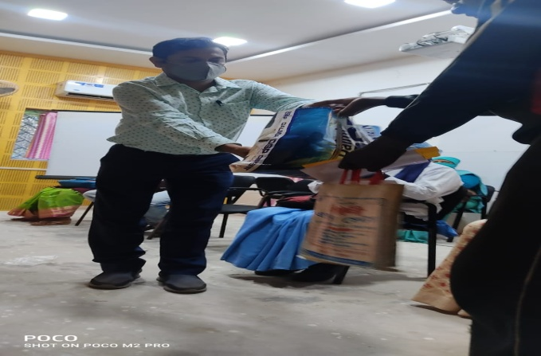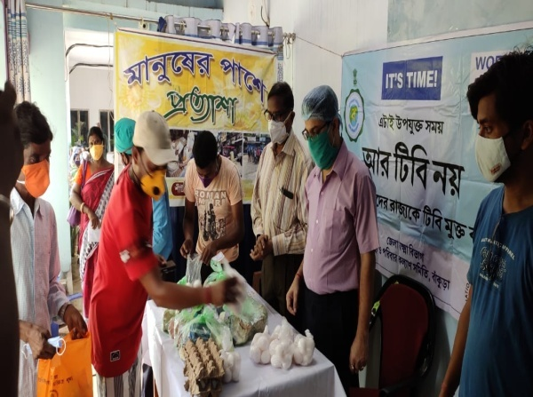

**Ranibandh BDO(left side) & CMOH, DTO Bankura given nutritional support to TB patients**

Apart from that socio-economic support and empowerment of TB patients are required to create an enabling and stigma free environment for the people suffering from TB.