**National Tuberculosis Elimination Programme**

**National Strategic Plan to END Tuberculosis in India**

**2020–25**

**Accelerating the national response for expanded coverage and sustained impact at scale to END TB in India**



**June 2020**

Ministry of Health with Family Welfare, Nirman Bhawan, New Delhi – 110 108

**Contents**

**Contents**

**Abbreviations**

**Acknowledgements**

**Foreword**

**Executive Summary 1**

**SECTION 1**

**CHAPTER 1: INTRODUCTION 6**

**CHAPTER 2: INDIA: EVOLVING COUNTRY CONTEXT 11**

**CHAPTER 3: JOINT MONITORING MISSION OF NTEP 21**

**CHAPTER 4: SITUATION ANALYSIS 25**

**CHAPTER 5: ENVIRONMENTAL ANALYSIS OF NTEP 31**

**SECTION 2**

**CHAPTER 6: NTEP IMPACT PROJECTIONS 34**

**CHAPTER 7: STRATEGIC DIRECTION OF THE NSP, THE NSP RESULTS FRAMEWORK AND PERFORMANCE MEASURES 37**

**NSP OBJECTIVE 1: BUILD**

**CHAPTER 8: ENSURE A FULLY FUNDED NSP 46**

**CHAPTER 9: HUMAN RESOURCE MANAGEMENT 48**

**CHAPTER 10: GOVERNANCE AND MANAGEMENT OF NTEP 53**

**CHAPTER 11: MULTISECTORAL ACCOUNTABILITY AND ENGAGEMENT 59**

**CHAPTER 12: PRIVATE SECTOR ENGAGEMENT 65**

**CHAPTER 13: ENGAGED AND EMPOWERED COMMUNITIES 71**

**CHAPTER 14: ADVOCACY AND STRATEGIC COMMUNICATIONS 77**

**CHAPTER 15: SURVEILLANCE, MONITORING AND SUPERVISION 81**

**CHAPTER 16: RESEARCH 84**

**CHAPTER 17: STRENGTHEN PROCUREMENT AND SUPPLY CHAIN 88**

**CHAPTER 18: DIGITAL INFORMATION ECOSYSTEM FOR TB CARE 91**

**CHAPTER 19: TECHNICAL ASSISTANCE TO NTEP 100**

**CHAPTER 20: ADDRESSING HUMAN RIGHTS AND GENDER RELATED BARRIERS TO TB SERVICES 102**

**CHAPTER 21: TB CARE IN THE ERA OF COVID 107**

**NSP OBJECTIVE 2: PREVENT**

**CHAPTER 22: TB PREVENTIVE TREATMENT AND PROGRAMMATIC MANAGEMENT OF LATENT TB INFECTION 111**

**CHAPTER 23: AIRBORNE INFECTION CONTROL 114**

**NSP OBJECTIVE 3: DETECT**

**CHAPTER 24: LABORATORY AND DIAGNOSTIC SYSTEMS 117**

**CHAPTER 25: TB CASE FINDING 121**

**NSP OBJECTIVE 4: TREAT**

**CHAPTER 26: TREATMENT OF DRUG SENSITIVE TB 125**

**CHAPTER 27: TREATMENT OF DRUG RESISTANT TB 128**

**CHAPTER 28: ADDRESSING TB IN PRIORITY POPULATIONS 132**

**CHAPTER 29: PATIENT SUPPORT SYSTEMS 140**

**SECTION 3**

**CHAPTER 30: BUDGETING AND COSTING THE NSP 143**

**List of Tables**

|  |  |  |
| --- | --- | --- |
| Table number | Description | Page number |
| **Table 1** | **Strategic Framework to END TB in India** | **2** |
| **Table 2** | **UNHLM Targets India** | **8** |
| **Table 3** | **Development Indicators: India** | **11** |
| **Table 4** | **Subnational prevalence survey estimates, and prevalence to notification ratio** | **26** |
| **Table 5** | **SWOT analysis of NTEP** | **31** |
| **Table 6** | **Impact indicators based on the modelling scenarios** | **35** |
| **Table 7** | **Output and Outcome indicators based on the modelling scenarios** | **35** |
| **Table 8** | **Pillars, Objectives, Strategic area and Interventions in the NSP 2021-25** | **38** |
| **Table 9** | **Key indicators for the priority programmatic areas and the targets: NSP 2020-25 India** | **43** |
| **Table 10** | **Sub-National Certification of Disease Free Status** | **56** |
| **Table 11** | **Awards on achieving milestones of disease free status** | **56** |
| **Table 12** | **Models for NTEP - private sector partnership** | **67** |
| **Table 13** | **An illustrative list of B6sources for funding research).** | **84** |
| **Table 14** | **Diagnostic facilities in NTEP** | **118** |
| **Table 15** | **Yield from case finding activities amongst vulnerable population** | **121** |
| **Table 16** | **Prioritization of vulnerable groups** | **123** |
| **Table 17** | **Funding TB control in India** | **143** |
| **Table 18** | **Budget for financial years 2020-24** | **145** |
| **Table 19** | **Budget by key programmatic areas for financial years 2020-24** | **145** |
| **Table 20** | **Financial indicators 2020-24** | **148** |

**List of FIGURES**

|  |  |  |
| --- | --- | --- |
| Figure number | Description | Page number |
| **Figure 1** | **Indian Healthcare system** | **16** |
| **Figure 2** | **NTEP implementation arrangements** | **17** |
| **Figure 3** | **Summary of Common Review Mission findings - RNTCP performance dashboard** | **24** |
| **Figure 4** | **Trends in annual number of notified TB patients, estimated TB incidence among new, previously treated (relapse), and HIV positive – India: 2000–2019** | **25** |
| **Figure 5** | **HIV-Negative TB mortality** | **26** |
| **Figure 6** | **Percent annual notification difference from the preceding reporting year – India, 2006–2018** | **26** |
| **Figure 7** | **Number of notified TB patients from public and private sectors, 2000–2019** | **27** |
| **Figure 8** | **Bacteriologically confirmed notifications amongst new and previously treated (RT) patients – India, 2012–2018.** | **27** |
| **Figure 9** | **Number of and rate examinations amongst presumptive TB patients – India, 2000–2019** | **28** |
| **Figure 10** | **Annual proportions of successful treatment outcome among new sputum-smear positives, previously treated, and drug-resistant TB patient cohorts– India, 2012–2018** | **28** |
| **Figure 11** | **Number of TB patients tested for HIV and percent with positive results – India, 2000–2019** | **29** |
| **Figure 12** | **Proportion of pediatric notifications (0–14 year old) amongst all notifications by geography – India, 2019** | **29** |
| **Figure 13** | **Age and sex specific notification per 100,000 person: India, 2012 and 2019** | **30** |
| **Figure 14** | **Estimated number of TB patients attributable to social determinants of disease – India, 2018** | **30** |
| **Figure 15** | **NTEP impact modeling** | **34** |
| **Figure 16** | **Pillars and strategies of the NSP 2020-25** | **38** |
| **Figure 17** | **NTEP Budgets and Expenditures, 2014 to 2020** | **46** |
| **Figure 18** | **Burn rate of NTEP funds 2018-2019 by region** | **47** |
| **Figure 19** | **Vacancy rate (%) for state-level positions** | **49** |
| **Figure 20** | **Vacancy at CDST labs** | **49** |
| **Figure 21** | **Vacancy of accountants** | **49** |
| **Figure 22** | **National level NTEP organogram** | **50** |
| **Figure 23** | **National Level Consultants** | **50** |
| **Figure 24** | **National TSU** | **50** |
| **Figure 25** | **State level NTEP Organogram** | **51** |
| **Figure 26** | **State TSU organogram** | **51** |
| **Figure 27** | **District level NTEP Organogram** | **51** |
| **Figure 28** | **Proposed structure of the NTEP and its support structures** | **58** |
| **Figure 29** | **Diagrammatic representation of the current ICT Landscape for TB Care** | **65** |
| **Figure 30** | **Stakeholders in the ICT Landscape for TB care** | **92** |
| **Figure 31** | **Proposed Organizational structure of national knowledge department** | **93** |
| **Figure 32** | **Work tracks of the Technical Support Unit and the Roles and Responsibilities of each work track** | **94** |
| **Figure 33** | **The proposed ICT system** | **95** |
| **Figure 34** | **Workload estimation** | **96** |
| **Figure 35** | **National Framework for a gender responsive approach to TB in India** | **97** |
| **Figure 36** | **Framework for addressing stigma in NTEP** | **104** |
| **Figure 37** | **Preventive therapy** | **106** |
| **Figure 38** | **Trends in NSP funding** | **112** |

**Acronyms**

AB-PMJAY Ayushman Bharat - Pradhan Mantri Jan Arogya Yojana

ACSM Advocacy, Communication, and Social Mobilization

ACF Active Case Finding

ADR Adverse Drug Reaction

ADSM Active Drug Safety Monitoring and Management

AE Adverse Events

AFB Acid-fast bacillus

AI Artificial Intelligence

AIC Airborne Infection Control

AMC Annual Maintenance Contract

ART Antiretroviral Therapy

ARTI Annual Rate of TB Infection

ASHA Accredited Social Health Activist

ATT Anti-tubercular Treatment

AYUSH Ayurveda, Yoga & Naturopathy, Unani, Siddha, Sowa Rigpa and Homoeopathy

BCAP Bedaquiline Conditional Access Programme

BCG Bacille Calmette-Guerin vaccine

BDQ Bedaquiline

BK+ Bacille de Koch (or Koch bacillus) positive smear

BMI Body Mass Index

BRICS Brazil, Russia, India, China, and South Africa

C&DST Culture and Drug Susceptibility Testing

CB-NAAT Cartridge-based Nucleic Acid Amplification Test

CBO Community-based Organization

CDS Clinical Decision Support

CDST Culture and Drug Sensitivity Testing

CFZ Clofazimine

CHC Community Health Center

CME Continuing Medical Education

CMSS Central Medical Services Society

CPT Cotrimoxazole Preventive Therapy

CSO Civil Society Organization

CSR Corporate Social Responsibility

CTD Central Tuberculosis Division

CXR Chest X-Ray

DBT Direct Benefit Transfer

DDS District Drug Stores

DLM Delamanid

DM Diabetes mellitus

DMC Designated Microscopy Center

DoP Department of Post

DOT Directly Observed Therapy

DOTS Directly Observed Therapy, Short-course

DR-TB Drug Resistant Tuberculosis

DRS Drug Resistance Surveillance

DST Drug Susceptibility Testing

DS-TB Drug-Sensitive Tuberculosis

DTC District Tuberculosis Center

DTO District Tuberculosis Officer

EPTB Extrapulmonary Tuberculosis

EQA External Quality Assurance

FDC Fixed-dose Combination

FIND Foundation for Innovative New Diagnostics

FLD First-line Drugs

FQ Fluoroquinolone

FY Fiscal Year

GoI Government of India

GDF Global Drug Facility

GeneXpert Xpert MTB/RIF cartridge-based nucleic acid amplification test to detect *M. tuberculosis* and rifampin resistance

GF Global Fund against HIV/AIDS, Tuberculosis, and Malaria

H Isoniazid

HR Human Resources

HS Health Systems

HSS Health Systems Strengthening

IC Infection Control

ICF Intensified Case Finding

ICMR Indian Council of Medical Research

ICT Information and Communication Technologies

ICTC Integrated Counseling and Testing Center

IDAT Integrated Digital Adherence Technologies

IEC Information, Education, and Communication

IGRA Interferon-Gamma Release Assay

IMA Indian Medical Association

INH Isoniazid

IP Implementing Partner

IRL Intermediate Reference Laboratory

ITRC India Tuberculosis Research Consortium

IVA Independent Verification Agency

JEET Joint Effort for Elimination of Tuberculosis

JMM Joint Monitoring Mission

KPI Key Performance Indicator

LF-LAM Lateral Flow Urine Lipoarabinomannan Assay

LIMS Laboratory Information Management System

LPA Line-probe Assay for detection of drug resistance

LT Laboratory Technician

LTBI Latent Tuberculosis Infection

LZD Linezolid

M&E Monitoring and Evaluation

MAF-TB Multisectoral Accountability Framework for Tuberculosis

MCH Maternal and Child Health

MDG Millennium Development Goal

MDR Multidrug Resistance

MDR-TB Multidrug Resistant Tuberculosis

MERMs Medication Event Reminder Monitors

MHRD Ministry of Human Resource Development

MHUPA Ministry of Housing & Urban Poverty Alleviation

MO Medical Officer

MOD Ministry of Defence

MoHFW Ministry of Health and Family Welfare

MOTC Medical Officer Tuberculosis Centre

MOU Memorandum of Understanding

MoUD Ministry of Urban Development

MPHW Multipurpose Health Worker

MWCD Ministry of Women & Child Development

NACO National AIDS Control Organization

NACP National AIDS Control Program

NCD Non communicable Disease

NDRS National Anti-Tuberculosis Drug Resistance Survey

NGO Non-governmental Organization

NGS Next-Generation Sequencing

NHA National Health Authority

NHM National Health Mission

NIKSHAY Web-enabled electronic TB case notification/ monitoring system

NIRT National Institute for Research in Tuberculosis

NITRD National Institute of Tuberculosis and Respiratory Diseases

NPCDCS National Programme for Prevention and Control of Cancers, Diabetes, Cardiovascular Diseases and Stroke

NPY NIKSHAY Poshan Yojana (nutritional support to TB patients)

NRHM National Rural Health Mission

NRL National Reference Laboratory

NSP National Strategic Plan

NSS National Sample Survey

NTCP National Tobacco Control Programme

NTEP National Tuberculosis Elimination Programme

NTIB National Tuberculosis Institute Bangalore

NTSU National Technical Support Unit

NUHM National Urban Health Mission

NVHCP National Viral Hepatitis Control Program

OOP Out-of-pocket expenditures

OpASHA Operation ASHA

OR Operational Research

OSE On-Site Evaluation

OTC Over-the-counter drugs

PDS Public Distribution System

PFMS Public Financial Management System

PHC Primary Health Center

PHI Peripheral Health Institution

PIP Project Implementation Plan

PLHIV People Living with HIV/AIDS

PMDT Programmatic Management of Drug Resistant Tuberculosis

PP Private Practitioner

PPE Private Provider Engagement

PPM Public-Private Mix

PPSA Patient Provider Support Agency

PR Principal Recipient of grant from the Global Fund Against HIV/AIDS, Tuberculosis, and Malaria

PRI Panchayati Raj Institution

PSM Procurement and Supply Management

PTB Pulmonary Tuberculosis

PVPI Pharmacovigilance Programme of India

QA Quality Assurance

R (or RIF) Rifampicin

RBSK Rashtriya Bal Swasthya Karyakram (initiative for early child screening and intervention services)

RBRC Random Blinded Re-checking

RCT Randomized Controlled Trial

RCH Reproductive and Child Health

RMRC Regional Malaria Research Centre, Bhubaneshwar

NTEP Revised National Tuberculosis Control Program

RR-TB Rifampicin-Resistant Tuberculosis

SDS State Drug Stores

SHG Self-help Group

SLD Second-line Drugs

SL-DST Second-line Drug Susceptibility Testing

SLI Second-line Injectable Drugs

STC State Tuberculosis Cell

STCI Standards for Tuberculosis Care in India

STDC State Tuberculosis Training and Demonstration Center

STR Shorter Treatment Regimen for drug-resistant TB

STLS State Tuberculosis Laboratory Supervisor

STO State Tuberculosis Officer

STS Senior Treatment Supervisor

TA Technical Assistance

TAT Turnaround Times

TB Tuberculosis

TBHV Tuberculosis Health Visitor

TOG Technical and Operational Guidelines

TOR Terms of Reference

TrueNat MTB Chip-based nucleic acid amplification test to detect *M. tuberculosis*

TrueNat MTB-RIF Dx Chip-based nucleic acid amplification test to detect rifampicin-resistant *M. tuberculosis*

TSG Technical Support Group

TST Tuberculin Skin Test

TSU Technical Support Unit

TU Tuberculosis Unit

UATBC Universal Access to Tuberculosis Care

UDST Universal Drug Susceptibility Tests

UHC Universal Health Coverage

UN United Nations

UNAIDS Joint United Nations Programme on HIV/AIDS

UNHLM United Nations High-level Meeting

USAID United States Agency for International Development

UVGI Ultraviolet Germicidal Irradiation

WCO World Health Organization Country Office

WHO World Health Organization

WHP World Health Partners

XDR-TB Extensively Drug Resistant Tuberculosis

YLL Years of Life Lost

**Executive Summary**

**Background**

The National Strategic Plan to END TB in India (NSP) 2017–25 set into motion an unprecedented and ambitious attempt to enhance the coverage, quality, equity, efficiency and effectiveness of the National Tuberculosis Elimination Programme (NTEP). Since the adoption of the NSP, NTEP has moved at a dramatic pace to match the bold ambitions of the Government of India, as well as those the country has committed at the Global level including the United Nations High-level Meeting (UNHLM) on TB. The impact of many innovations and interventions since 2017 is seen in the increased coverage, increased utilization of TB services and decreasing incidence of the disease. However, the present rate of ~3% annual decline in TB incidence would need to be accelerated to ~11% to achieve the 2030 Sustainable development goal targets by 2025. Since 2017, many new policies and guidelines have been promulgated, new tools made available, extensive learnings from implementation and scale up of new programme activities is ongoing. The joint monitoring mission in 2019 has also provided insights into the current status of programme performance and recommends further course of action towards ending TB in the country. While the strategic direction of the NSP 2017-2025 remains valid, there are issues that have gained critical importance and none more than continued access to quality TB care during complex emergencies like the COVID-19 pandemic. In addition, the unfinished agenda of addressing the ‘missing cases’, scale up of TB care services in the private sector, providing social support to TB patients, TB preventive services, and addressing the social determinants of TB through a multisectoral approach continue to challenge the NTEP and remain the focus of this NSP and NTEP over the next five years.

**Context**

After decades of successful program implementation, India has accomplished numerous impressive achievements in tuberculosis prevention, care and control. The NTEP has screened more than 80 million people for tuberculosis, successfully treated 15 million patients and saved millions of lives[1]. However, India continues to contribute the largest number of TB patients, and TB-related deaths in the world.[2] The epidemiology of tuberculosis in India is very heterogeneous, both from an epidemiological perspective and in terms of programmatic performance.[3] Results from subnational TB prevalence surveys, annual rate of tuberculosis infection surveys (ARTI) and analysis of routinely collected programme surveillance data reveal substantial local variation in prevalence, rates of HIV coinfection, drug-resistant forms of TB, and utilization of TB services in the private sector.

Over the past three years (2017-19) impressive gains have been made by the NTEP which include an additional 1,200,000 people with TB disease detected and notified through the Nikshay national digital information system. The programme has leveraged near-universal mobile network access and India’s digital payments infrastructure to deploy social support via accountable electronic direct benefits transfer (DBT), which is being expanded for all TB patients. The NTEP now effectively engage private providers, who account for most healthcare delivery services, and is scaling up these approaches, remarkably reaching 1.6 million in the private sector over the three years. In addition, NTEP is making progress towards offering universal drug susceptibility testing for people diagnosed with TB, employing 1530 rapid molecular diagnostic devices (NAAT), testing 1 million people with TB, and ultimately detecting and treating 66,255 patients with drug resistant forms of TB in 2019. Enabling these expansions reflects a new commitment to patient-centered services and care, emphasizing community engagement and in some settings mobilizing the general health system in the national effort towards ending TB.

Despite these accomplishments, the challenges ahead remain daunting and require concrete actions to achieve the national goals unless concrete and deliberate actions are promptly undertaken. India has more than 27% of the world’s burden of TB. In addition it has significant impact on the national economy. In 2016, TB caused India to lose an estimated 23.7 billion USD (around 1% of India’s GDP in 2016), and patients often deal with catastrophic out-of-pocket expenditures[4]. Patients are often deterred from seeking treatment by social stigma and poor access to quality services in the public sector. Most patients opt for treatment from formal or informal providers in the private health system. But because this sector is largely unregulated and data gathering is poor, tracking patients throughout their course of treatment is difficult. Close to 300,000 TB affected persons remain missing from TB surveillance/notification and services, and are likely in private health delivery systems or the community.[5] The majority of patients reported by private providers could not be confirmed to have completed treatment. Many are not screened or treated for key comorbidities such as HIV, diabetes, or malnutrition – all critical measures to maximize successful treatment outcomes and survival.

The strengths of India’s general health system is yet to be leveraged to its full potential for the national campaign against TB, particularly in settings with the highest burden of disease. Tools available to NTEP, such as advanced molecular diagnostics, enhanced patient and adherence support systems, or newer drug regimens, still remain incompletely implemented.

**Achieving the SDG for 2030 by 2025**

The actions over the next five years will contribute to the attainment of Sustainable Development Goal 3. The relationship between health and wealth is well-established, with better health resulting in enhanced cognitive development and increased human capital. Besides affecting health TB leads to income loss and forces people deeper into poverty. The NTEP will continue to contribute to the government’s efforts to achieve UHC, an acknowledged mechanism to catalyze realize SDG, by effective national coverage of TB through the proposed strategic areas and interventions (Table 1).

The requirements for moving towards ending TB and ultimately TB elimination have been integrated into four strategic pillars that correspond with the four NSP objectives and are reconfigured from the previous NSP framework. The NSP 2020-25 reasserts the thrust on early diagnosis of all TB patients, reducing transmission and treating those best at first interface with right drugs and regimens along with suitable patient support systems. This is supplemented by prevention strategies including programmatic scale-up of TB preventive treatment for risk populations nationwide and airborne infection control in health care facilities. All these are supported by creating an enabling environment with adequate finances and resources, and a strong digital ecosystem based programme management and service delivery. Ending TB will not be possible without addressing the social determinants which are an important driver of the TB epidemic in India. Table 1 describes the renewed approach to END TB in the country.

**Table 1: Strategic Framework to END TB in India**

|  |
| --- |
| **PILLAR 1: B U I L D, S T R E N G T H E N A N D S U S T A I N A N E N A B L I N G E N V I R O N M E N T F O R T B E L I M I N A T I O N** |
| **Objective 1. Build, strengthen and sustain enabling policies, empowered institutions, multi-sectoral collaborations, engaged communities, and human resources with enhanced capacities to create a supportive ecosystem which accelerates PREVENT – DETECT – TREAT** |
| **S T R A T E G I C A R E A** |
| * 1. Ensure a fully funded NSP |
| * 1. Enhance TB care related human resource and its management within the NTEP |
| * 1. Increase efficiency and effectiveness of governance and programme management mechanisms for TB elimination |
| * 1. Expedite multi sectoral collaboration with a focus on the improving accountability mechanisms |
| * 1. Strengthen, enhance and scale-up the existing private sector engagement with new additionalities to enlist greater private sector support and programme reach |
| * 1. Create empowered and engaged communities to fight TB |
| * 1. Undertake advocacy, strategic communication, and social mobilization for TB elimination |
| * 1. Enhance and strengthen surveillance, monitoring and evaluation of NTEP |
| * 1. Promote TB research on the prioritized national agenda for TB research |
| * 1. Strengthen procurement and supply chain management |
| * 1. Establish next generation program management (surveillance, planning, training, supervision, monitoring, and evaluation) built on state-of-art digital Information and communication technology. |
| * 1. Secure cutting edge technical assistance |
| * 1. Addressing human rights and gender related barriers in access to TB services |
| * 1. TB care in the era of COVID-19 : Build a resilient, responsive and agile NTEP to respond to complex emergencies |
| **PILLAR 2: P R E V E N T** |
| **Objective 2: Prevent the emergence of TB in susceptible populations using a combination of biomedical, behavioural, social and structural interventions.** |
| **S T R A T E G I C A R E A** |
| * 1. Access to shorter and effective TB Preventive Treatment (TPT) and Programmatic management of LTBI |
| * 1. Scale up TB - infection control (TB-IC) measures at home, community, and health care facilities |
| **PILLAR 3 : D E T E C T A L L** |
| **Objective 3: Early identification of presumptive TB, at the first point of contact be it private or public sectors, and prompt diagnosis using high sensitivity diagnostic tests to provide universal access to quality TB diagnosis including drug resistant TB in the country.** |
| **S T R A T E G I C A R E A** |
| * 1. Scale-up free, high sensitivity TB diagnostic tests and algorithms |
| * 1. Intensify TB case finding efforts amongst all programmes within the MOHFW and other ministries |
| **PILLAR 4: T R E A T A L L** |
| **Objective 4:** |
| **S T R A T E G I C A R E A** |
| * 1. Strengthen treatment of DSTB |
| * 1. Expand treatment and management of DRTB |
| * 1. Address TB in priority populations |
| * 1. Strengthen and expand coverage of patient support systems |

**The prioritized set of actions over the NSP period:**

The NTEP will undertake necessary structural and procedural changes to ensure a robust, responsive and agile NTEP that can safeguard and address the concerns of TB patients and providers during times of complex emergencies and unprecedented crisis.

1. The NTEP will **secure and sustain increased domestic funding** commensurate with the enhanced requirements of this NSP to End TB in India by 2025.
2. It will deploy and evaluate ambitious plans to implement **TB preventive treatment** of household and other close contacts, children, PLHIV and other locally-defined high-risk groups, using new, and shorter regimens, building programme capacity for systematic contact investigation, detection of TB infection among recommended target populations, so as to reach an expected 6 million eligible persons annually with TPT by 2022.
3. Private sector engagement will be scaled up and sustained to yield an additional 5.5 million TB patients.
4. Expand the **social protection cover** for people with TB and their families.
5. It will aggressively pursue the expansion of **NIKSHAY** and the related **digital information ecosystem** complete with adopting and effectively applying artificial Intelligence and analytics, to driveefficient service delivery and responsive program management.
6. In addition it will scale-up **advanced diagnostics services** and **TB surveillance capacity** by **replacing sputum microscopy services** with new **precision diagnostic tools** in all TB diagnostic centres in the country.
7. The programme will continue to address the **“missing persons with TB” and care delivery across sequential stages of care** with a focus on re-design of and targeted active case finding efforts in priority population.
8. It will also ensure full **community participation and ownership**, with reliance on **TB champions** and **TB Survivors** working alongside programme staff in advocacy, planning and implementation and monitoring of the local, state, and national TB response. Intensive efforts will be made to strengthen the local TB forums which are seen as effective change agents able to work at reducing/eliminating stigma and supporting TB care and prevention in a human rights response framework.
9. The programme will leverage capacities and strengths of **general health system** policies, institutions and implementation arrangements for improved access and continuum of care.
10. It will promote **an ecosystem of innovation** in thinking and implementation of NTEP.

**Conclusion**

The global public health and TB community is shifting its focus from control of the TB epidemic towards elimination. It is India’s success that will determine the global progress towards ending TB and subsequently elimination. India has committed to END TB and is at a critical stage with the national momentum expected to accelerate after the increased political commitment and heightened community awareness about public health and hygiene and the threat of communicable disease following the COVID-19 pandemic. Hence this NSP to END TB by 2025 seizes this opportunity to collaborate intensively with various ministries to promote a multisectoral response to END TB while continuing to implement the program and deliver impact. Over the NSP period NTEP

Section 1

CHAPTER 1: INTRODUCTION

1.1 The purpose of the ‘refreshed’ National Strategic Plan to END TB in India 2020-25

1.2 Developing the NSP

1.3 Global directions that shape the NSP

1.4 National directions that shape the NSP : National Health Policy and NSP’s linkage with the National Health Policy

1.5 COVID-19 pandemic shapes ENDING TB in India

CHAPTER 2: INDIA: EVOLVING COUNTRY CONTEXT

2.1 Demographic, geographic and socio-economic features

2.2 Health Systems in India

2.3 NTEP implementation arrangements

CHAPTER 3: JOINT MONITORING MISSION OF NTEP AND COMMON REVIEW MISSION OF NATIONAL HEALTH MISSION

CHAPTER 4: SITUATION ANALYSIS

4.1 TB epidemiology in India

4.2 Epidemiological projections in India

4.3 NTEP Performance and impact

4.4 Progress towards addressing the social determinants of TB (UHC, SDG3) and the Global commitments

CHAPTER 5: ANALYSIS OF THE ENVIRONMENT IN WHICH NTEP FUNCTIONS

# **Chapter 1 Introduction**

**1.1 The purpose of the reinvigorated National Strategic Plan 2020-25 to END TB in India**

This NSP is an update of the NSP 2017-25 which is necessitated by the rapidly changing environment within which NTEP operates. Knowledge and insights generated from the Joint Monitoring mission in 2019, 16 large scale programme evaluations (Central Internal Evaluations) during 2017-2019; implementation of the past NSP especially scale up of private sector involvement strategies, roll out of rapid molecular tests, LTBI treatment rollout; and updated recommendations from WHO sets the direction for this NSP. As in the past, the NSP 2020-25 is a framework to guide the activities of all stakeholders including the national and state governments, development partners, civil society organizations, international agencies, research institutions, private sector, and many others whose work is relevant to TB elimination in India. This NSP is a five year strategy document that provides goals, strategies and interventions for the country’s response to the disease and aims to direct the attention of all stakeholders to the most important interventions that the NTEP believes will bring about significant changes in the incidence, prevalence and mortality of TB. These strategies and interventions are in addition to the processes and activities already ongoing in the country.

As a strategic document, the subsequent operational plans will necessarily follow. The NSP will guide the development of the national project implementation plan (PIP) and state PIPs, as well as district health action plans (DHAP) under the national health mission (NHM). This NSP replaces previous strategies, and will inform and guide the updating of technical and operational guidelines and associated programme tools.

**1.2 Developing the NSP 2020-25**

The development of this NSP has been a collaborative effort between all the stakeholders including national and state governments, development partners, civil society organizations, and the private sector in India which has been led by the Central TB Division, Ministry of Health and Family Welfare, Government of India. With the COVID-19 pandemic altering the way we work, online consultations and meetings were undertaken to seek inputs from the stakeholders.

The development of the NSP started in earnest with the NTEP carrying out the JMM in 2019. This was followed by epidemiological and impact modeling of tuberculosis in India which covered various scenarios (Chapter 6) to attain the national END TB targets set for 2025. The results of both served as critical background document for this NSP. As part of the country dialogue, the draft NSP was shared with stakeholders consisting of national government, state governments, donors, technical partners, civil society organizations, non – governmental organizations, medical institutions, research institutes, key populations, private health providers and other stakeholders. It was uploaded on the NTEP website for feedback from the citizens of the country. The final draft was shared electronically with all the stakeholders and feedback incorporated by the NSP development secretariat.

The NSP is designed as a framework to coordinate the articulated end TB goals and objectives of the NTEP. The NSP will be used by government and non-government sectors as the roadmap for programme development, expansion, and progress in the medium term (2020-25) and will be continually updated for use in meeting longer term objectives (2030-35) as the NTEP moves towards the elimination of Tuberculosis. The NSP will enable leaders of all stakeholders to articulate the direction of priorities over the coming five year period. The NTEP through the NSP, can now clearly outline the pathway for implementation of national priorities. It will be accessible online to all stakeholders for review and for information.

**1.3 Global directions that shape the NSP 2020-25**

In addition to the National Health Policy, this NSP also takes into account the Sustainable Development Goals, Global direction to END TB as is enunciated in the END TB strategy, and the UNHLM. It also takes into account the guidance provided by WHO in setting its course for ending TB.

**1.3.1 GLOBAL TECHNICAL GUIDELINES**

Since the last NSP 2017-25, many new WHO policy documents provide guidance for national programmes. This NSP adapts the recommendations of these in the national context and incorporates for use in the country. The WHO policy documents consulted are as follows:

1. **Laboratory and diagnostic guidelines:** 
   1. Rapid Communication: Molecular assays as initial tests for the diagnosis of tuberculosis and rifampicin resistance (January 2020) (WHO)[6] - Includes use of TrueNaatTM for diagnosis of Tuberculosis and sequential rifampicin resistance detection
   2. Lateral flow urine Lipoarabinomannan assay (LF-LAM) for the diagnosis of active tuberculosis in people living with HIV: policy update (2019) (WHO)
   3. Technical manual for drug susceptibility testing of medicines used in the treatment of tuberculosis (2018) (WHO)
   4. The use of next-generation sequencing technologies for the detection of mutations associated with drug resistance in Mycobacterium tuberculosis complex: technical guide (2018) (WHO)
   5. Global Fund`s Empowered Review Panel for Diagnostics (ERPD) recommendations[7]
2. **Treatment guidelines**
   1. WHO consolidated guidelines on drug-resistant tuberculosis treatment (2019)
   2. Rapid Communication: Key changes to treatment of multidrug- and rifampicin-resistant tuberculosis (MDR/RR-TB) (Dec 2019) (WHO)
   3. WHO position statement on the continued use of the shorter MDR-TB regimen following an expedited review of the STREAM Stage 1 preliminary results (2018)
   4. WHO treatment guidelines for isoniazid-resistant tuberculosis: Supplement to the WHO treatment guidelines for drug-resistant tuberculosis (2018)
   5. Handbook for the use of digital technologies to support tuberculosis medication adherence (2018)
   6. WHO position statement on the use of delamanid for multidrug-resistant tuberculosis (2018)
   7. Compendium of WHO guidelines and associated standards: ensuring optimum delivery of the cascade of care for patients with tuberculosis (2017)
3. **Prevention guidelines**
   1. Overcoming key barriers to scale up tuberculosis preventive treatment (TPT) A Call to Action
   2. WHO consolidated guidelines on tuberculosis: module 1: prevention: tuberculosis preventive treatment (2020)
   3. WHO operational handbook on tuberculosis: module 1: prevention: tuberculosis preventive treatment (2020)
   4. Rapid Communication on forthcoming changes to the programmatic management of tuberculosis preventive treatment (2020)
   5. South-East Asia Regional Action Plan on Programmatic Management of Latent TB Infection (2019)
   6. WHO guidelines on TB infection prevention and control (2019)
4. **Programme management**
   1. People-centered framework for tuberculosis programme planning and prioritization, User guide (2018)
   2. Public–Private mix for TB prevention and care - A roadmap (2018)
   3. Multisectoral Accountability Framework to Accelerate Progress to end Tuberculosis by 2030 (2019)
   4. Roadmap towards ending TB in children and adolescents (2020)

**1.3.2 GLOBAL END TB STRATEGY 2015 2035**

WHO’s post-2015 End TB Strategy, adopted by the World Health Assembly in 2014, aims to end the global TB epidemic as part of the Sustainable Development Goals. This NSP adapts the END TB Strategy framework for designing its national strategic framework. The WHO End TB Strategy and the United Nations (UN) Agenda for Sustainable Development share the common aim of ending the TB epidemic; the former includes ambitious milestones (2020, 2025) and targets (2030, 2035) for reductions in TB cases and deaths.

**1.3.3 UNITED NATIONS HIGH LEVEL MEETING ON Tuberculosis (UNHLM)**

On Sept 26, 2018, the first ever UN General Assembly (UNGA) High-Level Meeting on Tuberculosis (UNGA-HLM-TB), with more than 1000 participants from across the world, assembled in New York. The meeting resulted in the adoption of a Political Declaration on Tuberculosis, which reaffirmed commitment to end the tuberculosis epidemic globally by 2030 and included ambitious and bold targets for scale-up of tuberculosis care and prevention services, as well as commitments on research for new tools, principles of equity and human rights, and resource needs targets for both implementation and research. A follow-up WHO Executive Board meeting focused on ending tuberculosis re-affirmed targets set for 2022. As a signatory to the declaration, India is committed to attain the UNHLM targets.

**Table 2: UNHLM Targets India**

|  |  |  |  |  |  |  |
| --- | --- | --- | --- | --- | --- | --- |
|  | 2018 | 2,019 | 2,020 | 2,021 | 2,022 | Cumulative 2018-2022 |
| TB diagnosis and treatment targets | 2,143,200 | 2,693,100 | 2,519,600 | 2,353,100 | 2,191,000 | 11,900,000 |
| MDR-TB diagnosis and treatment targets | 36,200 | 39,700 | 66,100 | 122,300 | 142,300 | 406,600 |
| Total Preventative Therapy (PT) targets | 378,100 | 900,300 | 1,489,300 | 1,959,700 | 2,270,000 | 6,997,400 |
| Childhood TB diagnosis and treatment targets | 130,400 | 174,200 | 179,400 | 181,000 | 179,200 | 844,200 |

**1.3.4 THE GLOBAL PLAN TO END TB 2018 2022**

The Global Plan to END TB[8] presents with directions to get on track to end TB by 2030. It follows the UNHLM declaration and is centered on strong political leadership to achieve the country shares of the global TB targets agreed in the UN Political Declaration on TB. It highlights the need for a rights-based, people-centered approach, accelerated innovation in care delivery, the introduction of new tools, substantial investment in R&D and a strong country response all of which have been taken into account while framing this NSP.

**1.4 National directions that shape the NSP: National Health Policy and NSP’s linkage with the National Health Policy and UHC**

The National health policy 2017 comes after 15 years of the last health policy in 2002. The policy envisages as its goal the attainment of the highest possible level of health and well-being for all at all ages, through a preventive and promotive health care orientation in all developmental policies, and universal access to good quality health care services without anyone having to face financial hardship as a consequence. This would be achieved through increasing access, improving quality and lowering the cost of healthcare delivery. It aims to raise public healthcare expenditure to 2.5% of GDP by 2025 from current 1.4%, thereby, reducing in proportion of households facing catastrophic health expenditure from the current levels by 25%, by 2025. Envisaging optimum use of existing manpower and infrastructure available in the health sector it also advocates collaboration with non -government sector on pro-bono basis for delivery of health care services through more than two-thirds of those resources going towards primary health. The policy also calls for retaining a certain excess capacity in the public sector to meet the needs of health security and in times of crisis as is being felt during the COVID-19 pandemic.

Assuring availability of free, comprehensive primary health care services, for the most prevalent communicable, non-communicable and occupational diseases in the population is primary objective to achieve Universal Health Coverage (UHC). The suggested architecture for achieving UHC is free primary care provision by the public sector, supplemented by strategic purchase of secondary and tertiary care services from both public and from non-government sector to fill critical gaps to assure healthcare services. With an objective to achieve Universal Health Coverage by 2030, the Government of India has initiated significant reforms to improve citizens' access to good quality, affordable healthcare. It too has innovated in its journey towards achieving universal health coverage – “Ayushman Bharat” and the NTEP proposes to utilize the “Ayushman Bharat” scheme to benefit TB patients. In line with the emergent international “Health in All” approach, it also articulates to institutionalize inter-sectoral coordination at national and sub-national levels to optimize health outcomes, through constitution of bodies that have representation from relevant non-health ministries through the national missions like ‘Swachh Bharat Abhiyan’ and ‘Atmanirbhar Bharat’.

Districts and blocks which have wider gaps for development of infrastructure and deployment of additional human resources would receive focus. Financing for additional infrastructure or human resources would be based on needs of outpatient and inpatient attendance with special focus on poor populations living in listed and unlisted slums, homeless, rag-pickers, street children, rickshaw pullers, construction workers, sex workers and temporary migrants. To addressed other determinants for the TB through convergence among the wider determinants of health – air pollution, better solid waste management, water quality, occupational safety, road safety, housing, vector control, and reduction of violence and urban stress. This also includes the interventions to address Malnutrition and Micronutrient Deficiencies.

Country objective of an integrated health information system necessitates developing and linking systems into a common network/grid for both public and private healthcare providers under National Digital Health Mission to mainstream the data flow under health system. Use of “Aadhaar” (Unique ID) for identification, creation of registries (i.e. patients, provider, service, diseases, document and event) and engagement of big data analysts to expand its utility to cover various quality indicators related to services deliveries.

Key policy shifts in the National health policy that have a potential for the NTEP to leverage for expanding and deepening programme impact relate to 1) Demand generation through building capacity of community-based organizations, ASHAs and VHSNCs supported by established referral services; 2) Early detection of TB symptomatic through Health and Wellness Centres with linkages to referral hospitals ; 3) assured free drugs, diagnostic and emergency services to all; 4) inter-sectoral preventive and promotive action leading to a social movement of health – the Swasth Nagrik Abhiyan or Health in All; 5) retention of doctors and specialists in remote areas in public services and collaboration with private sector for specialized services; 6) creation of a multi-disciplinary public health management cadre; 7) improve access by imposing the regulations on pricing, vaccine safety, manufacture of technologies/drugs; and 8) scaling up coordination within public sectors through multisectoral approach and leverage on CSR activities.

**1.5 COVID-19 pandemic shapes ENDING TB in India**

Not a single event over the last century has had such an impact on human life as the ongoing COVID-19 pandemic. Pandemics like the COVID-19 could derail progress made by the NTEP on ending TB in the country through disruption to treatment or other interventions or supply chains of critical medicines and medical supplies and efforts need to be made to mitigate the impact of COVID-19 on TB. Strong health systems are critical to help respond to COVID-19, and to reinforce health security. Particular attention will be given to health worker protection, communication to affected communities, maintenance of essential services, supply chain coordination, early replenishment of stocks, disinfection, and waste management. Additional activities include epidemic preparedness assessment, laboratory testing, sample transportation, use of surveillance infrastructure, infection control in health facilities, and advocacy campaigns. Specifically implementation of all-oral treatments for drug-resistant TB, as recommended by WHO, is now an imperative that cannot be delayed, as is the implementation of community-supported treatment to reduce contact with health structures and through telemedicine and the use of web apps. Additional details are discussed in Chapter 21.

# **Chapter 2**

# **COuntry Context**

.

* 1. **Demographic, geographic and socio-economic features**

1. India is the seventh-largest country by area (3,287,240 sq. km) and is the second populous country in the world with 1.36 billion (2019)[9]. It has an annual growth rate of 1.19% with a population density of 382 per sq. km. The population comprises of 51.5% males and 48.5% females and a Sex ratio of 940 females for every 1000 males as per 2011 Census.
2. The world’s biggest democracy and third largest economy in purchasing power parity terms, India aspires to better the lives of all its citizens and become a high-middle income country by 2030. India’s economic transition is matched by a shift from primarily communicable diseases to a dual disease burden. The contribution of communicable and non-communicable disease varies quite dramatically among states in both absolute and relative terms, with Empowered Action Group (EAG)[10] states having communicable diseases as three of the top-five causes[11] of Disability-Adjusted Life Year (DALY) loss. Despite this rapid increase in national wealth and the corresponding sharp reduction in extreme poverty, relative poverty has persisted. India’s significant progress in improving health services and outcomes is evidenced by the increase in life expectancy from 58 years in 1990 to 68.7 years in 2016[12].
3. India is rapidly urbanizing. In 2018, approximately a third of the total population in India lived in cities and according to the estimates of UNESCAP, 29.4 percent of India’s urban population lived in slums. By 2030, the UN estimates that more than 40 percent of Indians could be living in megacities. And two of the ten largest cities in the world are Indian already today – Delhi and Mumbai. The migration of people to urban areas coupled with socio-economic challenges will continue to increase the vulnerability of such people to TB.

**Table 3: Development Indicators: India**

|  |  |  |  |  |
| --- | --- | --- | --- | --- |
| **Key development indicators - India[13]** | **1990** | **2000** | **2010** | **2018** |
| **World view** |  |  |  |  |
| Population, total (millions) | 873.3 | 1,056.58 | 1,234.28 | 1,352.62 |
| Population, male (millions)[14] | 453.2 | 546.3 | 635.0 | 699.2 |
| Population, female (millions) | 420.1 | 509.3 | 598.3 | 653.4 |
| Population growth (annual %) | 2.1 | 1.8 | 1.4 | 1 |
| Population density (people per sq. km of land area) | 293.7 | 355.4 | 415.1 | 454.9 |
| Poverty headcount ratio at national poverty lines (% of population) | 45.3 | NA | 21.9 | NA |
| GNI, Atlas method (current US$) (billions) | 334.59 | 467.08 | 1,505.74 | 2,727.89 |
| GNI per capita, Atlas method (current US$) | 380 | 440 | 1,220 | 2,020 |
| GNI, PPP (current international $) (billions) | 1,065.81 | 2,254.50 | 5,323.99 | 10,393.26 |
| GNI per capita, PPP (current international $) | 1,220 | 2,130 | 4,310 | 7,680 |
| **People** |  |  |  |  |
| Life expectancy at birth, total (years) | 58 | 63 | 67 | 69 |
| Fertility rate, total (births per woman) | 4 | 3.3 | 2.6 | 2.2 |
| Mortality rate, under-5 (per 1,000 live births) | 126 | 92 | 58 | 37 |
| Prevalence of underweight, weight for age (% of children under 5) | 55.5 | 46.3 | NA | 33.4 |
| **Environment** |  |  |  |  |
| Urban population growth (annual %) | 3 | 2.5 | 2.5 | 2.3 |
| **Economy** |  |  |  |  |
| GDP (current US$) (billions) | 320.98 | 468.39 | 1,675.62 | 2,718.73 |
| GDP growth (annual %) | 5.5 | 3.8 | 8.5 | 6.8 |
| Inflation, GDP deflator (annual %) | 10.7 | 3.6 | 10.5 | 4.1 |
| **States and markets** |  |  |  |  |
| Mobile cellular subscriptions (per 100 people) | 0 | 0.3 | 60.9 | 86.9 |
| Individuals using the Internet (% of population) | 0 | 0.5 | 7.5 | 34.5 |
| Net official development assistance received (current US$) (millions) | 1,395.00 | 1,383.40 | 2,831.30 | 2,454.00 |

* 1. **Multi-Sectoral and Institutional Context:**

Despite substantial improvements in health outcomes since 1990, India still faces tremendous challenges in health care access, quality, and utilization. Between 1990 and 2016, infant mortality rates fell by half, deliveries in health facilities tripled, and maternal mortality ratios fell by more than 60 percent. However, overall progress in health remains slower than in countries of comparable income, and variations persist within and among states. India’s demographic and epidemiological transition calls for an aggressive response to persisting communicable diseases and a burgeoning burden of non-communicable diseases (NCDs).

India’s steadily increasing health expenditures are dominated by regressive out-of-pocket payments by households. Between 2013 and 2015, total health expenditures per capita grew by more than 10 percent per year–a higher rate than the country’s GDP growth (Figure below). Despite this rapid increase, India’s health expenditures are relatively low at India Rupees (INR) 3,800 (US$56) per person, compared to US$233 per person in other lower middle-income countries[15]. In addition, there is a weak correlation between per capita health expenditures and outcomes across states. Despite increases in health expenditures through central level schemes, including tuberculosis (TB) control, the private sector continues to dominate the provision of health services in India. Out-of-pocket expenditures—accounting for 63 percent ofIndia’s total health expenditure—are driven by outpatient care costs, diagnostics, and drugs, which disproportionately affect poor households[16].

* 1. 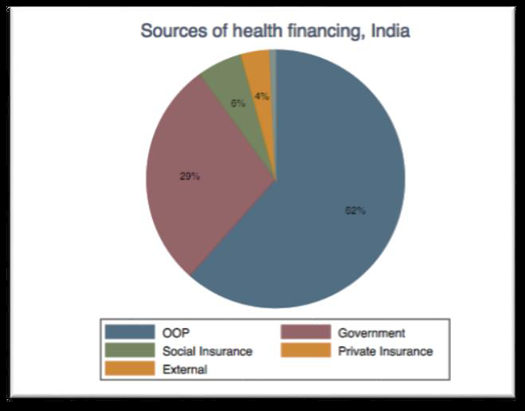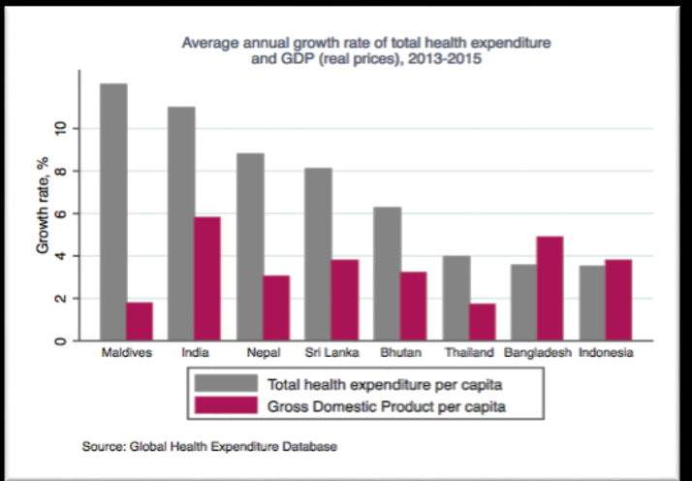**Analysis of key and vulnerable populations in India**

1. Vulnerable groups are disadvantaged as compared to others mainly on account of their reduced access to health services and the underlying determinants of health such as safe and potable drinking water, nutrition, housing, sanitation etc. These include those that on the grounds of sex, caste, birth, physical or mental disability, health status (including HIV/AIDS, TB, etc.), sexual orientation and civil, social or other status, which has the effect of nullifying or impairing the equal enjoyment or exercise of the right to health. In India, such groups include women, children, elderly, scheduled castes, scheduled tribes, slum dwellers, migrants, and others (a list of the vulnerable groups prioritized for targeted action by NTEP is provided in Table 13 Chapter 25 and Chapter 28). Poverty – and its common consequences such as malnutrition, homelessness, poor housing and destitution – is a major contributor to vulnerability.
2. In 2011, 65.5 million or 22.5% population lived in slums which are distributed among 2613 towns/cities. The slum areas also host the majority of migrants, and the health problems associated with poor housing and unsanitary environments prevail in these areas. Overcrowding, substandard housing, poor ventilation, poor sanitation, lack of access to safe food and water and poor nutrition- all facilitate the spread of infectious disease like TB. Economic deprivation exacerbates health and other risk factors among slum dwellers including migrants. Unplanned urban development puts them at higher risk for disease associated with indoor and outdoor air pollution and road traffic injuries. Many of the risk factors mentioned above make people susceptible to TB disease. Several independent studies have assessed the burden of TB and other issues related to the access of TB services by people from slum settlements.
3. According to the 2011 census, the tribal population in India was 104 million, constituting 8.6 per cent of country's population. The tribal population primarily inhabits rural and remote areas and is among the most vulnerable and marginalized section of the society. Moreover, they lag behind all other social groups in various social, health and developmental indicators[17]. In 2011, 40.6 per cent tribals were below the poverty line. Available evidence also indicates that the prevalence of tuberculosis (TB) is significantly higher among tribal populations; 703 per 100,000 compared to the national average (256 per 100,000)[18].
4. India has significantly high number of mobile populations. From 2011 to 2016, the inter-state migration stood at 9 million people (Economic Survey of India 2017). As per Census 2011, the number of internal migrants in the country (accounting for inter- and intra-state movement) were 139 million. Some of the most vulnerable populations belong to this group. These include seasonal workers, homeless people, pavement dwellers, street children and those residing in urban slums. Health indicators are typically poorer in these groups owing to inherent vulnerabilities and stigma that these populations are exposed to. A significant section of them live in congregated, crowded settings with poor ventilation and sanitary conditions. Alarmingly high burden of TB, a higher lost-to-follow ups and mortality are critical observations in homeless and other migratory people, especially in large cities. Undernutrition, chronic addiction, and unhealthy living further accentuates their vulnerability to TB. Their access to health services and diagnosis of TB including treatment initiation if detected with TB is often hampered in the absence of valid identity documents and residence-proofs whereas their rapid migratory nature imposes key barrier to adherence to treatment. There is an urgent need to bring rapid systemic changes to make health and TB services key population friendly.
   1. **Health Systems in India**
5. The constitution of India considers the “right to life” to be fundamental and obliges the government to ensure the “right to health” for all. To a significant extent, India’s health sector has been shaped by its federal structure and the federal–state divisions of responsibilities and financing. The states are responsible for organizing and delivering health services to their residents. The central government is responsible for international health treaties, medical education, and prevention of food adulteration, quality control in drug manufacturing, national disease control, and family planning programs. It also sets national health policy including the regulatory framework and supports the states.
6. Healthcare is one of India's largest service sectors. Under the Indian constitution, health is a state subject and each state has its own and unique healthcare delivery system, enacted and determined on a state level, in which both public and private (for profit as well as non-profit) sectors operate, with the central government supporting with important and crucial role in formulating national policies being implemented through state and districts. The health systems in India have evolved based on the geographical dispersion of the population and in context of the specific needs of the rural and urban areas.
7. The Indian health system has had multiple achievements in the last couple of decades include elimination of polio, guinea worm disease, yaws and maternal and neonatal tetanus and also achieving the Millennium Development Goals in respect of the Maternal Mortality Ratio (MMR level of 130 against a target of 139) and almost succeeded in meeting the Under-5 child mortality target (U5 MR level of 43 against a target of 42).
8. However, India’s healthcare scenario remains less than ideal. It is short by almost half of what the WHO recommends as the optimal number of doctors, nurses, medical technicians and healthcare facilities required to serve the population. Under excessive strain for decades, and without sufficient budget, India’s health system is frail, inadequate and of inconsistent quality, quality, particularly in the public sector.
9. Further, the double burden of disease – with a rising burden of non-communicable diseases in addition to the persistence of communicable diseases – stretches the system thin. The disease burden due to communicable, maternal, neonatal, and nutritional diseases, as measured using Disability-adjusted life years (DALYs), dropped from 61 per cent to 33 per cent between 1990 and 2016. In the same period, disease burden from non-communicable diseases increased from 30 per cent to 55 per cent. The epidemiological transition, however, varies widely among Indian states: 48% to 75% for non-communicable diseases, 14% to 43% for infectious and associated diseases, and 9% to 14% for injuries[19].
10. Currently the Government (Union and the States put together) spends roughly 1.13 per cent of GDP on health. As a result, 62 per cent of healthcare spending is financed by households through out-of-pocket expenditure at the point of care[20]. The Government of India is planning to increase public health spending to 2.5 per cent of the country's GDP by 2025.[21]
    1. **Indian healthcare delivery system - public and private.**

India has a mixed health-care system, inclusive of public and private health-care service providers. However, most of the private health-care providers are concentrated in urban India, providing secondary and tertiary care health-care services. The public health-care infrastructure in rural areas has been developed as a three-tier system based on population norms.

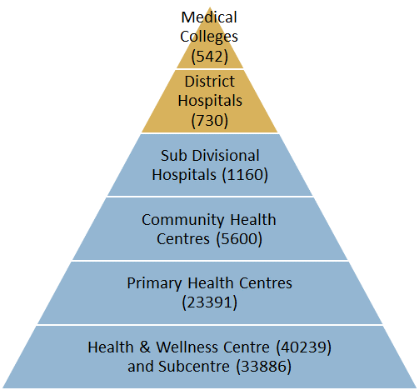**A sub-center** (SC) is established in a plain area with a population of 5000 people and in hilly/difficult to reach/tribal areas with a population of 3000, and it is the most peripheral and first contact point between the primary health-care system and the community. SCs are assigned tasks relating to interpersonal communication in order to bring about behavioral change and provide services in relation to maternal and child health, family welfare, nutrition, immunization, diarrhea control and control of communicable diseases programs. **A primary health center (PHC)** is established in a plain area with a population of 30 000 people and in hilly/difficult to reach/tribal areas with a population of 20 000, and is the first contact point between the village community and the medical officer. PHCs were envisaged to provide integrated curative and preventive health care to the rural population with emphasis on the preventive and promotive aspects of health care. **Community health centers** (CHCs) are established and maintained by the State Government under the MNP/BMS program in an area with a population of 120 000 people and in hilly/difficult to reach/tribal areas with a population of 80 000. It serves as a referral center for PHCs within the block and also provides facilities for obstetric care and specialist consultations. An existing facility (**district hospital, sub-divisional hospital, CHC**) can be declared a fully operational **first referral unit (FRU)** only if it is equipped to provide round-the-clock services for emergency obstetric and newborn care, in addition to all emergencies that any hospital is required to provide.

1. **Healthcare is provided by five major sectors in India**
   1. Public Health Sector
      1. Primary health care- PHC’s and sub-centres
      2. Secondary and Tertiary health care – CHC’s, Rural hospitals, district hospitals, speciality hospitals and teaching hospitals
      3. Health insurance schemes providing healthcare – ESI, CGHS
      4. Other agencies: Defence services, Railways, Public sector Units
   2. Private sector
      1. Private hospitals, nursing homes, polyclinics etc.
      2. General practitioners
   3. Indigenous systems of medicine
      1. Ayurveda, Unani, Homeopathy etc.
   4. Voluntary health agencies
   5. National health programs

**Figure 1: Indian Healthcare system** 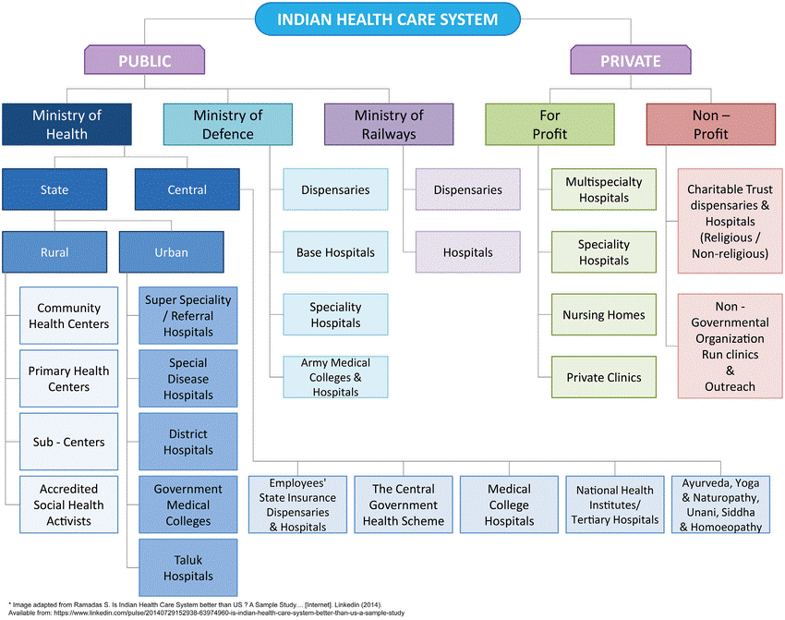

1. **Public health care system:** The **National Health Mission (NHM)** encompasses two Sub-Missions, the National Rural Health Mission (NRHM) and the National Urban Health Mission (NUHM). Earlier known only as NRHM, the Mission was launched on 12th April 2005, to provide accessible, affordable and quality health care to the rural population, especially the vulnerable groups. The main programmatic components include Health system strengthening in rural and urban areas, Reproductive Maternal-Neonatal-Child and Adolescent Health (RMNCH+A) and Communicable and Non-Communicable Diseases. The NHM envisages achievement of universal access to equitable, affordable and quality healthcare services that are accountable and responsive to people’s needs.

* **National Rural Health Mission (NRHM):** NRHM seeks to provide quality healthcare to the rural population, especially the vulnerable groups. Under the NRHM, the Empowered Action Group (EAG) States as well as North Eastern States, Jammu, Kashmir, and Himachal Pradesh have been given special focus. The thrust of the mission is on establishing a fully functional, community owned, decentralized health delivery system with inter-sectoral convergence at all levels, to ensure simultaneous action on a wide range of determinants of health such as water, sanitation, education, nutrition, social and gender equality.

Major Initiatives under NRHM include the provision of Accredited Social Health Activists (ASHAs), other human resource support, and untied grants; establishment of Rogi Kalyan Samiti/Hospital Management Society/Hospital Development Society, Village Health Sanitation and Nutrition Committee (VHSNC), Janani Suraksha Yojana (JSY), Janani Shishu Suraksha Karyakram (JSSK), Facility Based Newborn Care, National Mobile Medical Units (NMMUs), National Ambulance Services (NAS), Launch of National Quality Assurance Framework for Health facilities, Kayakalp, Free Drugs Service Initiative, Free Diagnostics Service Initiative and Bio Medical Equipment Maintenance.

* **National Urban Health Mission (NUHM):** NUHM seeks to improve the health status of the urban population particularly urban poor and other vulnerable sections by facilitating their access to quality primary healthcare. NUHM covers all State capitals, district headquarters and other cities/towns with a population of 50,000 and above (as per census 2011) in a phased manner. Mahila Arogya Samitis (MAS) play a crucial role for health and hygiene, behaviour change promotion and facilitating community risk pooling mechanism in their coverage area. Cities and towns with population below 50,000 continue be covered under NRHM.
* **Funding support by NHM:** The National Health Mission (NHM) is a major instrument of financing and support to the States to strengthen public health systems and healthcare delivery. This financing to the States are based on the State’s Programme Implementation Plan (PIP).

1. **Private healthcare system:** Private healthcare sector has become one of India’s largest sectors - both in terms of revenue and employment. It comprises hospitals, medical devices, clinical trials, outsourcing, telemedicine, medical tourism, health insurance and medical equipment. The Indian private healthcare sector is growing at a brisk pace due to its strengthening coverage, services and increasing expenditure by public as well private players. The private sector provides majority of secondary, and tertiary care institutions with a major concentration in metros, tier I and tier II cities. The NTEP has leveraged the private sector over the last decade to ensure that TB patients in the private sector receive timely diagnosis, good quality treatment, and protection from high out-of-pocket expenditure.
   1. **NTEP implementation arrangements**

**Figure 2: NTEP implementation arrangements**

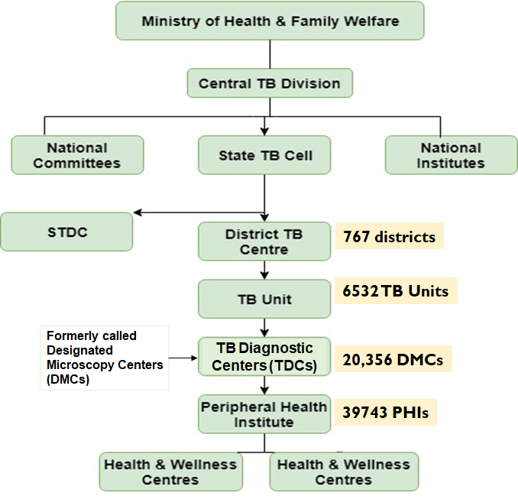**National TB Elimination Programme** is a Centrally Sponsored Scheme being implemented under the aegis of National Health Mission with resource sharing between the State Governments and the Central Government. It is managed by the Central TB Division (CTD), the technical arm of the Ministry of Health and Family Welfare (MoH&FW). The CTD is assisted by six national level institutes, namely the National TB Institute in Bengaluru, the National Institute of TB and Respiratory Disease in New Delhi, the National Institute of Research in Tuberculosis in Chennai and the JALMA Institute of Leprosy and other Mycobacterial Diseases, Agra, BMHRC, Bhopal, and RMRC, Bhubaneshwar. Fourteen committees have been constituted at national level to provide technical guidance for programme implementation.

1. **At the State level,** State Health Secretary and MD-NHM are responsible for programme implementation in the State where in the planning, training, supervising and monitoring of the programme in their respective states is as per the guidelines of the State Health Society and CTD. State TB Training and Demonstration Centre (STDC) supports the State TB Cell in most of the larger states. State Drug Store (SDS) has been established for the effective management of anti-TB drug logistics. The STDC is supported by the State TB Forums for community engagement, State level PMDT committee for implementation guidance and review of PMDT, State level TB comorbidity coordination committee and Technical Working Group for HIVTB for smooth TB- comorbidity coordination. Nodal Drug Resistant TB centres are established for management of drug resistant TB with newer drugs, adverse drug reactions and as referral unit.
2. **The district** is the key level for the management of the primary health care services. The District Tuberculosis Centre (DTC) is the nodal point for all TB control activities in the district and has the overall responsibility of management of NTEP at the district level as per the programme guidelines and the guidance of the District Health Society. District level TB comorbidity coordination committee is in-place for smooth TB comorbidity coordination.
3. **At the sub-district level** End TB activities are implemented through a Tuberculosis Unit (TU) which consists of a designated Medical Officer-Tuberculosis Control (MO-TC) supported by two full-time NTEP contractual supervisory staff exclusively for tuberculosis work - a Senior TB Treatment Supervisor (STS) and a Senior TB Laboratory Supervisor (STLS). The TU is generally aligned with the administrative blocks in the district with 1 STS /TU at NHM block or urban area ( approx. pop 1.5-2.5 l) and 1 STLS /5 lac population (~ 5 DMCs).
4. **Peripheral Health Level:** For the purpose of NTEP, a Peripheral Health Institution (PHI) is a health facility which is manned by at least a medical officer. At this level there are public or private (including NGO supported) dispensaries, PHCs, CHCs, referral hospitals, major hospitals, specialty clinics or hospitals, medical colleges. Some of these PHIs may also serve as a Tuberculosis Diagnostic Centers (TDCs), previously called Designated Microscopy Centre (DMC), which is the most peripheral level laboratory in the NTEP structure. Through these TDCs, tuberculosis case-finding activities take place. Treatment may be initiated at the PHIs and in some instances (such as drug resistant TB) where initiation is at higher levels, the treatment of the patients may continue at PHI level. For establishment of a TDC in the lab of a PHC, it must have adequate physical infrastructure, binocular microscope and a trained LT.
5. **Health and Wellness Centres (HWCs):** Under Ayushman Bharat, around 1, 50,000 existing Sub- Health Centres (SHCs) and Primary Health Centres (PHCs) are being transformed to Health and Wellness Centres (HWCs) to deliver Comprehensive Primary Health Care (CPHC), that is universal and free to users, with a focus on wellness and the delivery of an expanded range of services close to the community. The wide range of services provided at these Health and Wellness Centres will encompass maternal and child health services, communicable and non-communicable diseases, services for the elderly and palliative care including free essential drugs and diagnostic services. For the treatment of tuberculosis it will serve as the last level of healthcare facility for continuation of treatment and for receiving ancillary drugs to support TB treatment.
6. **Program Implementation Plan and Planning Process:** As with other components of NHM, financial support to NTEP is provided through the Program Implementation Plan (PIP) mechanism of the National Health Mission. NTEP / NHM follow a Bottom-Up approach for planning and budgeting. The process begins at the district level by NTEP preparing the district PIP at the District TB Centre (DTC) which gets incorporated into the integrated District Health Action Plan (IDHAP) which is further sent to the state level to form the State PIP. The PIP indicates the physical targets and budgetary estimates in accordance with the approved pattern of assistance under the NHM. This will cover all aspects of activities required to be carried out under NTEP in one financial year. The State PIPs are approved by the Union Secretary of Health and Family Welfare, as Chairperson of the EPC, based on appraisal by the National Programme Coordination Committee (NPCC) which is chaired by the Mission Director and includes representatives of the State, Technical and Programme divisions of the MoHFW, other Departments and Ministries, as required. The approved Record of Proceeding (ROP) includes Central as well as State share, and includes cash as well as commodity component. The preparation of the PIP follows a standardized template specified by the NHM.
7. **Collaborative activities with other NHM Components:** NTEP works in collaboration with other Programmes such as the National AIDS Control Organization (NACO) and the National Programme for Prevention and Control of Cancer, Diabetes, Cardiovascular diseases and Stroke (NPCDCS). Bi-directional screening for HIV and Tuberculosis, along with testing for Diabetes Mellitus is offered for all TB patients. Testing for co-morbidities is part of the bouquet of services provided to patients being treated under NTEP, in order to provide comprehensive care and support.

NTEP adopts the Health Systems Approach of the NHM, as per which the entire health system machinery works together to achieve common goals of improved health, better responsiveness and better financial protection to the patients. Human resources and infrastructure of the general health system and also of medical colleges are utilized to achieve maximum utility. For example, many drug-resistant TB treatment centres are situated in medical colleges, with medical college staff and infrastructure playing crucial role in the treatment of drug-resistant TB. Likewise, laboratory technicians from the general health system pool are re-appropriated for work under NTEP; a single counsellor in some low work-load districts/ blocks provides counselling support across various disease programmes, including Tuberculosis. Additional aspects are discussed in greater details in Chapter 12.

* 1. **Community Processes for Health**

The term ‘community participation’ was included in the **Alma Ata declaration of 1978** as one of the key principles of the “Health for All” movement. It was envisaged as the participation of community in the planning, organization, co-operation and control of primary health care, making fullest use of local, national and other available resources. It necessitated collective action by community which is sufficiently empowered to take leadership in health matters.

**In October 2018, 120 countries renewed the commitment to comprehensive primary health care for all with the Astana declaration.** The new primary health care declaration affirms the “commitment to the fundamental right of every human being to the enjoyment of the highest attainable standard of health without distinction of any kind”, and reaffirms the commitment to the Alma-Ata core principles. Astana incorporates ‘universal health coverage’ that is at the centre of the health related Sustainable Development Goal (SDG) 3[22]. The 2015 SDGs that succeeded the MDGs can provide impetus to the Alma Ata and Astana principles through other SDGs such as ‘equity’ (SDG 10), ‘community participation’ (SDG 6) and ‘intersectoral collaboration’ (SDG 17), while evidence shows that countries that reorient their health systems towards primary care are better placed to achieve almost all of the SDGs, including SDG 1 – ‘end poverty’.[23] [24]

Over the past 15 years, National Health Mission has put in place certain systems and community processes in this regard. Over 10 lakhs (one million) ASHAs act as the link between community and health care system in both rural and urban areas, while 5.5 lakhs Village Health, Sanitation and Nutrition Committees (VHSNCs) and 80,000 Mahila Arogya Samitis (MASs) serve as mechanism for promoting community participation in planning and implementation of health programs, in rural and urban areas, respectively. Role of ASHA in improving maternal and child health outcomes and in reducing incidence of communicable diseases like Malaria is well documented. However, the success of VHSNCs in building community level collective action, has been mixed and special campaign (VISHWAS) has been designed to build a collective initiative at community level.

The community processes for health also rely on the existing community level functionaries such as Anganwadi workers and Tribal Volunteers. In many States, Anganwadi workers are directly involved with ASHAs and ANM in convening the Village Health & Nutrition Days and VHSNCs. Further, community organizations promoted through other government initiatives such as Self- Help Groups are leveraged in states like Kerala and Gujarat for improving awareness and health seeking behavior in the community.

While, the model of community processes under NHM revolves around the general village/urban slum population, the National AIDS and STI Control Programme demonstrated effectiveness of peer led interventions and mechanisms through the Targeted Interventions for HIV prevention among key populations and care & support interventions among People Living with HIV. Reaching out to the key population through their peers and empowering the key populations to actively participate in various facets of the programme have helped the country in reducing burden of HIV infection and in promoting well-being of PLHIV. Similar initiatives are also being promoted under the TB programme through engaging with TB affected communities. Peer Support Groups, another peer led intervention, found helpful in HIV settings, is also being implemented in care and management of Communicable diseases like TB and in NCDs.

The TB Programme proposes to leverage and build on the existing mechanisms and processes in the field for wider community action and mass movement by civil society for ending TB. Taking lessons from the NACP, it will also further strengthen its engagement with key populations affected with TB, including TB survivors, for a rights-based, community driven response to TB.

**Chapter 3**

# **JOINT monitoring mission of NTEP and Common Review Mission of National Health Mission**

**3.1 Joint Monitoring Mission of NTEP**

The WHO-GoI JMM conducted a two-week intensive review of the TB program in India during November 11th to 22nd, 2019. As one of the largest JMMs in the world, it had a 165 (32 international and 133 national experts) member multidisciplinary team to review the progress, challenges, and plans for India’s TB efforts and to advise GoI, WHO, and partners on the pathway towards achieving Universal Access to TB care.

The recommendations presented below represent the minimum required to fulfill the Prime Minister’s national and global commitment and reach SDG targets for TB in India by 2025. These recommendations are largely in line with India’s National Strategic Plan, and a new expanded budget is required commensurate with the historically unprecedented national ambition.

**3.1.1 Challenges**

The challenges in the coming years remain daunting and are accompanied by a risk of failure to achieve the national goals unless concrete and deliberate actions are promptly undertaken. The key high level challenges are as follows.

1. Hundreds of thousands of people with TB disease remain missing to TB surveillance/ notification and services, and are likely in private health delivery systems or the community. Those who are found experience serious attrition through the cascade of care, with hundreds of thousands lost along their journey through diagnosis and treatment, particularly among those reported by private providers.
2. Furthermore, the majority of patients reported by private providers could not be confirmed to have completed treatment. Many are not screened or treated for key comorbidities such as HIV, diabetes, or malnutrition – all critical measures to maximize successful treatment outcomes and survival.
3. Existing vacancies in allocated NTEP staff positions in many states also limit progress.
4. The power of India’s general health system has not been harnessed for the national campaign against TB, particularly in settings with the highest burden of disease.
5. Tools available to NTEP, such as advanced molecular diagnostics, enhanced patient and adherence support systems, or newer drug regimens, still remain incompletely implemented.
6. Under diagnosis of paediatric TB remains a challenge. The most pressing challenges include limited capacity for case detection, lack of sensitive diagnostics and inconsistent availability of child friendly anti-TB drug formulations for prevention and cure.

**3.1.2 Recommendations**

To approach the Prime Minister’s commitment to reach the SDG targets by 2025, the Mission recommends the following ten actions.

1. **Mount the TB elimination campaign** **envisaged in India’s NSP with clear accountability and multisectoral engagement** – inspired by lessons gained from Polio eradication in India. This TB elimination campaign must be properly budgeted and financed for the remaining 5 years, drive multi-sectoral action and accountability, based on the Right to Health, under the stewardship of a National TB Elimination Board, with State counterparts backed by legislation. Rapidly develop, implement, monitor and rigorously review TB Elimination plans for every State, and consider convening the eight mega-cities for a focused effort specific to these areas and commensurate with their high burden. Also act so that vulnerable and marginalized populations are served with urgency. India can only succeed if local government, communities, and civil society are mobilized to detect and support every person suffering from TB and every affected family.
2. **Provide urgent reinforcements to the existing workforce of dedicated and skilled workers** with additional trained persons to tackle the increased workload. Immediately hire pending vacancies at all levels of local, state and national level. Deploy human resources and outsource selected functions to properly address the unprecedented expansion of early TB case finding, up-to-date and quality-assured diagnostic laboratory services, new prevention activities, management of private sector models, DBT schemes. Also, develop and execute a multi-year national and state human resource plan that informs the targeted addition of trained and dedicated staff “fit for purpose” by relying on in-person and digital training platforms, using principles of quality improvement to strengthen cascades of care, and outsourcing support for capacity development**.** In parallel, incorporate aggressive forecasting, and direct procurement or innovative contracting for drugs and diagnostics to meet rapidly expanding demand. Translating these and other recommendations into action will require adequate financing for TB. An ambitious budget for the next 5 years is required, and the Government of India should increase the level of financing for TB based on robust estimates and work plans for the 2020-25 period, making sure that the most innovative aspects of the NSP are adequately funded.
3. **Rapidly scale-up private provider engagement,** by collaborating with qualified modern medicine care providers and AYUSH providers to find and successfully treat 2 million patients in 2020-2021. Leverage the newly released Guidance for Partnerships and technical support units for output-based contracting of the workforce and services required to reach and provide quality services to double the number of TB patients being treated today. Employ conscious change management as the government undertakes the new ways of working inherent to output-based contracting, and consider using public funds to purchase privately supplied quality-assured drugs and diagnostics. Embed and implement reimbursement packages for outpatient TB services in Pradhan Mantri Jan Arogya Yojana (PMJAY).
4. **Move from passive community engagement to full community participation and ownership**, with reliance on TB champions and TB Survivors working alongside programme staff in advocacy, planning and implementation and monitoring of the local, state, and national TB response. Invest in local TB forums which are effective change agents able to work at reducing/eliminating stigma and a human rights **response framework.**
5. **Invest in TB surveillance staff and systems for accurate, complete, and timely information that** ensures the collection and analysis of high-quality, effective service delivery, performance monitoring, and understands the drivers of TB transmission. A network of national-, state-, and district-level TB Surveillance Units will be established by 2020. Augment the surveillance network with technical assistance to help address emerging priorities, build communities of practice, use local data for local action, and rapidly respond to outbreaks.
6. **Deploy new precision diagnostic tools and ensure access to prompt, quality-assured testing for accelerated progress,** and scale-up advanced diagnostics services and TB surveillance capacity**.**  Displace insensitive sputum smear microscopy with molecular TB diagnosis fully decentralized nationwide, alongside outsourcing to India’s enormous private laboratory capacity, for 20 million advanced molecular diagnostic tests annually. Provide rapid drug susceptibility testing to all persons diagnosed with TB disease -- adult and pediatric, public and private.
7. **Support patients** **comprehensively throughout treatment, using a people-centered approach**. Enable people identified with TB disease to initiate, and sustain themselves on treatment, including via budgeted support for patient peer groups, and eliminate the social and economic impacts of disease. Supplement staff, and community support and use of digital tools. Revise the DBT system and nutritional/social support implementation to reach all TB patients and secure nutritional gains and end catastrophic costs. Provide similar services and access to the latest evidence-based and recommended regimens for improved treatment of people with drug-resistant forms of TB.
8. **Re-design and pursue targeted active case finding** efforts, learning from experiences to better **screen epidemiologically-defined key affected populations and close contacts of people with TB disease**. Emphasize the proven roles of digital chest x-ray screening and rapid molecular diagnostic tests.
9. **Deploy and evaluate ambitious plans to implement TB preventive treatment** of household and other close contacts, children, PLHIV and other locally-defined high-risk groups, using new, shorter regimens (reaching an expected 5 million eligible persons annually by 2021).
10. **Invest in research to develop additional new tools required to end TB** and in the rapid uptake of available new tools, products – such as simple triage/screening, use of non-sputum clinical specimens for accurate bacteriologic diagnosis of extrapulmonary and paediatric TB, and simpler/safer/shorter universal curative TB treatment regimens. Immediately scale-up available tools, such as novel specific skin tests (e.g. C-TB) for diagnosing latent TB, automated digital chest x-ray interpretation, and new drugs/regimens, and based on the latest evidence-based global guidance. Expand research investments with urgency against these national and global needs.

**3.2 Findings from the 12th Common Review Mission of National Health Mission 2018**

The 12th Common Review Mission (CRM) was held from 04th September to 12th September 2018, to review implementation progress of the National Health Mission (NHM) in sixteen states. The focus of the CRM was to undertake a rapid assessment of the implementation status of NHM and its key strategies and priority areas, analyze strengths and challenges with respect to strengthening health systems, identify trends in progress of key indicators, particularly relating to coverage, equity and affordability, document innovations and best practices, evaluate the readiness of the state to undertake implementation of new initiatives, and review the progress and coordination mechanisms with various partners having focus on aspirational and NCD districts. This CRM had a different focus where teams assessed the implementation of the programmes from the citizen perspective and hence the interactions examined service provision from Sub Health Centres (SHCs) onwards up to District Hospital based on the principle of continuum of care.

**RNTCP: Positives**

1. **Community** in most of the states were **aware of symptoms of TB and knew where to get tested**
2. **Annual TB notification rates in public sector** met target in most states but low in private sector. Maharashtra has initiated JEET project to improve the same
3. **Schedule H1 data reporting** was done well in Himachal Pradesh: “**Mukhya Mantri Kshay Rog Niwaran Yojna”**

**RNTCP: Areas of Concern**

1. **Poor Knowledge** of Nikshay Poshan Yojana (NPY) amongst the community as well as the health workers (ASHAs/ANMs)
2. **Capacity on Extra Pulmonary-TB, Drug Resistant-TB and newer Rx guidelines of T**B for the healthcare providers(MO, MPHWs) and **ASHAs is inadequate**
3. **Underutilization of CBNAAT** centers in few states like AP and Gujarat.
4. Universal DST percentage to be improved in all States
5. **OOPE incurred in traveling to CBNAAT centers**, a deterrent in getting the tests done
6. Functional X-ray facility to be provided and utilized in most of the states

**Summary of Findings: RNTCP**

**Figure 3: Summary of Common Review Mission findings - RNTCP performance dashboard**

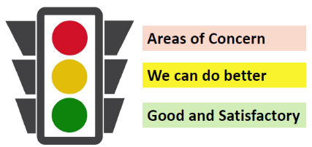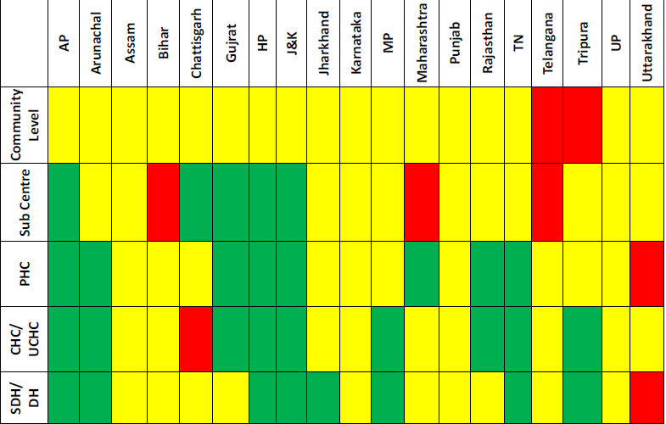

**Key Recommendations:**

1. Strict enforcement of the Gazette Notification mandating TB notification from private health care providers and private chemists.
2. More intensified ACSM activities needs to conducted for mass awareness on the newer activities especially NIKSHAY POSHAN YOJNA (Nutritional support) and all diagnostic and treatment facilities available under the programme.
3. All district level vacancies should be filled up at the earliest.
4. Real-time updating of records in NIKSHAY needs to be ensured in all the districts for quality data analysis and feedback.
5. Districts to establish sputum collection and transportation mechanism from the periphery to the CBNAAT laboratories as it has been observed that patients themselves are travelling to the CBNAAT site.

# **Chapter 4**

# **SITUATION ANALYSIS**

* 1. **TB epidemiology in India** 
     1. **TB Incidence:**

In 2019, India notified 24,04,815 (M-1511309, F-891210, TG-2296) patients, representing a 51% percent increase in total notifications as compared to 2015. The total estimated TB incidence in 2018 was 199 patients per 100,000 persons (Male – 239, Female – 156) (95% Confidence Limits [95%CL]: 136–273). TB incidence appears to be on the decline; with an 8.3 percent rate decrease since 2015 (2015 ir: 217; 95%CL: 112–355). These trends appear to be consistent among new, previously treated and HIV positive patients (Figure 4).

**Figure 4: Trends in annual number of notified TB patients, estimated TB incidence among new, previously treated (relapse), and HIV positive – India: 2000–2019.**

**Source: World Health Organization. WHO Global TB Report, 2019. Data for 2019 from NTEP**

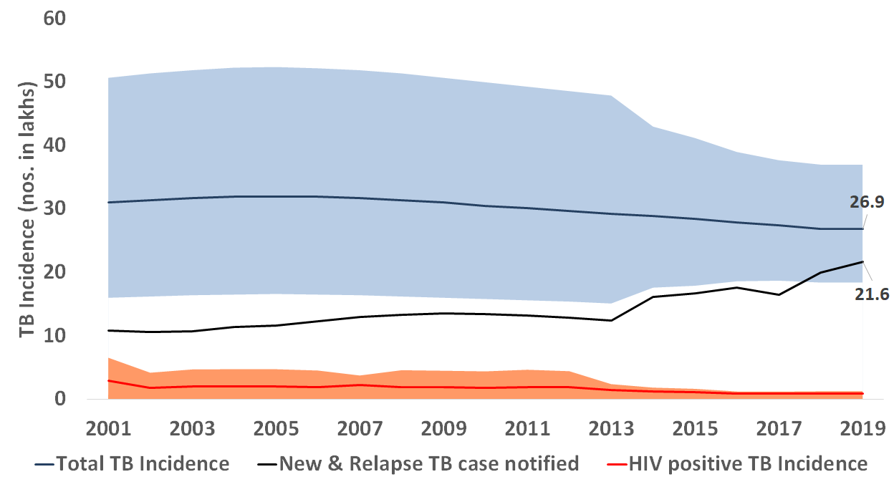

It should be noted that current estimates of incidence rely on the extent of under-reporting (assumed at 40 percent based on expert opinion). However, recent analysis of private drug sales data suggested that that an enormous number of TB patients are seeking treatment in the private sector (1.2–5.3 million patients per year). While it is unknown how many of the patients studied were over-diagnosed, there are concerns that the true incidence may be much higher than has been estimated, despite consistent and stable trends in drug sales. The pending results of the national prevalence survey holds promise to recalibrate our assumptions and calculate more accurate burden estimates.

* + 1. **TB Prevalence**

Direct estimates of TB prevalence have not been obtained since the first nationwide prevalence survey in 1955–1958. Current estimates for national TB prevalence are mathematically derived from previously conducted state-based surveys. In 2009, national TB prevalence was estimated at 301 per 100,000 population.

Nationwide national prevalence survey has begun (September 2019), and results from the 500,000 persons, 625 survey sites are likely to be available in 2021. In the interim, a recent publication summarized recent sub-national surveys and revealed wide geographic variation and discordance with the corresponding annual notification rates (Table 4).

**Table 4. Subnational prevalence survey estimates, and prevalence to notification ratio.**

**Adapted from: Chadha VK, Anjinappa SM, Dave P, et al. 2019**

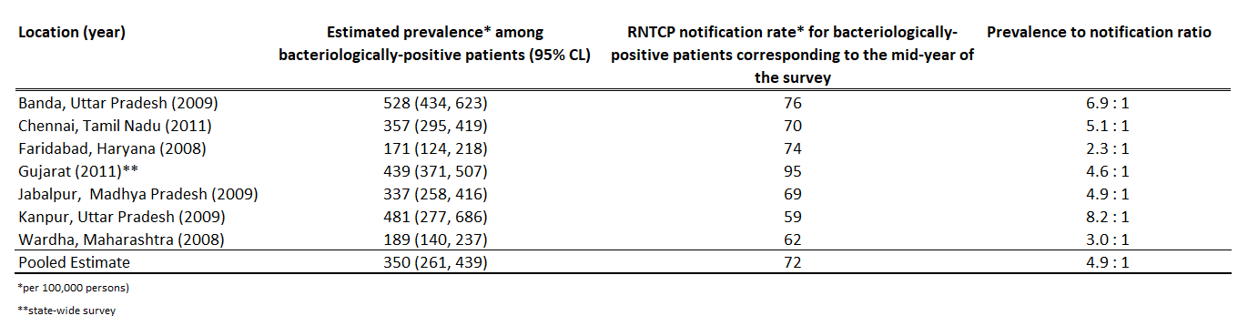

* 1. **TB Mortality**

The estimated mortality rate in India declined from almost 58 deaths per lakh population (HIV-negative) in 2000 to 32 per lakh in 2018, while the global mortality rate declined at the same rate, from 30 per lakh to 16 per lakh.

**Figure 5: HIV-Negative TB mortality**

**Rate per 100,000 population per year**

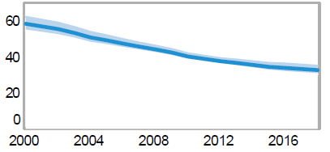

* 1. **NTEP Performance and impact**
     1. **Case notification:**

A significant year-after-year case notification increase has been observed since 2015, including a 12 percent increase in overall notifications from 2018 and 2019.

**Figure 6: Percent annual notification difference from the preceding reporting year – India, 2006–2018.**

**Source: NTEP Programme Data, 2019**

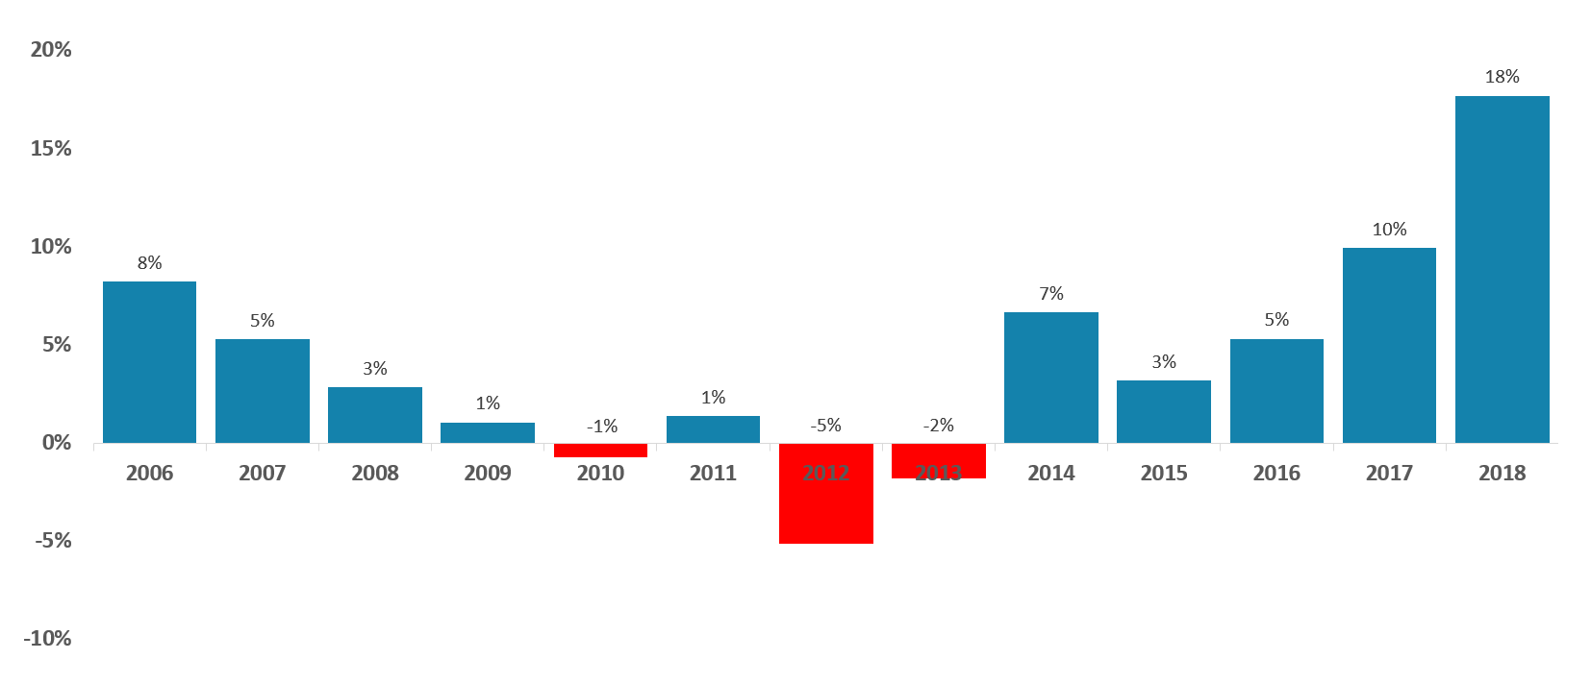This has been primarily owing to an increase in the proportion of patients notified from the private sector which has increased substantially. In 2013, only 2 percent of all notified patients were from the private sector; this proportion has increased to 28 percent in 2019.

**Figure 7: Number of notified TB patients from public and private sectors, 2000–2019.**

**Source: NTEP Programme Data, 2020.**

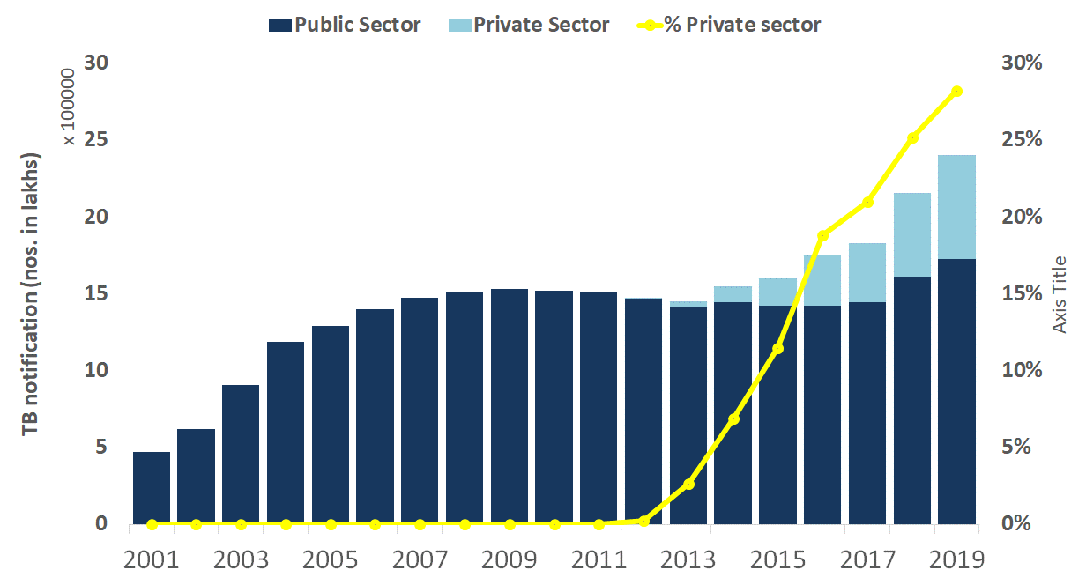

It remains unclear if the positive trend for increases case notifications resulted in more TB contact investigations, more opportunities to prevent transmission, or reduced the progression from infection to disease with impacting overall incidence

* + 1. **Presumptive examinations, bacteriologic confirmation**

Bacteriologic confirmation of TB disease is essential for starting the most effective treatment course and to monitor clinical outcomes. Since 2012, bacteriologic confirmation amongst new and previously treated patients in the public sector has remained relatively stable (Figure 8). This is despite the number of presumptive examinations increasing over time with wide geographic variation.

**Figure 8. Bacteriologically confirmed notifications amongst new and previously treated (RT) patients – India, 2012–2018.**

**Source: NTEP Programme Data, 2020.**

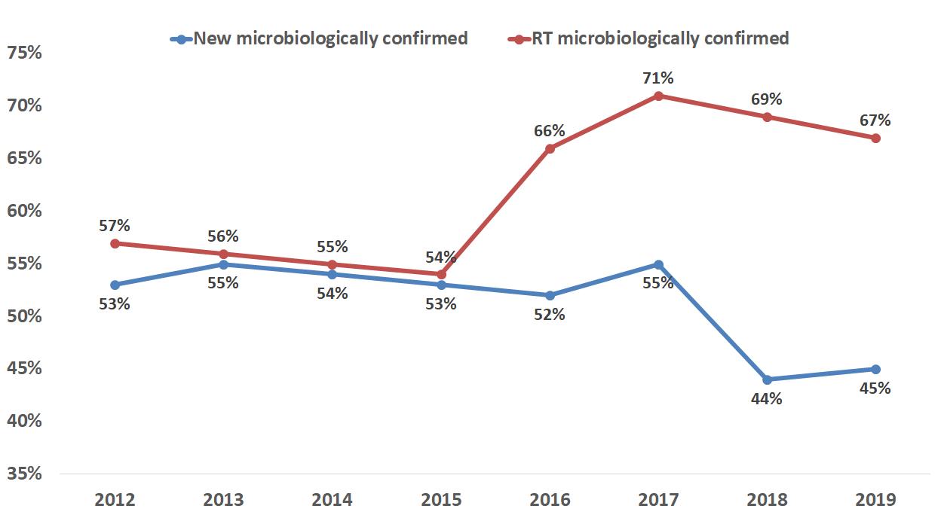

**Figure 9: Number of and rate examinations amongst presumptive TB patients – India, 2000–2019.**

**Source: NTEP Programme Data, 2020.**

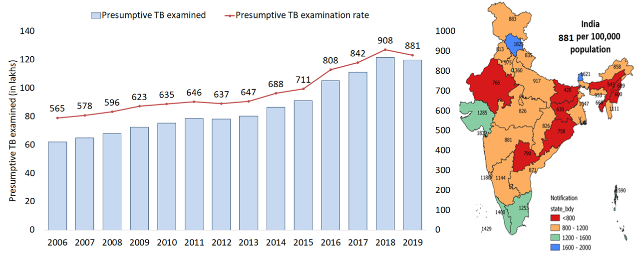

* + 1. **Drug resistant tuberculosis**

During 2007–2018, India tested 2,798,599 patients using CB-NAAT and line-probe assays (LPAs). These tests — which remarkably reduce the time to MDR identification from months to days — detected 236,725 drug-resistant TB patients. Among those tested, 166,472 (70%) were started on MDR-TB treatment, including 11,948 patients with a more severe form of extensively drug resistant TB (XDR-TB). While the scale up and performance in a relatively short period of time is impressive, a substantial proportion of patients (approximately 45 percent) remain without an accurate diagnosis and/or effective DST-guided treatment. In 2018, WHO reported an estimated 130,000 (95% CL: 77,000, 198,000) patients with RR-TB, and an estimated 9 RR-TB patients per 100,000 population.

* + 1. **Treatment outcomes**

At a national-level, treatment success (i.e. completing treatment or sputum-smear conversion) has been relatively stable amongst new sputum-smear positive patients (Figure 10). However, treatment success remains below fifty percent and there has been marginal change over the last five years amongst drug-resistant patients. There is a worrisome trend for decline in treatment success amongst previously treated patients. Death during DR treatment remains high at 20 percent, and a substantial proportion of drug-resistant patients are lost to follow-up (18 percent). It is unknown what proportion of these lost patients died but were misclassified as lost to follow-up. A recent study suggested a significant proportion of death during MDR-TB treatment may be attributed to tuberculosis-related causes.

**Figure 10: Annual proportions of successful treatment outcome among new sputum-smear positives, previously treated, and drug-resistant TB patient cohorts– India, 2012–2018\***

**Source: NTEP Programme Data, 2020. *MDR cohort for 2017 not available.**

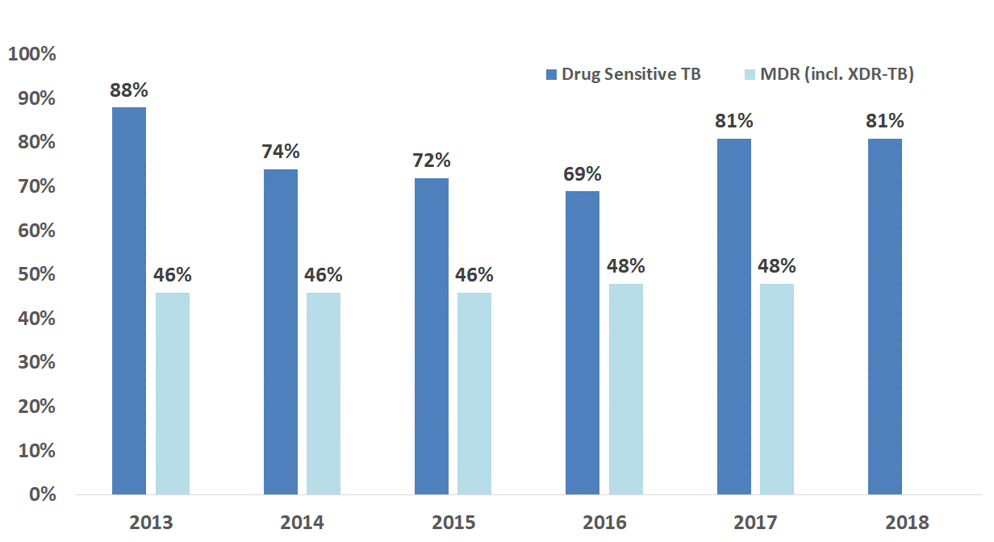

* + 1. **TB HIV**

HIV testing has substantially increased overtime; from around 11 percent in tested 2008 to more than 81 percent tested in 2019. During this time, the percent with positive results has significantly declined (Figure 11). In 2019, 46,741 TB patients tested positive for HIV 44,517 (95 percent) (M - 30290, F - 14112, TG - 115) received ART.

**Figure 11: Number of TB patients tested for HIV and percent with positive results – India, 2000–2019.**

**Source: NTEP Programme Data, 2020.**

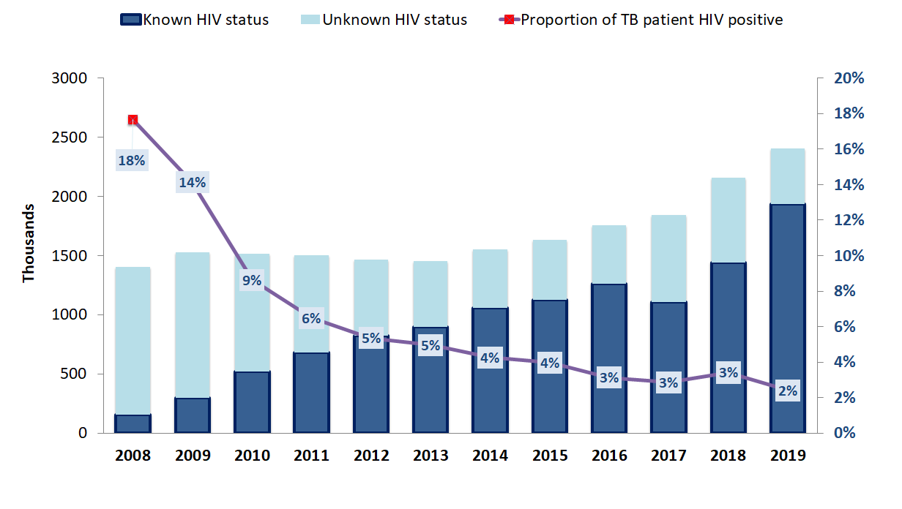

* + 1. **Vulnerable populations: children, elderly, women**

India also contributes to nearly one-third of all pediatric cases in the world and about 13 percent of all notified cases were estimated to be in children aged 0 – 14 years. Children continue to be relatively underrepresented in the national TB surveillance system. While, the number of notifications amongst 0–14-year-old patients substantially increased over the past five years (n=85,780 in 2015 to n=151,286 in 2019) (M - 75771, F - 75354, TG - 161), children are only a minor fraction of total notifications each year (around six percent annually). There also appears to be substantial geographic variation in pediatric notification. The Geriatric age group constitutes about 12% of the TB notification in the country.

**Figure 12. Proportion of pediatric notifications (0–14 year old) amongst all notifications by geography – India, 2019.**

**Source: NTEP Programme Data, 2020.**

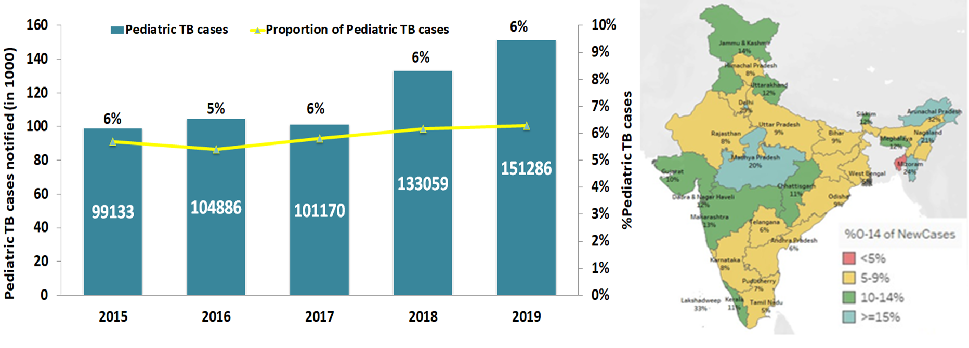

Women-specific TB notifications have increased across all age strata since 2012, but TB notifications are substantially more amongst men (Figure 13).

**Figure 13. Age and sex specific notification per 100,000 person: India, 2012 and 2019.**

**Source: NTEP Programme Data, 2020.**

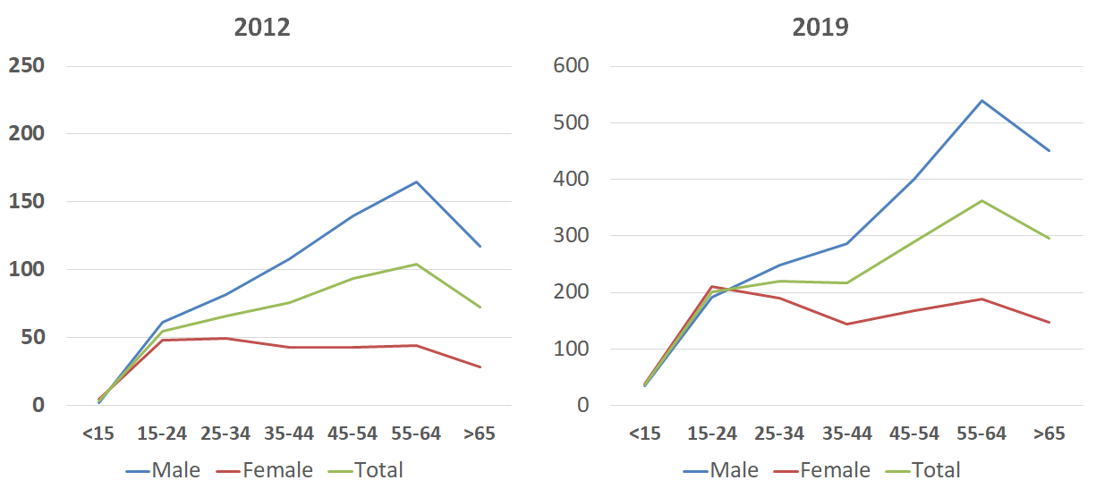

* 1. **Progress towards addressing the social determinants of TB (UHC, SDG3) and the Global commitments**

India is simultaneously burdened by multiple health conditions that have been associated with TB, including undernutrition, diabetes, excessive alcohol use, and tobacco smoking. These syndemics[25] are further fueled by poverty, indoor (e.g. solid cooking fuels) and outdoor air pollution, and overcrowding. WHO published estimates of the number of TB patients attributable to the five main risk factors (HIV, diabetes, smoking, harmful use of alcohol, and undernourishment) based on mathematical modeling and assumptions from the Global Burden of Disease studyand other sources (Figure 14). Based on this analysis, undernutrition contributed the largest fraction of TB patients in 2018, followed by harmful alcohol use, smoking, diabetes, and HIV, respectively.

**Figure 14: Estimated number of TB patients attributable to social determinants of disease – India, 2018.**

**Source. World Health Organization. Global tuberculosis report, 2019. WHO: Geneva, 2019. (WHO/CDS/TB/2019.15).**

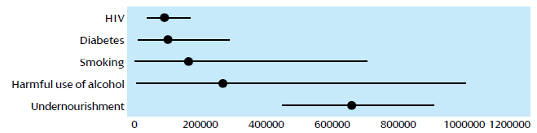To date, there has been no nationally representative study of catastrophic costs for TB in India. Smaller, local studies (with varying methodologies, populations and settings) suggest that 7 to 32 percent of TB patients in India experience catastrophic costs during the diagnosis and treatment of TB. While the NTEP acknowledges that progress towards UHC is essential to ending the epidemic, it also believes that guaranteeing UHC will be insufficient to address the tuberculosis epidemic. Social protection interventions that prevent or mitigate other financial risks associated with tuberculosis, such as income losses and non-medical expenditures, must also be considered[26].

# **Chapter 5**

# **Environmental ANalysis of NTEP**

**5.1. SWOT analysis**

**Table 5: SWOT Analysis of NTEP**

|  |  |
| --- | --- |
| Strengths | Weakness |
| 1. Highest level of political and administrative commitment with deep engagement in the TB elimination efforts of the country. 2. State Strategic plans based on the NSP 3. Availability of much greater financial resources for TB elimination 4. Availability of new drugs, regimens, diagnostics, approaches and strategies to end TB. 5. Rapid adoption of global best practices | 1. Insufficient human resource at National, State, and district levels limits programme implementation and management at all level. 2. Addressing the social determinants of TB is beyond the scope of the Ministry of Health. 3. Competing priorities in the states result in lack of focus and thrust on TB care activities 4. Significant provision of TB care continues to be provided by a fragmented and relatively unregulated private sector. 5. Low coverage of basic program services for patients accessing care in the private sector, and weak systems for contracting partners (unreliable payments for results) |
| **Opportunities** | **Threats** |
| 1. The COVID-19 pandemic response by the government focuses attention on communicable diseases and the necessity of strengthening public health systems at all levels. Also the current momentum to “fix” the long standing problems of the Indian health system presents a good opportunity for NTEP to further improve the national response. 2. Potential of leveraging the programmes of other ministries to compliment NTEPs actions to end TB 3. Increased enforcement of mandatory notification / Schedule H-1 4. Emerging business models: consolidation, chains, e-pharmacies, etc. for engaging the private sector 5. Expansion of Ayushman Bharat and Pradhan Mantri Jan Arogya Yojana (PMJAY) to cover TB patients 6. Tapping into the vibrant start up culture in India has the potential to provide innovative solutions to END TB. 7. Technical Support Units (TSUs) to intensify private sector participation 8. Vibrant community systems for supporting TB care 9. Participation by other ministries and programmes that can accelerate and augment the national END TB response | 1. Insufficient budgetary outlay for health in the national budgets compromising the allocation to TB commensurate with requirements to END TB. 2. Inadequate budgetary allocation due to competing priorities 3. The socio-cultural-economic effects and impact of COIVD19 isn’t yet well understood however it has the potential to derail the TB programme which will have an impact on reaching the targets of END TB. 4. Economic slowdown owing to the pandemic 5. Repurposing of infrastructure and existing TB human resources for emergent needs 6. Rapid urbanization, poor living conditions, ever increasing migrant population 7. Future epidemics |

Section 2

CHAPTER 5: IMPACT MODELLING

CHAPTER 6: THE NSP STRATEGIC FRAMEWORK, RESULTS FRAMEWORK AND PERFORMNACE MEASURES

# **Chapter 6**

# **NTEP IMPACT MODELING and proritization approach**

The NTEP has committed to achieve the 2030 SDG targets by 2025, 5 years ahead of the Global timeline. This necessitates aggressive actions to reduce the TB incidence by 80% and TB mortality by 90% in 2025 compared to 2015. To understand the implications of these for NSP strategies and interventions, a mathematical modeling exercise was undertaken to define the TB burden (incidence, and mortality) under different scenarios of scaling-up existing and potential newer interventions.

**Intervention Scenario**

A TB-specific transmission-based compartmental mathematical model was adapted to the Indian context to understand dynamics of coverage of different interventions and its impact on TB incidence. The various model inputs were based on expert consultations and the overall country target achievements. The models demonstrate the range of projected future estimations. These will be refined and revised in the future with new information being available each year and with the results of the National TB Prevalence survey.

We developed three scenarios depending upon coverage of various services and speed of the coverage and assessed their impact on reduction of incidence rate of TB in the country. These scenarios are as follows:

**Scenario 1: Sustained service delivery at the current trends with available tools**

**Scenario 2: Scale-up of existing strategies and introduction of newer tools**

**Scenario 3: Accelerated expansion of existing and newer tools**

**Scenario SDG: Newer vaccine, drugs, diagnostics, and non-pharmaceutical interventions**

**Projected impact**

**Incidence and Mortality trends that would arise from each of these intervention scenarios, for total TB burden over the NSP period is depicted in the graph below.**

**Figure 15: NTEP impact modelling.**

**Table 6: Impact indicators based on the modelling scenarios**

|  |  |  |  |  |  |
| --- | --- | --- | --- | --- | --- |
| **Impact Indicators** | **Baseline** | **Scenario 1** | **Scenario 2** | **Scenario 3** | **Scenario SDG** |
| **Impact indicators** |  |  |  |  |  |
| **TB Incidence rate (per 100,000 population)** | **199** | **170** | **148** | **120** | **44** |
| **TB Mortality rate (per 100,000 population)** | **33** | **27** | **21** | **15** | **3** |
| **Budget estimates for FY 2020-21 to 2023-24 (in INR crores)** |  | **16999** | **24092** | **42109** | **52867** |
| **Budget estimates for FY 2020-21 to 2025-26 (in INR crores)** |  | **27694** | **45348** | **67565** | **96099** |

**Prioritization approach**

Based on the interplay of coverage of services, its impact on TB burden and resources requirements, strategic interventions that are best suited to decrease incidence at the available resources have been prioritized and will be implemented in the country. The interventions have been also prioritized based on recommendations of the Joint Monitoring Mission in 2019 (chapter 3), Central Internal Evaluations over the last three years, various donor missions, and programme evaluations conducted by the Central TB Division.

Key interventions which are focused to impact reduction in incidence are **population screening for TB through outreach, use of molecular tests for TB diagnosis, high standard of care in private sector through comprehensive engagement, achieving high treatment success, introducing preventive therapy of adult and adolescent contacts.** Details of annual coverage (output indicators) of key TB services and outcome indicators and its impact on annual rate of incidence have been placed for baseline and all three scenarios in table below.

**Table 7: Outcome and output indicators based on the modelling scenarios**

|  |  |  |  |  |  |
| --- | --- | --- | --- | --- | --- |
| **Annual Indicators** | **Baseline** | **Scenario 1** | **Scenario 2** | **Scenario 3** | **Scenario SDG** |
| **Output indicators** | 2019 | By 2025 | | |  |
| **LTBI treatment** *(% of contacts, PLHIV, immunocompromised)* | 13% | 15% | 48% | 70% | 90% |
| **Active Case Finding** *(% of population)* | 20% | 25% | 30% | 70% | 90% |
| **Presumptive TB examination** *(in lakh)* | 119 | 140 | 293 | 468 | 600 |
| **Use of molecular test for diagnosis** *(% of presumptive TB)* | 18% | 20% | 25% | 70% | 90% |
| **PPSA** *(number of districts)* | 130 | 150 | 350 | 400 | 600 |
| **Newer vaccine** | NA | NA | NA | NA | Available |
| **Non-health interventions at scale** | + | + | + | + | ++++ |
| **Outcome indicators** |  |  |  |  |  |
| **TB Notification Coverage** *(% of estimates)* | 82% | 85% | 100% | 100% | 100% |
| **RR/MDR-TB Notification** | 51% | 55% | 68% | 90% | 95% |

These three scenarios **projected to reduce incidence rates by 15%, 26% and 39% from 2020 to 2025 and bring down the incidence rates to 170 per lakh, 148 per lakh, and 120 per lakh per year, by 2025, respectively.**

As presented above, these interventions have a considerable impact on TB burden, but – by themselves – will not be sufficient to achieve TB elimination by 2025. In addition to all the measures listed in three scenarios, we also modelled additional, aspirational measures to bring down TB burden. These measures are population level; non-TB health interventions; social and developmental interventions addressing determinants of disease; newer vaccines, drugs, diagnostics. Possible mechanisms might be

* Measures addressing diabetes, immunodeficiency conditions, smoking, abuse of alcohol etc.,
* Health system strengthening, lowering barriers in access to care and Community empowerment
* Reducing recurrent TB through therapeutic vaccination, used as an adjunct to anti-TB treatment.
* Reducing the rate of reactivation of latent TB infection through reduction of undernutrition, the deployment of a new, post-exposure vaccine
* Reducing transmission intensity through airborne infection control; addressing indoor air pollution; and improving living conditions.

These measures are not modelled in terms of specific activities, but rather in terms of their impact on the TB care cascade. These scenarios therefore cannot be costed at present, but they nonetheless provide some indication of the changes that would need to be exerted, in order to meet incidence targets by 2025. For all of these measures, although we propose some potential mechanisms, further evidence is needed for the efficacy and feasibility of these approaches. It is only with comprehensive approach of pulmonary health that the target for achieving SDG by 2025 can be achieved.

Overall to achieve the goal of achieving the END TB targets by 2025, ambitious scale up of current interventions alone will not be enough, additional bold measures, to prevent incidence at the population level, in co-ordination with the other departments and the Ministries at large, funded completely, rolled out immediately and scaled up rapidly, are urgently required.

# **Chapter 7**

# **NSP StrategiC FRAMEWORK AND PERFORMaNCE MEASUREs**

* 1. **Vision, Goals and Targets of NSP**

The NSP proposes bold strategies with commensurate resources to rapidly decline TB incidence and mortality in India by 2025 to achieve the Sustainable Development Goals on its march towards attaining the vision of a TB-free India.

**VISION: TB-Free India with zero deaths, disease and poverty due to TB**

**GOAL:** To achieve a rapid decline in burden of TB, morbidity and mortality to achieve the Sustainable Development Goals of 80% reduction in incidence and 90% reduction in deaths by 2025; five years earlier of the global targets.

**Objectives:**

**Objective 1:** Build, strengthen and sustain enabling policies, empowered institutions, multi-sectoral collaborations, engaged communities, and human resources with enhanced capacities to create a supportive ecosystem which accelerates **PREVENT – DETECT – TREAT** pillars to END TB.

**Objective 2:** Prevent the emergence of TB in vulnerable populations.

**Objective 3:** Early identification of presumptive TB, at the first point of contact (private or public sectors), and prompt diagnosis using high sensitivity diagnostic tests to provide universal access to quality TB diagnosis including drug resistant TB in the country.

**Objective 4:** Initiate and sustain, equitable access to free high quality TB treatment, care and support services responsive to the community needs thereby protecting the population especially the poor and vulnerable from TB related morbidity and mortality..

The NSP objectives are translated into four pillars that represent the consolidated NSP 2020-25 strategies and interventions. The four pillars of BUILD-PREVENT-DETECT-TREAT (BDPT) encompass all that is required to achieve the goals of the NSP. TB elimination requires the country to BUILD strong foundations for PREVENT-DETECT-TREAT components of the programme. These cut across all areas of NTEP activities and is critical in building an enabling environment that enhances the performance of the programme, ensuring quality, equity, efficiency, accountability, resilience, and sustainability in the delivery of TB care services.

The NTEP is aware and acknowledges that resilient and sustainable systems for health are an essential building block of universal health coverage, of which TB care is a part. Hence in this NSP 2020-25, it envisages to facilitate health systems strengthening and at the same time leverage the strengths of the current systems to implement its interventions.

The schematic diagram below represents the foundational pillar of BUILD with its cross cutting components at the bottom on which rest the core TB care activities represented by the pillars of PREVENT, DETECT and TREAT. The NSP pillars are deliberately reconfigured in the current order of B-D-P-T (D-T-P-B in the NSP 2017-25) to allow for greater focus on systems level solutions.

**Figure 16: Pillars and strategies of the NSP 2020-25**

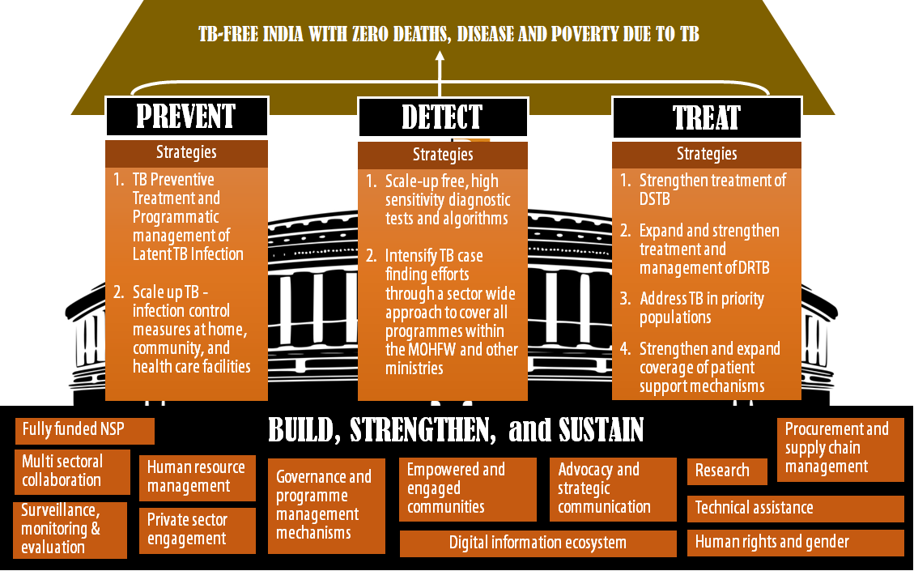

While the pillars remain the same, it must be noted that the pillars in NSP 2020-25has been reconfigured in **BUILD–PREVENT–DETECT-TREAT** sequence.

* 1. **The NSP strategic framework**

Significant progress has been made towards achieving the objectives laid down in the NSP 2017-25, especially in the last 3 years. The 2019 JMM provided NTEP with direction on the way forward to accelerate the progress towards ending TB. It recommended comprehensively deployed interventions to accelerate the decline in TB incidence, to more than 6 - 7 % annually to achieve the 2030 SDG by 2025. The prerequisites for moving towards ending TB and ultimately TB elimination have been integrated into the four strategic pillars of **BUILD - PREVENT - DETECT – TREAT** to accelerate the achievement of programme goals**.** The following table describes the renewed approach to END TB in the country.

**Table 8: Pillars, Objectives, Strategic area and Interventions in the NSP 2021-25**

|  |  |  |
| --- | --- | --- |
| **PILLAR 1: B U I L D, S T R E N G T H E N A N D S U S T A I N A N E N A B L I N G E N V I R O N M E N T F O R T B E L I M I N A T I O N** | | |
| **Objective 1. Build, strengthen and sustain enabling policies, empowered institutions, multi-sectoral collaborations, engaged communities, and human resources with enhanced capacities to create a supportive ecosystem which accelerates PREVENT – DETECT – TREAT pillars of the NSP** | | |
| **S R A T E G I C A R E A :**  **1 . 1 to 1 . 1 4** | **I N T E R V E N T I O N S** | |
| * 1. Ensure a fully funded NSP | 1.1.1 Improve health financing  1.1.2 Improve financial flow | |
| * 1. Enhance the human resource and its management within the NTEP | 1.2.1 Create and fill key positions in line with the scope of new NSP activities  1.2.2 Update the staffing structures for NTEP staff in the states.  1.2.3 Training  1.2.4 Strengthening the capacity of the STDCs to execute key functions | |
| * 1. Increase efficiency and effectiveness of governance and programme management mechanisms for TB elimination | 1.3.1. National TB Policy and TB Bill  1.3.2. Expedite setting up of prescribed governance structures  1.3.3. Extend the governance and management structures to the States and District  1.3.4. Strengthen governance for private sector engagement | |
| * 1. Strengthen and scale-up the existing private sector engagement mechanisms with new additionalities to enlist greater pvt sector participation and programme reach | 1.4.1. Continue to Improve TB notification from private healthcare providers  1.4.2. Strengthen collaboration with corporate hospitals  1.4.4. Improve access to diagnostics for TB patients notified from private sector  1.4.5. Improve access to drug for TB patients notified from private sector  1.4.6. Enhance Surveillance and Quality improvement  1.4.7. Expand ICT support to support the TB patients and private provider  1.4.8. Involvement of AYUSH Providers  1.4.9. Involvement of Health Establishments under other line Ministries, PSUs, Corporates, etc. | |
| * 1. Expedite multi sectoral collaboration with a focus on the implementation of multisectoral accountability framework | 1.5.1. Adopt a National multisectoral accountability framework to end TB  1.5.2. Drive multisectoral action, based on the right to health, via a TB Elimination Board/Committees and state/local counterparts, and inter-sectoral committees  1.5.3. Strengthen the Inter ministerial committee  1.5.4. Actions to ensure major national initiatives/programmes are and can contribute to ending TB  1.5.5. Undertake mapping of key populations and interventions | |
| * 1. Support to create empowered and engaged communities to fight TB | 1.6.1. Amplify and scale up active engagement of communities affected by Tuberculosis, especially TB survivors and key populations  1.6.2. Expand community participation in the mission to end TB  1.6.3. Build new need-based collaborations and strengthening current partnerships at national and sub-national levels with Community-Based and Civil Society Organizations  1.6.4. Institute mechanisms at various levels for ensuring accountability of the health system to the community and making the programme responsive to the community needs.  1.6.5. Explore innovative resource mobilization strategies for community engagement, including but not limited to leveraging CSR funds.  1.6.6. Build a knowledge base and sharing of experiences and good practices with potential for replication in different settings  1.6.7. Build capacity of community structures and institutions for supporting different facets of TB elimination | |
| * 1. Advocacy and strategic communication | 1.7.1. Engage in high-level advocacy with the National Parliament and State Assemblies  1.7.2. Conduct round-the-year communication campaigns that are strategically designed in close collaboration with affected communities to influence positive behaviors and improved awareness. Implement, monitor and evaluate the impact of communication campaigns | |
| * 1. Enhance and strengthen surveillance, monitoring and evaluation of NTEP | 1.8.1. Build and mentor a strong surveillance, epidemiology, and monitoring and evaluation workforce.  1.8.2. Use local data for local action; create process indicators that are vital for larger outcomes.  1.8.3. Develop user-friendly, virtual “workspaces” and data visualizations to prompt local public health action.  1.8.4. Accelerate alignment with all health information systems and applications.  1.8.5. Phase out paper-based recording systems. | |
| * 1. Research | 1.9.1. Improve the institutional structure and capacity for TB research  1.9.2. Address issues related to Operational Research and Implementation Science 1.9.3. Undertake research in key priority areas like Case Finding, treatment, and prevention among different high risk populations | |
| * 1. Strengthen procurement and supply chain management | 1.10.1 Create an alternative back-up mechanism to speed up procurement of drugs and diagnostics  1.10.2 Develop E-Pharmacy / commerce platforms to enable door-step delivery of drugs  1.10.3 Strengthening of procurement and supply chain management systems by upgrading institutional and individual capacities  1.10.4 Increase uptake of Digital Technologies for SCM  1.10.5 Create mechanisms for enabling the availability of NTEP drugs to patients in the private sector  1.10.6 Strengthening of Nikshay Aushadi  1.10.7 Improve supply chain efficiency and effectiveness  1.10.8 Strengthen and upgrade drug store infrastructure at state, district and block levels  1.10.9 Set up state level PSM units  1.10.10 Build capacity at state level  1.10.11 Establish / strengthen transportation system through third party logistics  1.10.12 Prepare and execute mechanism for thorough upkeep and uptime maintenance of Mobile Medical Vans & Equipment  1.10.13 Strengthen supervision and M&E in PSM  1.10.14 Establish Policies for decentralized write off up to 2% of cost of annual supply for expired drugs and commodities | |
| * 1. Digital information ecosystem for TB care | 1.11.1 Strengthen Central TB Division, to be equipped with resources to develop and maintain IT Systems, manage and use real time information for program management  1.11.2 Systems for monitoring TB Epidemiology, information dissemination and capacity building  1.11.3 Strengthen National TB Call Centre for provision of comprehensive inbound and outbound call services. | |
| * 1. Secure cutting edge technical assistance | 1.12.1. Strengthen the TSN and make TA responsive to the emerging TB landscape in India.  1.12.2. Extend TA to other line ministries  1.12.3. Expedite the establishment of the TSU’s for high priority States  1.12.4. Create a platform/mechanism to enlist and provide information on the available TA subject experts | |
| * 1. Address human rights and gender related barriers in access to TB services | 1.13.1. Provide equitable, rights-based TB services for women, men and transgender persons by adopting a gender-specific programmatic approach at all levels  1.13.2. Mobilize, empower and engage women, men and transgender persons in the TB response at the health system and community levels  1.13.3 Create empowered community monitoring system for ensuring human right centric care for people affected by TB. | |
| * 1. TB care in the era of COVID-19 : Build a resilient, responsive and agile NTEP to respond to complex emergencies | 1.14.1. Leverage the momentum generated on anti-COVID-19 response across institutions, policies, regulations and behavioural risk communication for NTEP.  1.14.2.Pandemic preparedness actions  1.14.3. Pandemic response  1.14.4 Post pandemic restoration response | |
| **PILLAR 2: P R E V E N T** | | |
| **Objective 2: Prevent the emergence of TB in vulnerable populations using a combination of biomedical, behavioural, social and structural targeted interventions.** | | |
| **S R A T E G I C A R E A :**  **2 . 1 t o 2 . 2** | **I N T E R V E N T I O N S** | |
| * 1. TB Preventive Treatment (TPT) and Programmatic management of TPT | **2.1.1** Saturation of TPT coverage and integrated monitoring of TPT amongPLHIV, contacts of TB patient and other target populations  2.1.2 Introduce and expand phase wise LTBI management coverage among adolescent and adult contacts in households, proximity contacts, vulnerable populations and workplace contacts  2.1.3 Introduce and expand coverage of newer and effective TPT diagnostics and shorter TB preventive treatment regimens  2.1.4 Expedite research and fast tracking adoption of new products and innovations | |
| * 1. Scale up TB - infection control (TB-IC) measures at home, community, and health care facilities | 2.2.1 Enhance policy support and human and financial resources to mainstream Airborne Infection Control (AIC)  2.2.2 Strengthen AIC through effective implementation of administrative, environmental measures and personal protection measures at healthcare, community and workplace settings  2.2.3 Strengthened and responsive system for surveillance of TB among health workers | |
| **PILLAR 3 : D E T E C T A L L** | | |
| **Objective 3: Early identification of presumptive TB, at the first point of contact (private or public sectors), and prompt diagnosis using high sensitivity diagnostic tests to provide universal access to quality TB diagnosis including drug resistant TB in the country.** | | |
| **S R A T E G I C A R E A :**  **3 . 1 t o 3 . 3** | **I N T E R V E N T I O N S** | |
| * 1. Scale-up free, high sensitivity diagnostic tests and algorithms | 3.1.1. Enhance the use of novel and improved strategies to enable diagnosis of latent as well as active TB (including DR TB)  3.1.2. Strengthen the laboratory and diagnostic systems to shift from sputum microscopy to molecular diagnostics for diagnosis of TB, in a phased manner  3.1.3 Strengthen efficient specimen transport mechanisms  3.1.4 Establish and implement systems for monitoring of quality assurance and time-bound delivery of laboratory services | |
| * 1. Intensify TB case finding efforts through a whole of sector approach to cover all programmes within the MOHFW and other line ministries | 3.2.1 Create an Integrated diagnostic algorithm to detect all forms of TB (latent, active, and DR-TB)  3.2.2. Integrate TB diagnosis with public health laboratories at sub district levels within the existing health system and decentralize molecular diagnostics to block levels for extensive outreach  3.3.3. Conduct predictive analysis for hot spot identification and vulnerability mapping  3.3.4 Conduct systematic screening of high-risk / vulnerable groups through outreach and community-based approaches using digital x-rays and rapid and more sensitive molecular diagnostics  3.3.5 Institute systematic screening for TB symptoms in health care institutions/ OPDs including COVID screening  3.3.6 Intensified contact tracing/investigation using community-based and other approaches to cover households, proximal contacts and workplace settings and follow up | |
| **PILLAR 4: T R E A T A L L** | | |
| **Objective 4: Initiate and sustain, equitable access to free high quality TB treatment, care and support services responsive to the community needs thereby protecting the population especially the poor and vulnerable from TB related morbidity and mortality .** | | |
| **S R A T E G I C A R E A**  **4 . 1 t o 4 . 4** | **I N T E R V E N T I O N S** | |
| * 1. Strengthen treatment of DSTB | 4.1.1. Continue with the current modalities for treatment that include daily regimens for DSTB and expand coverage among patients seeking care in the private sector  4.1.2. Strengthen adherence monitoring and post treatment follow up for the prevention of relapse and development of drug resistance  4.1.3. Care cascade monitoring  4.1.4. Redesign Directly Observed Treatment (DOT) modalities and expand options for adherence monitoring and supervision through involvement of Health & Wellness Centres and innovative digital tools  4.1.5. Strengthen Clinical management support through tele-medicine and digital artificial intelligence driven tools  4.1.6. Strengthen implementation and monitoring of Pharmacovigilance for DS-TB and DR-TB | |
| * 1. Expand and strengthen treatment and management of DRTB | 4.2.1 Introduction and scale up of effective all oral regimens with shortened duration  4.2.2 Estimate burden and protocols for addressing Non-tuberculous Mycobacteria (NTM)  4.2.3 Build capacity and linkages to existing programs for palliative care and rehabilitation. | |
| * 1. Address TB in priority populations and scale up integrated action on TB and comorbidities | 4.3.1. Common strategic interventions for strengthening TB care services in priority populations  4.3.2 Pediatric TB and TB among Adolescent population  4.3.3. Malnutrition and TB  4.3.4. Alcohol dependence/substance use  4.3.5. Tobacco use  4.3.6. TB – Diabetes  4.3.7. TB-HIV | 4.3.8. TB-Gender  4.3.9. TB-Pregnancy  4.3.10. TB in Congregate settings/incarcerated population including juveniles  4.3.11. TB-Geriatrics  4.3.12. TB-Mental Health  4.3.13. TB-Hepatitis  4.3.14. TB-Silicosis  4.3.15. Tribal TB  4.3.16. TB in urban slums  4.3.17. TB among migrants  4.3.18. TB among Truckers, public transport workers  4.3.19. TB among TGs/MSMs/IDUs and Sex Workers  4.3.20 TB and COVID-19 |
| * 1. Strengthen and expand coverage of patient support mechanisms | 4.4.1 Expand the coverage of treatment adherence mechanisms for all TB patients.  4.4.2 Provide social benefits to patients available under NTEP and linkages to other relevant social support schemes with line ministries  4.4.3 Initial Screening and review of data and improvement of monitoring tools in Nikshay  4.4.4 Call Centre support for strengthening and monitoring treatment adherence | |
| * 1. Institutionalize mechanisms to monitor Catastrophic Health Expenditures (CHE) in persons affected by TB | 4.5.1 Undertake regular analysis of CHE through dip-stick studies, review missions and direct patient feedback through national call center | |

* 1. **Results framework[27]**

The performance measures is a detailed account of the indicators for each of the pillar and strategic area of the NSP. Measuring, monitoring, and evaluating programmatic achievements against these indicators is central to the success of the NTEP. A major activity for the programme will be to strengthen the surveillance system and further integrate these indicators into the existing Nikshay platform.

**Table 9: Key indicators for the priority programmatic areas and the targets: NSP 2020-25 India.**

|  |  |  |  |  |  |  |  |
| --- | --- | --- | --- | --- | --- | --- | --- |
|  | PREVENT |  | DETECT |  | TREAT |  | BUILD |

|  |  |  |  |  |  |  |  |  |
| --- | --- | --- | --- | --- | --- | --- | --- | --- |
|  | **Indicator** | **2019** | **2020** | **2021** | **2022** | **2023** | **2024** | **2025** |
|  | Total number of beneficiaries to be initiated on TB Preventive therapy | 8,03,846 | 7,14,265 | 15,00,000 | 20,00,000 | 25,00,000 | 30,00,000 | 40,00,000 |
|  | No of presumptive TB cases to be tested | 1,31,22,971 | 82,88,018 | 1,50,00,000 | 1,75,00,000 | 2,00,00,000 | 2,50,00,000 | 3,00,00,000 |
|  | Proportion of presumptive TB cases tested with molecular technology | 16% | 18% | 20% | 23% | 25% | 30% | 30% |
|  | Total TB patients notified | 24,04,815 | 15,00,000 | 24,00,000 | 26,00,000 | 25,00,000 | 25,00,000 | 25,00,000 |
|  | Public sector (notification) | 17,31,680 | 10,80,000 | 16,25,000 | 15,50,000 | 14,50,000 | 14,50,000 | 14,50,000 |
|  | Private sector (notifications) | 6,73,431 | 4,20,000 | 7,75,000 | 10,50,000 | 10,50,000 | 10,50,000 | 10,50,000 |
|  | Proportion of microbiologically confirmed TB patients in private sector | 20% | 25% | 28% | 30% | 35% | 38% | 40% |
|  | Proportion of notified TB cases with known HIV status (Including private sector) | 81% | 86% | 88% | 90% | 95% | >95% | >95% |
|  | Number of priority population screened for TB through ACF annually (in Cr) | 19 | 15 | 22 | 25 | 28 | 30 | 35 |
|  | Proportion of notified TB patients offered DST | 59% | 60% | 65% | 65% | 65% | 70% | 70% |
|  | No of MDR/RR TB patients notified | 66,255 | 45,419 | 71,073 | 75,969 | 81,438 | 92,750 | 99,375 |
|  | Proportion of patients from private sector who are provisioned free for anti TB drugs | 8% | 15% | 25% | 35% | 40% | 40% | 40% |
|  | Treatment success rate of TB Pts in the private sector | 71% | 75% | 80% | 85% | 90% | 90% | 90% |
|  | Treatment success rate for DS TB | 84% | 85% | 86% | 87% | 88% | >90% | >90% |
|  | Treatment success rate for RR TB | 48% | 48% | 52% | 56% | 60% | 60% | 65% |
|  | Proportion of notified TB patients receiving financial support through DBT for NPY | 70% | 75% | 80% | 85% | 90% | 90% | 90% |
|  | Proportion of notified TB – HIV cases initiated on ART | 94% | 94% | 95% | 95% | 95% | 95% | 95% |
|  | No of rapid molecular laboratories established | 1530 | 3945 | 7645 | 7645 | 7942 | 7942 | 7942 |
|  | No of laboratories with first line DST established | 54 | 92 | 100 | 100 | 100 | 100 | 100 |
|  | No of second-line DST (SLDST) laboratories established | 85 | 100 | 100 | 115 | 120 | 120 | 120 |
|  | Proportion of sanctioned positions filled at State level | 70% | 80% | 90% | 95% | 95% | 95% | 95% |
|  | Proportion of sanctioned positions filled at district level | 80% | 90% | 95% | 95% | 95% | 95% | 95% |
|  | Number of districts covered under patient provider support agency (PPSA) | 130 | 200 | 300 | 350 | 350 | 350 | 350 |
|  | Proportion of PHIs reporting notification and drug consumption directly in Nikshay | 50% | 80% | 90% | >90% | >90% | >90% | >90% |
|  | No. of districts covered under District Level Annual Survey | 0 | 0 | 350 | 500 | 700 | 700 | 700 |
|  | Proportion of notified TB patients experiencing any stigma associated with TB disease | 40% | - | ↆↆↆ | - | ↆↆↆ | - | ↆↆↆ |
|  | No. of TB champions trained and engaged in NTEP | 300 | 1500 | 2000 | 2500 | 3000 | 4000 | 5000 |

# **NSP PILLAR 1**

# **BUILD**

# **Chapter 8**

**NSP STRATEGIC AREA 1.1**

# **Ensure a fully funded NSP**

**THE PROGRESS SO FAR**

Over the last three years since the aspirational and bold NSP 2017 2025 was adopted by the Government, there is a strong political commitment at the highest levels that is matched by financial commitment. A rapid budget increase from 2015 to 2019 was quickly implemented to support the ambitious goals of the NSP (2017-2025). The NTEP budget more than doubled since the launch of the NSP (see figure 17 below).

**Figure 17: NTEP Budgets and Expenditures, 2014 to 2020 Source: NTEP data**

**Remark: State contributions not included. Global Fund non-government PRs expenditures not included**

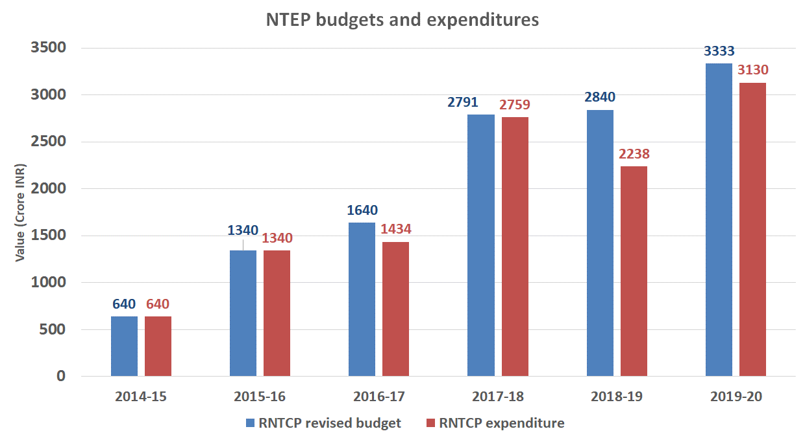

The programme has also identified and utilized Innovative and results-based financing for high impact NSP interventions (i.e. private sector scale-up and DBT). Over the period of NSP 2017-25, the NTEP has spent over 90% of the allocated resources ( Rs 8127 Cr expended against an allocation of Rs 8964 Cr during 2017-20).The electronic Public Financial Management System (PFMS) was rolled out to all the districts **to improve the efficiency of district-level accounting and financial management.**

**CHALLENGES REMAIN**

1. **Health Financing:**
   1. No system in place to monitor out-of-pocket and catastrophic health expenditures for TB.
   2. Continued gaps in coordination with the National Health Authority (NHA) to better implement AB-PMJAY schemes to ensure free and accessible outpatient and inpatient treatment for TB patients.
2. **Financial Flow:**
   1. Insufficient, incomplete and timely release of NTEP budgets to State/UTs.
      1. Burn rate (figure 18) and budget release varies by states.
      2. Marked delays (range of 52-262 days) in release of the first installment of the budget.

**Figure 18: Burn rate of NTEP funds 2018-2019 by region.**

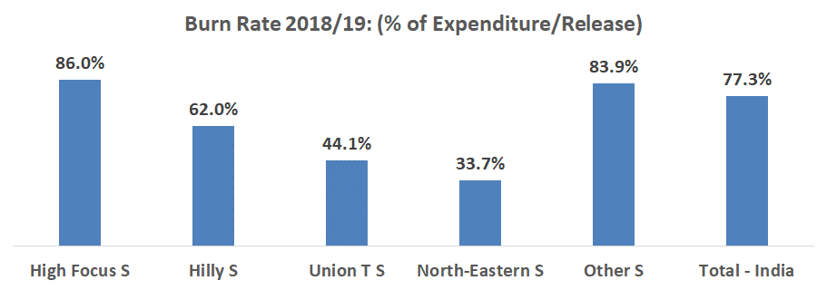

* 1. Inefficacies in monitoring budget and expenditures. At the state level, excel sheets separate and independent from the PFMS are used to track financials.
  2. Lack of capacity for implementing and monitoring important financial systems. For example, technical staff (i.e. Senior TB Treatment Supervisor (STS), Senior TB Laboratory Supervisor (STLS), etc.) are responsible for accounting entries and DBT transactions.
  3. Delays in effective auditing processes. For example, untimely submission of audit reports by State and delayed appointment of auditor firms by NHM persists.

**THE WAY FORWARD**

In order to meet the SDG target by 2025, it is important to sustain, and in some case continue to increase, funding levels for TB, as supported by accurate, robust costing exercise(s) of the NSP from 2020 to 2025. It will be particularly important to ensure that the most innovative aspects of the NSP are adequately funded. Leveraging resources from Health System Components of NHM would help in efficiently utilizing TB programme budget. Funds generated through Corporate Social Responsibility (CSR) initiatives and other line ministries can be strategically utilized to augment and catalyze critical high impact interventions

**1.1.1 To improve health financing**

1. Cost the NSP from 2020-21 onwards to attain SDGs by 2025
2. Ensure budgetary provision for TB in sync with the estimated NSP financing envelop and activities to end TB by 2025 (Ministry of Finance and NHM)
3. Increase financial resources for line items in the budget that relates to increasing the coverage of private sector engagement
4. Obtain robust estimates on TB expenditures:
   1. Public Expenditure Reviews for TB programs
   2. National Health Accounts and/or household surveys and small TB expenditure studies
5. Periodically measure and monitor the Out of Pocket Expenditure (OOPE) and Catastrophic HE for TB
6. Further strengthen linkages with the National Health Authority for better coordination on financing from PMJAY for in-patient care and potentially Out Patient package.
7. Explore TA options offered by various partners in improving PFMS utilization.
8. Create a technical support group at CTD for resource mobilization through innovative financing options

**1.1.2 To improve the financial flow**

* 1. States to provide up-to-date financial contributions to the next FY by the end of each financial year (April).
  2. Timely appointment of auditors by NHM needed and submissions of auditor’s report and audited UCs thereof.

# **Chapter 9**

**NSP STRATEGIC AREA 1.2**

# **Human resource manAgement**

**INTRODUCTION**

The ambitious goals of the NSP will only be achieved if it has a TB health workforce in sufficient numbers, with right knowledge and skills, and proper motivation. And the absence of such a well-prepared HR workforce will continue to be a major bottleneck in achieving the goal of a TB free India by 2025. With evolving TB management, NTEP has increased its workforce and skill mix over the years to match with demand of service provision. Though NTEP has been defining needs of the staff for TB services, it is the State NHM which manages staff across programmes, and synchronizes their work and efforts following health system approach. As a part of NHM, TB programme is moving towards workload based staffing, performance based incentives, loyalty incentives etc.

To address the challenges the NTEP will develop a National HR Plan in 2020 with a focus on addressing the HR shortcomings by updating NTEP staffing requirements (to include, but not limited to, quantity, skills mix, salary scale, quality of in-service training of staff at all levels) and prioritizing recruitments of positions at all levels.

**THE PROGRESS SO FAR:**

1. HR levels are better aligned to the need and to block level TB units.
2. In 2014, there was one Senior Treatment Supervisor (STS) per 413,000 population; in 2019, there is one STS per 274,000 population.
3. Workload Assessment for undertaking the new initiatives outlined in the earlier NSP is ongoing and nearing completion.
4. Training contents and methodology has been updated and new tools (e.g. e-training modules) have been developed.
5. A performance-based incentive system has been designed and approved to help address the implementation gaps in performance of frontline workers. (E.g. of service delivery teams).

**CHALLENGES REMAIN**

1. High vacancy rates (Figure 19) of key positions at all levels, including the general health system and NTEP.

**Figure 19: Vacancy rate (%) for state-level positions.**

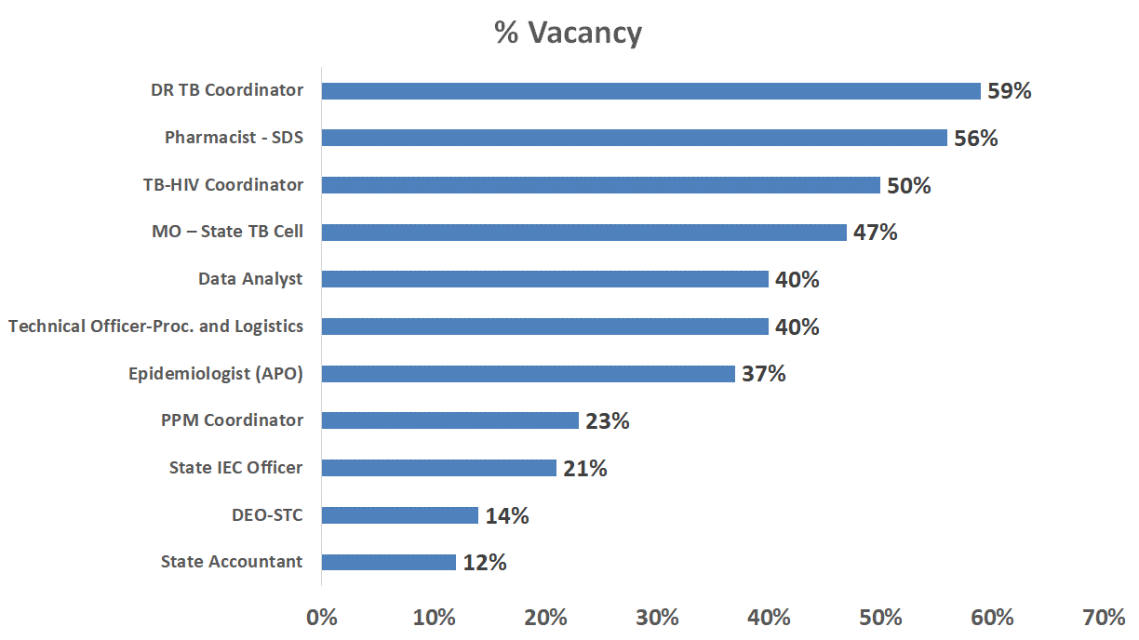

**Figure 20: The graph below shows the number of approved positions for the culture and drug sensitivity testing (CDST) labs and the number of actual filled positions at the CDST labs.**

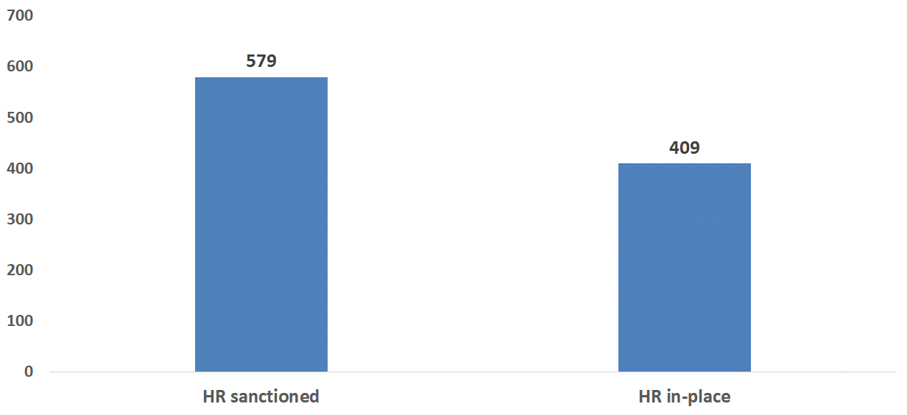

**Figure 21: The graph below shows the number of approved positions for district-level accountants and the number of actual district-level accountant positions filled.**

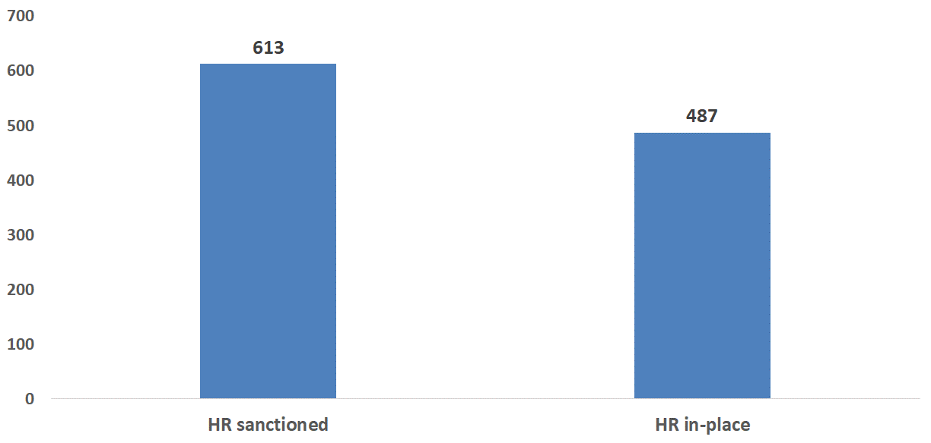

1. The Terms of Reference (TOR) for staff at the state, district and sub-district level are not representative of the expanded, ambitious scope of the NSP.
2. State level decision on salary scales leads to inequity among states. Further, these scales are often ill-aligned with market rates leading to lack of interested, qualified applicants
3. While some strides have been made in ensuring that adequate training of personnel, gaps persist. For example, a needs assessment has not been completed at all levels and e-training modules are not yet operational.
4. A marked lack of capacity at the State Tuberculosis Training and Demonstration Center (STDC) perpetuates weak state and district/sub-district level capacity to support the increasing programmatic demands of the NTEP

**THE WAY FORWARD**

**1.2.1** Execution of the **National NTEP HR plan** with the aim to harness the full potential of human resources in the NTEP structure. The proposed organograms at various levels are as follows:

**Figure 22: National level NTEP organogram:**

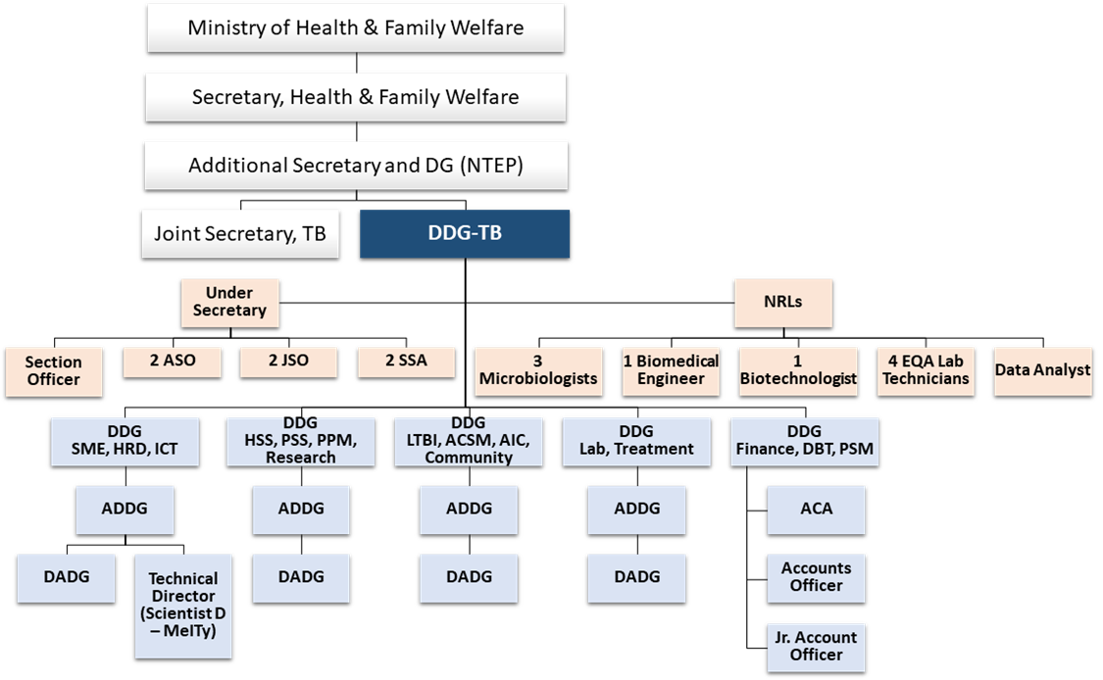

**Figure 23: National Level Consultants**

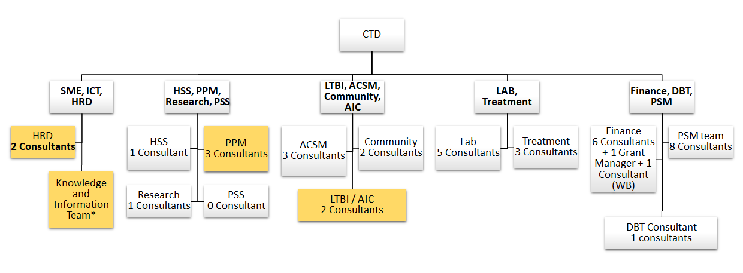

**Figure 24: National TSU**

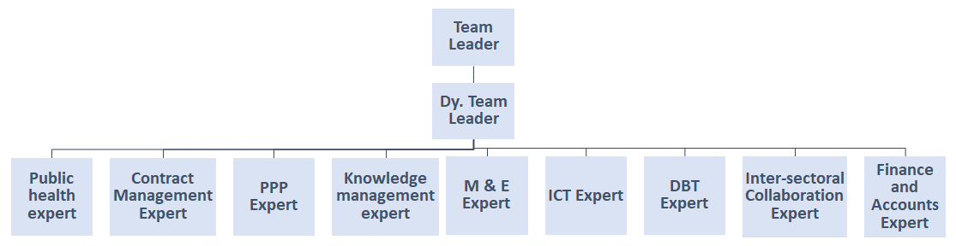

**Figure 25: State level NTEP Organogram**

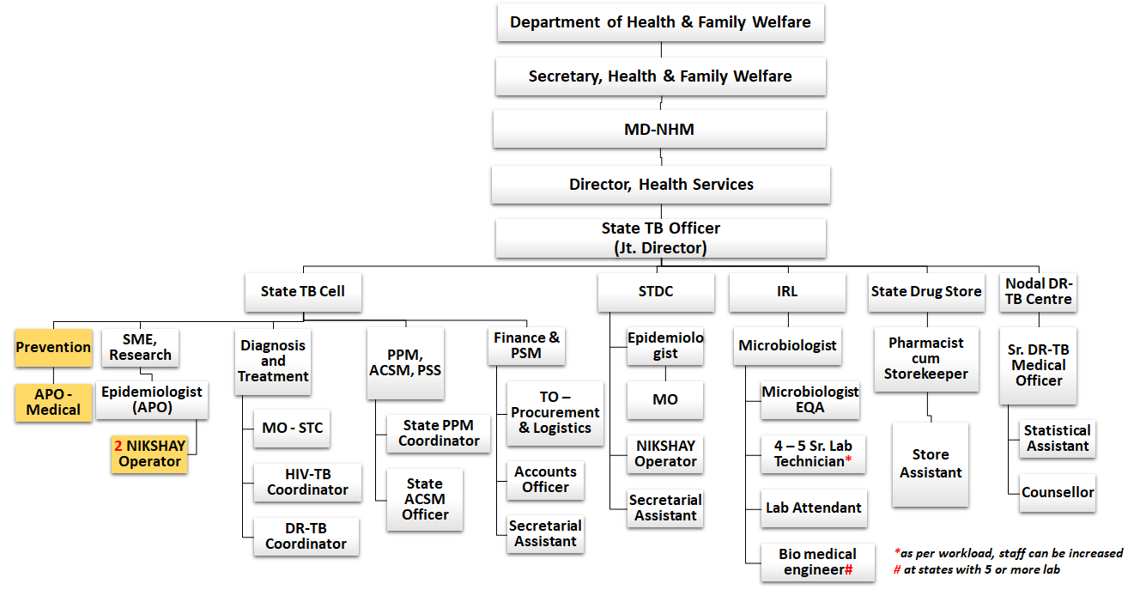

**Figure 26: State TSU organogram**

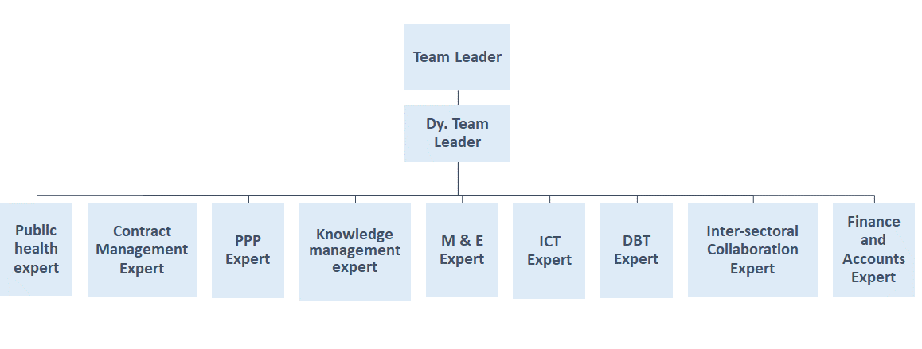

**Figure 27: District level NTEP Organogram**

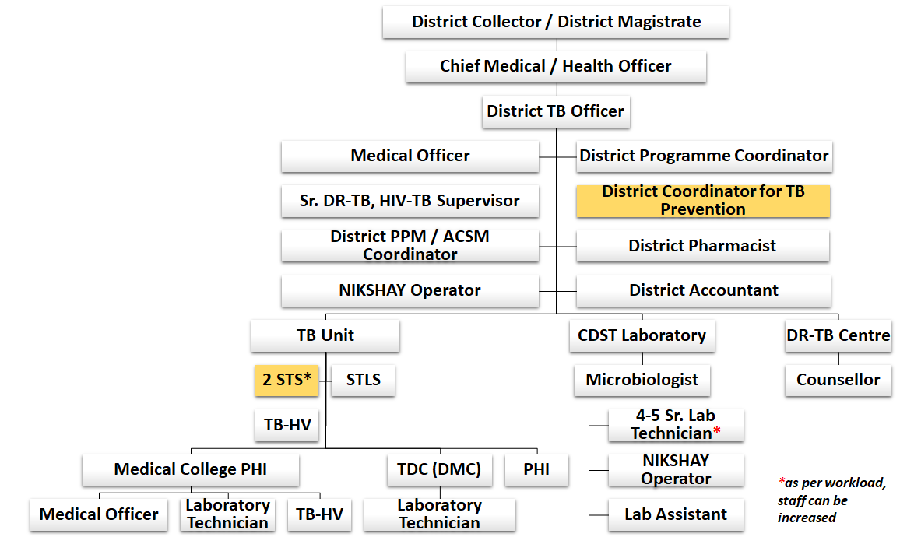

**1.2.2** Update the terms of reference for each cadre of contractual staff to ensure placing the right person for the services. The TORs are detailed in the **National HR plan.**

**1.2.3** Empanel **Human Resource Recruitment Agencies** to ensure a process of transparent, credible and open recruitment. The empanelment of such agencies offers States/UTs to access agencies that will provide an approved, standardized process for advertisement, skill and knowledge assessments, interviews, and final selection. (Reference: D.O. No. Z -18015/10/2015 – NHM – II, dated 8th February 2017)

**1.2.4 Leverage Health System: In the long term, this program has the potential to create a health workforce which will not only be responsive to the needs of the TB program but also for the entire health system.**

**1.2.4.1** Every health care provider in the system will be trained on latest NTEP guideline and developments. This include both service delivery and programmatic management.

**1.2.4.2** Prepare a dedicated training curriculum, operational guidelines for TB services at health and wellness center will be prepared by the NTEP. CHOs will be engaged for public health action, contact investigation, preventive treatment expansion, ACF and referral linkages establishment. TB related indicators have been incorporated in the performance based incentives of the CHOs.

**1.2.4.3** Advocate with NHM to re-vitalize MPW-M cadre, ensure their presence at every sub health center and increase their engagement for tracking, contact investigations, preventive treatment expansion in the community.

**1.2.5 Training:**

1.2.3.1 CTD and states to undertake a training need assessment at all levels.

1.2.3.2 Monitoring and reporting on implementation of approved training plans at state level by STDCs and CTD on a bi-annual basis.

1.2.3.3 Outsource training

1.2.3.4 E-learning mode: NTEP has prepared e-learning modules for medical officers and district programme managers and an E-learning platform is established to deliver the content to the targeted staff. NTEP needs to expedite the training of these cadres.

1.2.3.5 In-service training: A growing body of literature suggests that in-service training programs are likely to be more impactful if their approach aims towards holistic continuous professional development of the health workforce. Hence in-service training programmes will be carefully crafted and implemented. The designing and conduct of these trainings will be done using adult learning techniques given that these are likely to be more effective.

**1.2.5 HR policies:** Execute the compensation package, loyalty bonus, annual increment, performance based incentives and TA/DA as defined in the National HR plan

**1.2.6** **Ensure Quality Improvement by monitoring HR placement, Training, and expenditure on trainings.**

**1.2.7 Health worker surveillance: Screen all health workers working in TB at the time of placement and subsequently every year as per the guidance document by CTD.**

**1.2.8** Create and fill key positions in line with the scope of new NSP activities as also **prioritize filling of key positions** at all levels (DR-TB Coordinator, Labs, Accountants, State Logistics and Procurement, PPM Coordinator)

**1.2.9** Develop **grievance redressal mechanisms** for care providers

**1.2.10** Initiate a **national fellowship program and immersive experiential learning programs** for postgraduates from eminent medical, management, pure and social sciences institutions to create a multi-skilled pipeline for NTEP.

# **Chapter 10**

**NSP STRATEGIC AREA 1.3**

# **Governance and management of NTEP**

**10.1 INTRODUCTION**

Good governance and effective management are critical to the performance of NTEP. The NSP 2017 2025 clearly outlines key governance interventions and structures that need to be in place to end TB by 2025. However, the planned expansion and restructuring of the NTEP has not happened. Hence for moving closer to the goals of END TB, the current NSP 2020-25 rededicates it efforts at creating the strategic policy framework and platforms to provide effective oversight, coalition building, regulation, attention to system-design and accountability. In particular, elimination efforts will be provided the necessary impetus by the framing of a new policy on sub-national **certification of “Disease Free” status TB with benchmarks at every 20% reduction in incidence from the baseline of 2015.**

Also, in spite of the significant achievements, it is realized that the power of existing interventions is not matched by the power of health systems to deliver them to those in greatest need, in a comprehensive way, and on an adequate scale. Although integration between the health systems and NTEP has been achieved in the provision of services, it is limited in other operational areas such as administration, financial management and monitoring and supervision. This has affected the quality of programme implementation because of the inadequate and sub optimally trained human resource, multiple administrative, financial and operational functions to be carried out by field level staff.

**10.2 THE PROGRESS SO FAR:**

1. **Formulating policy and guidelines: To match the national and global commitments, NTEP has created an enabling policy, legislative and institutional environment for TB elimination actions aimed at furthering the realization of programme goals. All of these guidelines and changes to the earlier norms (mentioned below) are in various stages of application and will continue to support the NTEP interventions in the coming years.**
2. Population norms for establishing designated microscopy centers done away with. Microscopy services have been expanded to Peripheral Health Institutes based on availability of infrastructure and human resource, and not restricted to 1 DMC per 100,000 population norms. This has resulted in scaling up of DMCs from 13657 in 2014 to 20,356 across the country currently.
3. Phasing out Sputum microscopy: Expansion of rapid molecular technology (CBNAAT) and introduction of newer technology (TrueNat). 507 additional CBNAAT machines had been installed and molecular diagnostic laboratories have been scaled up from 1180 in 2018 to 3945 currently (by 2020). CBNAAT utilization has increased from 144 tests / machine / month in 2017 to 249 tests / machine / month in 2019
4. Systematic Active TB Case Finding among high risk population
5. Universal Drug Susceptibility Testing – Rifampicin resistance testing for all TB patients
6. INH drug susceptibility testing for all those patients tested for rifampicin and found as rifampicin sensitive and treatment of INH resistant TB
7. Newer drugs (Bedaquiline and Delamanid) containing regimen for treatment of drug resistant TB
8. **Policy decision on discontinuation of regimen for previously treated TB patients:** India envisages implementing injection free regimen for all TB patients. As per the recommendation of the National Technical Expert Group (NTEG) on Treatment of TB, the regimen for previously treated TB (erstwhile known as Category II), was discontinued under RNTCP and directives were issued to the States in Dec’18.
9. Injection free regimen has been introduced
   1. Removal of previously treated TB treatment regimen
   2. Change of INH resistant TB treatment regimen to injection free regimen
   3. All oral longer regimen for treatment of drug resistant TB
10. Patient Provider Support Agency (PPSA) approach expanded for private sector engagement nationwide through project JEET and further scaled up through domestic budgetary provisions
11. **Mandatory TB notification** has been strengthened through **Gazette notification** with expanding scope of notification of patients from chemists and penal provision
12. Reinforcement of provisions of Schedule H1 of the Drugs and Cosmetic Act to involve chemist for notification
13. **Direct Benefit Schemes** introduced
    1. NIKSHAY Poshan Yojana – Every TB patient is being provided nutrition support through Rs. 500 per month till completion of treatment
    2. Treatment Supporter – Honorarium for treatment support has been provided through DBT
    3. Private Provider Incentives – Rs. 500 for notification and Rs. 500 for reporting of treatment outcome have been initiated for private practitioners
    4. Informant Incentives – To encourage referral from private sector and community volunteers, Rs. 500 are being provided for each referral of patient who is diagnosed as TB in public sector
14. Community Engagement – TB survivors are sensitized and mentored to become TB advocate and eventually TB champion to contribute for service delivery in TB programme
    1. State and District level TB Forums have been formed to provide platform for TB champions to execute their role
15. Multi-sectoral engagement
    1. **MoU entered into with Ministry** of AYUSH, Railway and Department of ECHS
    2. **Policy Framework to address TB at place of work** has been formed and issued by the Ministry of Labour and Employment
    3. **Multi-sectoral action framework** has been formed and at the national level, inter-ministerial collaboration committee has been established
16. NIKSHAY version 2.0 has been launched and used under NTEP with the features of transaction-based information system, uniform public and private sector MIS, PHI level logins and users, private sector agencies active users, and integration with digital adherence technologies
17. Norms and basis of costing has been changed
    1. Addition of laboratory staff for transition of FIND staff at C&DST laboratories
    2. STS are being provided as per the workload, beyond population / geographical norms
    3. Two MOs at STDC for surveillance and training, District level pharmacist, counsellors are provided
    4. Performance based incentives have been designed for staff to encourage quality of work
    5. Norms of activity costing are now based on previous experience or planned activities instead of population based norms for budgeting
18. **Competitive encouragement for States to drive TB Free agenda**
    1. State TB Score has been given on selected 9 indicators to encourage competition between states. Quality score have been introduced.
    2. Sub-national certification and award mechanism has been introduced to drive districts and states to achieve reduction in incidence
19. TB Preventive treatment has been introduced for PLHIV in addition to child contacts (under 6 years) of TB patients
20. **TB HIV Coordination committee has been reformed to TB Comorbidity Coordination Committees** to give focus to TB -HIV, TB-Diabetes, and TB -Tobacco collaborative activities.
21. **TB Harega Desh Jeetega Campaign** was launched in September 2019 with massive advocacy and large scale awareness programmes targeting community and multiple stakeholders
22. There has been forward movement in terms of putting in place levers and tools for implementing policy which includes revision of health system organizational structures and their roles, powers and responsibilities; design of regulation; standard-setting; incentives; enforcement related to notifications and H1 as provided for in the NSP 2017 2025
23. Collaboration and coalition-building across sectors and with external partners
24. Ensuring accountability by ensuring governance structures, rules and processes for health sector organizations; mechanisms for independent oversight, monitoring, review and audit; transparent availability and publication of policies (on the tbcindia.org website), regulations, plans, reports, accounts, etc.; and openness to scrutiny by political representatives and civil society.

**10.3 CHALLENGES REMAIN**

1. Top level governance recommendations of NSP 2017-2025 are not yet completely implemented and this includes the National TB Policy and TB Bill, and the institutional structures proposed.
2. Technical Support Unit (TSU) for PPP not yet established
3. Surveillance Units at NTI and CTD not yet established
4. Multiple expert groups are in place but planned restructure/ expansion of CTD as outlined in NSP 2017 2025 is not undertaken as yet.

**10.4 THE WAY FORWARD**

* + 1. **National TB Policy and TB Bill:** The bill will consist of the responsibilities of the public and private health care providers and National Health Mission in curtailing TB, and rights and responsibilities of people affected by TB (the TB patient charter).
    2. **Sub-National Certification of Disease Free Status:** It is known that **t**he Government has undertaken bold target to reduce incidence of new TB cases by 80% for ending TB by 2025, five years ahead of global timelines. The Government has also set similar ambitious targets for other communicable diseases. To achieve these targets of elimination of communicable diseases at a large scale, it is essential to take disease control initiatives to the grass root level. Evidence suggests that these communicable diseases targeted for elimination have a wide variation in infection/disease epidemiology across the country and the level of efforts across districts towards this path to elimination are also varied. Timelines of implementation of advanced interventions for elimination of disease across country may vary from district to district and some districts are in an advanced stage of progress towards disease elimination.

Hence the government has proposed to incentivize and reward well performing States/Districts for achieving target that are within their control and capacity. This will not only motivate States/Districts to prioritize and undertake implementation of these programs in elimination mode, but will also generate a sense of healthy competition among States/Districts. Accordingly, it is considered to have sub-national level disease elimination status documented and “Awards” be presented to respective State/Districts upon achievement of such status.

**Criteria for attaining TB Free status**

For tuberculosis, a District or a State/UT will be recognized for “TB Free” efforts based on the criteria outlined below. Since, it may take a longer duration for achieving TB free status, in order to motivate States/Districts, interim recognition is also considered to give awards under bronze, silver and gold categories.

**Table 10: Sub-National Certification of Disease Free Status**

|  |  |
| --- | --- |
| Achievement of reduction in TB incidence as compared to 2015 incidence rate (in terms of number of incident TB cases per lakh population) | Award / Status |
| 20% | Bronze |
| 40% | Silver |
| 60% | Gold |
| >80% | TB Free District / State |

Monetary and non-monetary awards approved by the NHM MSG are as follows:

**Table 11: Awards on achieving milestones of disease free status**

|  |  |  |  |
| --- | --- | --- | --- |
| **Award / Status** | **Monetary award for district (Rs.)\*** | **Monetary award for State / UT (Rs.)\*** | **Non-Monetary award** |
| \Bronze | 2,00,000 | 25,00,000 | Medal and Felicitation at the National level |
| Silver | 3,00,000 | 50,00,000 |
| Gold | 5,00,000 | 75,00,000 |
| TB Free District / Cities | 10,00,000 | 1,00,00,000 | Certification and Felicitation at the National level |

*\*For States /UTs with population less than 50 lakhs and districts with population less than 2 lakhs, the award amount shall be 50% of the amounts considered.*

*\* District level awards will be financed through the state\UT's PIPs.*

* + 1. **Expedite setting up of prescribed governance structures at the National and State level including National and State TB Elimination Boards. (detailed organogram at the end of this chapter)**
       1. **National TB Commission:** It will be the apex body to take policy decisions on strategy, operations, resources and timelines for TB Elimination. The commission translates the highest political and administrative commitment to ensure multisectoral coordination and accountability for timely decision making and to support implementation. It also monitors implementation of TB elimination strategy at all levels and adopts appropriate corrective measures on recognition of shortfalls or gaps. The National TB Commission will be chaired by the Prime Minister or the Representative of Prime Minister and will have ministers from allied ministries as members.
       2. **National TB Elimination Board:** The national TB Elimination Board will translate the highest political and administrative commitment (of the National TB Commission) into actions to ensure multisectoral coordination and accountability. The board is an executive authority that ensures administrative response to TB at national and state levels. The National Board advises the state TB Elimination boards on local strategies, and encourage implementation of local strategies by recognizing their efforts through appropriate rewarding mechanisms. The board will be chaired by the Secretary, Union Ministry of Health and Family Welfare. Members are the Secretaries of all stake holder ministries. The Health Secretaries of five high burden States will also be members.
    2. **Extend the governance and management structures to the States and District level for fast-tracking End TB.** 
       1. **State TB Elimination Board** is the apex autonomous body to take policy decisions on strategy, operations, resources and timelines for TB Elimination. It is the direct demonstration of state government’s stewardship for TB elimination. It monitors implementation of TB elimination strategy at all levels and adopts appropriate corrective measures on recognition of shortfalls or gaps. The board will have the Chief Minister of the state as the Chief Patron and Ministers of health allied ministries as other patrons.
       2. **District TB Elimination Board** is the district level apex body to take policy decisions on adaptation of National Strategic Plan for TB elimination, operations, resources and timelines. Since TB epidemiology, population characteristics and access to health care vary across districts, the district TB elimination board will need to customize state’s strategies to suite local situations. The board also monitors implementation of TB elimination strategy at sub district levels and adopts appropriate corrective measures on recognition of shortfalls or gaps. The Board is to be formed with the District Panchayat President, Member of Parliament, members of Legislative Assembly and Mayor as the patrons, District collector as the chairperson and key district officials as the members.
       3. **Block TB Elimination Unit** will be headed by a Medical Officer from the general health services. This BTEO will be responsible for supervision and monitoring of TB prevention, TB diagnosis and management including DRTB.
    3. **The proposed structure of the NTEP and its support structures are depicted in the organogram below:**

**Figure 28: Proposed NTEP structure**

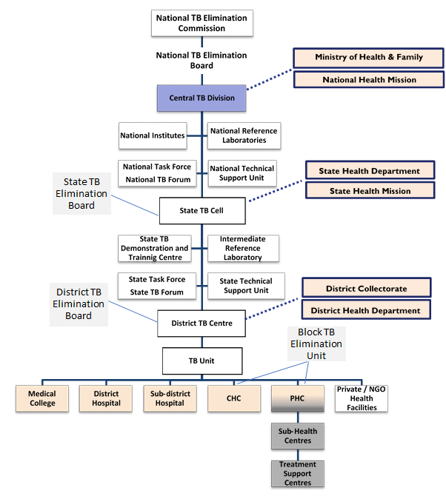

# **Chapter 11**

**NSP STRATEGIC AREA 1.4**

# **Multisectoral Engagement and Accountability**

**11.1 INTRODUCTION**

The Moscow Declaration (November 2017) to End TB with commitment by member states and call to global agencies to accelerate efforts addressed four key areas for action, one of which is multisectoral accountability. Prevention, diagnosis and management of TB require multisectoral collaboration and resources. To have multisectoral collaboration, appropriate coordination mechanisms should be in place that would closely bind the governments (central, state and local governments), intergovernmental agencies, non-governmental organizations, private health care providers, affected citizens and the civil society.

Also, the NSP 2017 2025 called for “mission-mode” actions. This needs to be fully realized within and beyond the health sector to enable accountability and fulfillment of vision and goals towards ending TB. The MOHFW set forth approaches with the aim to meet the political commitments of the prime minister as well as those that the nation has committed at the UNHLM. Important progress has been made in the TB response because of highest-level engagement and commitments made through increased budgets. Yet some of the structures needed to enable a mission mode and accountability still need to be established and activated. However, the existence of major new Government-wide initiatives with major resources, high-level support and momentum, including Ayushman Bharat, Public Distribution System (PDS), supplementary nutrition programs, Smart Cities, Ujjwala Yojana, Swachh Bharat, etc. all provide major opportunities for collaborations and ending TB objectives. With multisectoral collaboration and accountability ensured by creating institutional structures in the next NSP period; it is envisaged that the NTEP will be able to fast track its approach in a mission mode.

**11.1.1 Coordination with development partners**

India has increased funding from the domestic budget substantially in the last couple of years. Having recognized that, the NTEP has been receiving support (23% of National TB Budget) from multilateral and bilateral organizations to accelerate efforts towards elimination of TB in India. Key stakeholders which contribute to the NTEP in India are World Bank, Global Fund for AIDS, TB and Malaria, USAID, Bill & Melinda Gates Foundation, World Health Organization, UNOPS amongst others.

Coordination with multiple development partners, donor agencies and implementing partners working for TB care and control in the country will be strengthened through a collaborative partnership forum. This forum will be established at Centre, State and District level and will provide a platform for facilitating engagement, to avoid duplication of efforts and for knowledge management. The scope of the forum will not be limited to only implementation level, but it will be used to reach for funding gap in implementing strategies of National Strategic Plan.

It is important for the programme to put upfront the key strategic areas in which partnership is required. List of broad strategic areas in which funding agencies may invest to support NTEP in India are given below, but not limited to it.

|  |  |
| --- | --- |
| 1. Diagnosis of Latent TB infection and TB Preventive Treatment | 1. Direct Benefit Transfer |
| 1. Airborne infection control measures | 1. Active Case Finding |
| 1. Improving treatment adherence | 1. Contract Management |
| 1. Reduce out-of-pocket expenditure | 1. Digital tools for information management and project management |
| 1. Private health care provider engagement | 1. Accelerating adoption of newer tools (diagnostics, drugs, vaccine) |
| 1. Public health action for TB patients in private sector | 1. Programmatic Management of Drug Resistant TB |
| 1. Access to free diagnostics and drugs to TB patients in private sector | 1. Surveillance |
| 1. Use of Artificial Intelligence for automation or augmentation of programme interventions | 1. Research |

**11.1.2 Collaboration with departments/divisions within** **MOHFW**

Under the NTEP, HIV-TB collaboration has been a success story. The collaboration has not only improved care of TB among PLHIV and HIV care among TB patients, systematic arrangements like single window delivery addressed patient care in a more holistic manner. The NTEP has been now moving further and has engaged with NPCDC to address diabetes among TB patients and vice versa. NTCP has been engaged to address TB-tobacco comorbidity and it is in the process of establishing close collaboration with MCH division for TB management in pregnancy and among children. The programme has also formed a TB-comorbidity committee, replacing individual disease specific committees.

To address TB in a more holistic way and increase the reach with the approach of “go where patient goes”, NTEP will collaborate with the following departments.

|  |  |
| --- | --- |
| **Department of Health Research** | * Ongoing collaboration for TB Prevalence Survey and ITRC * Health technology assessment * Validation and feasibility study of newer tools |
| **NCDC** | * Surveillance * IHIP Integration |
| **e-Health** | * Electronic Health Records * MDDS compliance * Integration with Mera Aspatal * Integration with other digital intervention of the Ministry |
| **Mental Health** | * Patient Support |
| **Medical Council of India** | * Medical College Involvement |
| **Nursing Council of India** | * Involvement of Nursing Colleges |
| **CGHS** | * TB services at CGHS health facilities and CGHS empaneled private hospitals |
| **National Health Authority** | * Engagement with PMJAY empaneled hospitals * TB service package under PMJAY |
| **CDCSO** | * Leverage Schedule H1 provisions * Access to anti-TB drugs in private market * Engagement with pharmaceutical agencies for drug access * Drug sales surveillance |

**11.1.3 Involvement of Medical colleges in RNTCP**

To widen access and improving the quality of TB services, involvement of medical colleges and their hospitals is of paramount importance. The current mechanism of their involvement through structured task forces at national, zonal and state levels will be continued during the NSP period. The role of the task forces will continue to be as it is. The main role of the NTF will be to recommend policy suggestion regarding medical colleges’ involvement in the RNTCP and monitor the activities of the ZTF. The ZTF will facilitate the establishment, functioning, and monitoring of State Task Forces (STF), and coordinate between the NTF and STF. The STF will facilitate establishment of DMCs and DOT centres, in all the medical colleges in the respective states.

Scope of activities of medical colleges are going to be expanded with increasing diagnostic and treatment services in newer areas of TB control efforts. This will include following:

* Decentralized drug resistant TB services: DR-TB wards will be expanded to more number of medical colleges to support district level DR-TB treatment services. These DR-TB centres in medical colleges will be useful for management of not only MDR-TB but, for DST-guided treatment, newer regimen use and management of complicated cases of drug resistant TB. Existing staff of medical college i.e. medical officer and TB-HV will be utilized for these DR-TB wards for coordination with the programme and DTC data entry operator will support e-communications and for MIS operations.
* Culture service support: With follow up of drug sensitive TB patients with culture at the end of treatment and post treatment follow up with culture for all TB patients, additional capacity of laboratories with culture facilities will be needed. To support this strategy, the programme will engage medical colleges to expand its microbiology laboratory for RNTCP. The programme will support identify and support these microbiology laboratories through existing HR and infrastructural norms for culture laboratories.
* Air borne infection control measures in health care facilities in districts: Under the air borne infection control committee of the districts, medical college faculties will be involved to execute AIC measure in all health care settings in the district. The faculties from medical colleges will be trained at the state level and then support in assessment, recommendations and monitoring of AIC implementation in all health facilities in the districts.
* Planning, surveillance and quality improvement support to districts: Faculties of medical colleges will be involved in planning of RNTCP services and subsequent monitoring and evaluation. The department of community medicine will be involved to in monitoring and surveillance of disease including carrying out local surveys. For quality assurance of laboratory services, the department of microbiology will be involved and appropriate capacity enhancement will be done.
* Private provider engagement: Support of medical colleges will be sought for peer education, dissemination of diagnostic and treatment practices and advocacy with professional associations.
* Research: Operational Research mechanisms will be strengthened. Uniform systems of protocol development and capacity building workshops will be implemented. An online system of protocol submission, protocol review, approval and quick release of funds will be established.
* Centers of excellence (COEs): Select medical colleges will be designated COE for a particular thematic area of the programme on the lines of AIIMS being designated a COE for extra pulmonary TB.

**11.2 THE PROGRESS SO FAR:**

1. The Ministry of Health and Family Welfare has established an Inter-Ministerial Committee for TB with 25 ministries participating so far. It has set its Terms of Reference, and has the intention to create a joint operational working group.
2. NTEP published a Multisectoral Action Framework. It sets out key efforts planned, particularly with regard to health workplaces and corporate contributions and engagement.
3. MOUs have been signed with Ministries of Defence, Railway, and AYUSH for activities to be undertaken on tuberculosis. Special initiatives have been launched with the Department of Post, Ministry of Labour and Employment, Ministry of Panchayati Raj, Ministry of Women and Child Development, and for TB-free Workplaces.
4. Under the NTEP, HIV-TB collaboration has been a success story.
5. The NTEP has engaged with NPCDCS to address diabetes among TB patients and vice versa.
6. National Tobacco Control Programme has been engaged to address TB-Tobacco comorbidity
7. Collaboration with MCH division for TB management in pregnancy and among children has been designed.
8. The Programme has also formed a TB-Comorbidity Committee, replacing individual disease specific committees.

**11.3 CHALLENGES REMAIN**

As these are relatively early days for many elements of multisectoral engagement, significant challenges are also faced by the programme.

1. Accountability of the Inter-Ministerial Committee, including frequency of meetings and monitoring progress of activities.
2. The collaborations / MoUs already signed needs to be operationalized and actions being implemented at the facility / implementation levels

**11.4 THE WAY FORWARD**

To overcome critical bottlenecks in implementation and pursue a whole-of-government approach, including multisectoral engagement, a **TB Elimination Board,** as envisioned in the NSP, urgently needs to be established with highest-level participation from central and state levels, and from all major stakeholders including civil society representation. An operational body could accompany this high-level board to help manage regular interaction. This TB Elimination Board could also serve the critical need for a periodic review body. The **Civil Society Fora** established at national and state/district levels need to be activated and robustly operated as another key lever of multisectoral accountability and to drive scaled-up action.

**1.4.1** Drive multisectoral action, based on the right to health, via **a TB Elimination Board and state/local counterparts, and inter-sectoral Committees,** operational plans (with ambitious and achievable deliverables for priority sectors, with indicators and accountability, and stakeholder engagement. **(Refer details in Strategic area 1.3, Chapter 10 on Governance and management of NTEP)**

**1.4.2** Strengthen the **Inter ministerial committee** with a focus on clarification of roles and responsibilities, including how this Committee relates to actions to be taken at state and district level, and budgetary responsibilities. Indicators of performance need to be defined. There needs to be a clear secretariat/focal point within the Ministry of Health and Family Welfare.

**1.4.2.1** Given the limited capacity to support the multisectoral engagement so far, focused intensive efforts with a few ministries that drive budgetary commitments and accountable actions may be wise in the first year as first examples that drive much greater commitments from more ministries thereafter. As a major step for focused high-priority multisectoral engagement, specific actions with the Ministry of Home Affairs and state counterparts, as well as with the Ministry of Mines and Ministry of Labour and Employment, are needed to increase systematic screening efforts, reporting on results, and actions taken for diagnosis and care based on the results.

**1.4.2.2** Provide human resources and financial support from key ministries beyond health for successful mission-mode actions across sectors and these should be measured carefully yearly.

**1.4.3** Actions to ensure major national initiatives/programmes are and can contribute to ending TB given their scope and potential: including, Ayushman Bharat, Public Distribution System (PDS), supplementary nutrition programs, Smart Cities, Ujjwala Yojana, Swachh Bharat.

**1.4.4** Collaboration with Departments/Divisions within MoHFW: To address TB in a more holistic way and increase the reach with the approach of “go where patient goes”, NTEP will collaborate with the following departments.

**Table 12: NTEP collaboration with MOHFW departments**

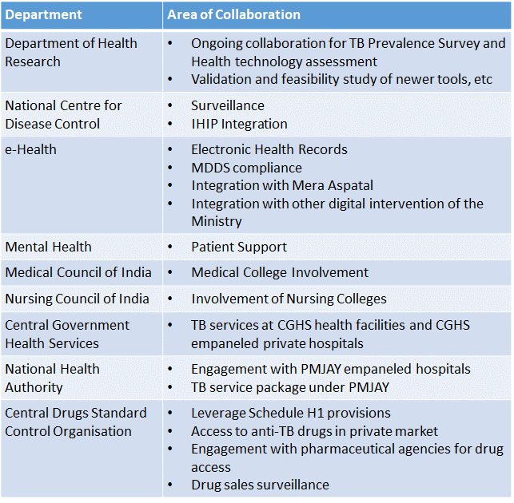

* + 1. **Involvement of AYUSH Providers (3,598 hospitals and 25,723 dispensaries)** 
       1. AYUSH providers will be provided with informant incentives for referring presumptive TB and detection of TB patients.
       2. AYUSH providers may work as treatment supporters along with incentives associated with it. Drugs may be supplied from public sector to the AYUSH providers.
       3. Under the MoU with Ministry of AYUSH, additional role of AYUSH providers will be explored to reduce delay and improve treatment completion rates.
    2. **Involvement of Health Establishments under other Ministries, PSUs, Corporates and other organized groups**

There are large numbers of health facilities run by public sector other than MoH&FW under different ministries of Centre/State Governments. Ministries like defence, railways, home, etc. have their own medical services set up. There are public sector undertakings like Coal India, SAIL etc. which run their own healthcare set ups. Usually these facilities cater to a “captive population” who receive subsidized or free services from said facilities.

* + - 1. NTEP already has MoUs with Ministry of Railway, Ministry of AYUSH, and Department of ECHS. The programme will continue to establish formal MoUs with other such Ministries. Under the overall umbrella of such collaboration, the NTEP will ensure coverage of all health facilities run by these Ministries.
      2. Private sector engagement mechanism of these departments will be leveraged like empanelled health facilities under the ESI, CGHS, ECHS etc. will have mandatory notification and STCI adherence as a mandate in the empanelment conditions
    1. Undertake mapping of key populations and interventions which will be a significant element of baseline work that will contribute to robust planning for multisectoral action.

# **Chapter 12**

**NSP STRATEGIC AREA 1.5**

# **Private sector engagement**

**12. 1 INTRODUCTION**

With an estimated 70% of the TB patients seeking care in the private sector, the NSP 2017 2025 deemed it crucial to ensure that they receive timely diagnosis, good quality treatment, protection from high out-of-pocket expenditure and other public health services such as co-morbidity testing, contact investigation, counselling, adherence monitoring, nutritional support and outcome reporting. Over the last three years significant progress has been made under NTEP to expand the coverage and involve more private sector providers in TB care. Interventions instituted nationwide has been on a dual track: 1) Public-Private program collaboration and coordination defined by the scale up of private sector engagement programs and strengthening of links between public and private TB program. These included strengthening private sector notification, PPSA support, government supply medicines and tests to private providers, etc.; and 2) Private market creation and service purchasing which included creating an enabling environment and market mechanism to encourage more private sector participation. It included streamlining private sector contracting, strategic purchasing for TB services, and enhanced regulation of private sector TB service quality, use of DBT etc.

**12.2 PROGRESS MADE SO FAR**

1. Private sector notifications have increased dramatically to reach over half a million nationally and so has microbiological confirmation and treatment success amongst those reported from the private sector (see figure 29 below).

**Figure 29: TB notifications from the private sector**

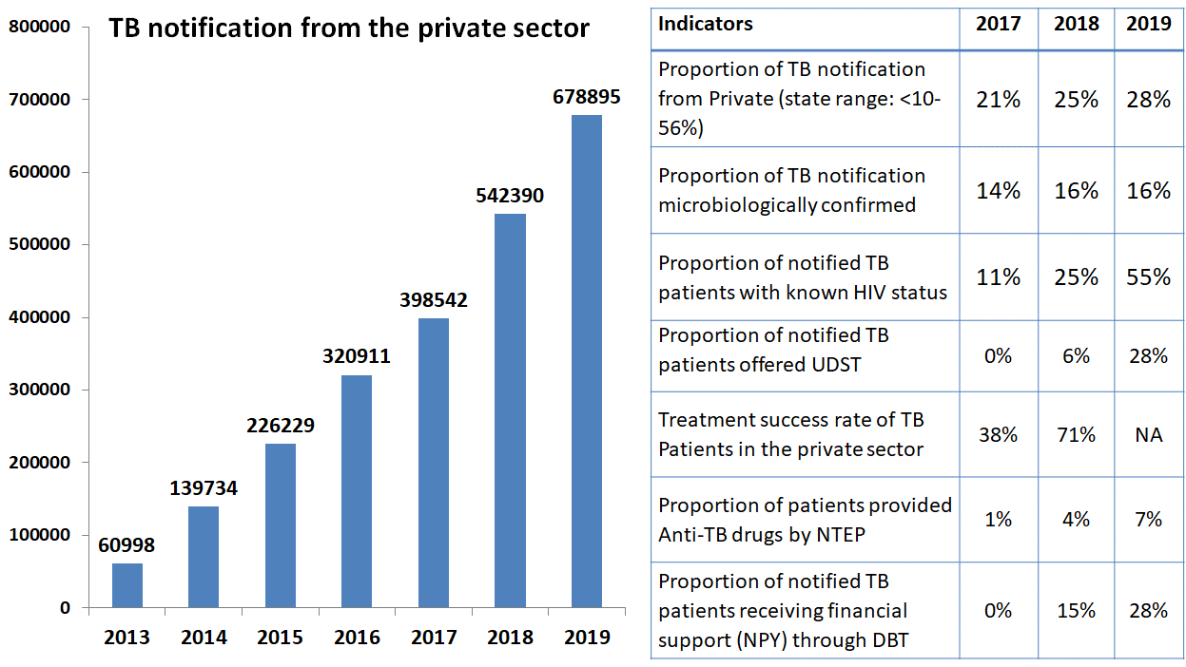

1. **Strengthening use of Schedule H1 Register:** A government directive to all states wherein drugs incorporated in the Schedule H1, as is the case with Anti TB medicines, can only be sold in retail on prescription of a Registered Medical Practitioner and details of the prescriber, the patient and the drug sold needs to be maintained. This will regulate “over the counter” sale and prevent indiscriminate use of the drug.
2. **Penalizing non-notification of TB cases**: Following the mandatory notification of all tuberculosis patients by all clinical establishments, pharmacists, chemists and druggists, another directive penalizing failure to notify TB patients has been promulgated. This provides for penal action under the law.
3. **Engagement with the Private Sector through Indian Medical Association (IMA):** IMA has over 3, 25,000 doctors as its members through more than 1700 local branches in 32 states and union territories[28]. The NTEP has engaged IMA and leverages its reach to encourage private practitioners to use the tools to facilitate access of free services available through the Public Health System even to patients who seek care in the private sector. IMA conducts CMEs and training programs, and helps disseminate uniform messages on private sector engagement. It has also engaged a PR agency for mass communication on TB with private health care providers as targeted audience.
4. **Supporting Partners and NGOs working with NTEP:** To END TB by 2025, thirty five development and technical partners with funding support from multi-lateral and bilateral agencies are supporting NTEP. Broadly, these partners support on following major areas as identified under the National Strategic Plan (2017-2025):
   1. Active TB Case Finding in Key Population
   2. Private Sector Engagement through Public Private Support Agency
   3. Expansion of newer drugs and regimens for treatment of drug resistant TB
   4. Expansion of laboratory services
   5. Establishing patient support systems
   6. Community engagement for patient-centred and community led response to TB
   7. Multi-sectoral response against TB
   8. Advocacy and Communication
   9. Digital solutions for information management
5. **Partnership through financial support from NTEP:** The NTEP has National Guideline on Partnership to fund NGOs/PPs. In 2019, there are 685 such partnership projects engaged with the States and Districts with funding support from NTEP.
6. **Incentives to private providers/ chemists for notification and reporting treatment outcomes:** NTEP’s recent policy recommends that 500 INR would be given at the time of TB notification and the other 500 INR at the time of reporting treatment outcome. Benefits under this scheme are also to be given as a Direct Beneficiary Transfer, provisions for which have been included in Nikshay as well.
7. **Nikshay Poshan Yojana:** A nutritional support of 500 INR per month for the entire duration of treatment will be extended to all TB patients irrespective of the sector from which they seek treatment.
8. **Nikshay Sampark:** Establishment of a National Call Centre – Nikshay Sampark- which, in addition to serving as a platform for grievance redressal, can also be used for notification of TB patients, and for treatment adherence support. This can be particularly useful in case of private sector notification. The Program currently runs a 100 seat Call Centre and supports 14 languages.
9. **Patient Provider Support Agency (PPSA):** Learnings from successful interventions of Patient Provider Interface Agency (PPIA) from the **Universal Access to TB Care** (UATBC) has been translated to the Patient Provider Support Agency (PPSA) and expanded to 45 cities (92 districts) with Global Fund supported **JEET** project. To augment private sector notification, 48 patient provider support agencies have been operating using input-based financing and producing both results and lessons for the future, and 145,000 and 35,000 private patients have benefited from the use of public sector CBNAATs and fixed dose combination (FDC) program drugs, respectively. More recently, 48 new PPSA have been contracted on an output-based financing arrangement. Going forward, the NTEP is transitioning all the PPSA’s to domestically funded agencies wherein the GOI will scale-up it up in nine states supported by the World Bank under the **“Programme towards Elimination of Tuberculosis”.**

**12.3 CHALLENGES REMAIN**

In spite of the remarkable progress in private sector engagement major challenges continue to impede the pace of reaching out to all TB patients in the private sector.

1. There is substantial increase in notification from the private sector and the private sector drug sales is also declining. However, still there are gaps in notification and TB patients managed in the private sector. Notification and public health action is not converted into routine practice.
2. More than 70% of privately notified patients (even in PPSA) currently don’t benefit from programme services such as access to free diagnostics, free FDCs and public health action such as contact tracing, counseling, co-morbidity testing.
3. Weak capacity for implementation of public health functions like contact investigation and provision of TPT.
4. Quality of TB diagnosis and treatment in private health care sector are pertinent challenges to address. Only 1/5th of notified TB patients are microbiologically confirmed.
5. Limited engagement with AYUSH health care providers who remains a first care provider and contribute to delay in diagnosis
6. Weak capacity for contract management.
7. Mechanisms for developing comprehensive and rigorous output based contracts with private service providers.
8. Delays in payment to service providers may lead to mistrust by private providers on the government, affect contract performance and the overall survival of the scheme.
9. Limited experience of potential implementers in performing PPSA functions.
10. Patient data management such as reporting of treatment outcomes, managing transfers between geographies leading to change of service providers, duplication of patient entries, etc. may pose as major challenges that would need a good coordination between PPSAs and the government.

**12.4 THE WAY FORWARD**

**Private sector engagement in NTEP is based on a partnership** between the public and private sectors. Rather than additionally burdening the existing under-trained and over-stretched staff, the programme will contract professional agencies with the skills and capacity to engage with large number of providers. The two models currently under operation are depicted below and both will be continued and strengthened over the next five years.

**Table 12: Models for NTEP - private sector partnership**

|  |  |
| --- | --- |
| **PPSA (Interface Agency) Approach** | **Direct NTEP Engagement Approach** |
| 1. Interface agency support would be primarily required when there is a high density of private providers (e.g., urban) and/or low ratio of public staff to TB patients 2. Program drugs and diagnostics are provided free to TB patients seeking care in the private sector and linkages are established 3. HR support for provider engagement, linkages, and patient support. 4. The concept includes outsourced management to improve diagnostic processes and use program diagnostics and drugs | * + 1. Primarily using existing NTEP staff - PPM coordinators to direct and motivate; TB HVs etc. to track patients     2. Even though this model has so far yielded ~2/3 of private notifications, quality improvements remains a challenge. This is currently a weak model that needs strengthening. |

* + 1. **Continue to Improving TB notification from private healthcare providers** 
       1. Expand collaborative efforts with the private sector by building capacity of existing staff on relationship management
       2. Use behaviour change techniques to improve practices of TB care in private healthcare settings. This may include but not limited to regular feedback, positive stories, peer learning, peer pressure, and involvement in multi-lateral platform (for other diseases, research, pilots).
       3. Strengthen and leverage existing regulatory mechanisms like expansion of the use of schedule H1 registers
       4. Establish coordination mechanism with Insurance Regulatory and Development Authority of India (IRDAI), Insurance Schemes of Government like PMJAY, CGHS, ECHS, NABL, NABH or Private Sector Insurance Agencies, for ensuring that the patients getting treatment in private nursing homes/ hospitals etc. are being managed as per STCI and the notification of such case to the NTEP is ensured
    2. **Deepen collaboration with corporate hospitals to cover all facets of TB elimination (hospital chain engagement, MIS integration, AIC, DRTB, EPTB, Paediatric TB)**
       1. Establish a nodal centre / focal point within the hospital set up which coordinate with the programme for notification, provision of diagnostic and treatment services and undertake public health action themselves. The additional capacity enhancements of patient management will be used to ensure treatment adherence and patient retention.
       2. ICT advances and interface will be used to facilitate reporting from these corporate hospitals which have their own MIS, by linking them to NIKSHAY, particularly in the case of large hospital chains
       3. A consortium of corporate hospitals will be created to give value to the arrangement **with a view to better** collaborate with the Programme in TB policy implementation.
    3. **Ensure Patient Support till completion of treatment**
       1. Refilling and adherence monitoring system for TB patients notified from private sector will be strengthened with use of call centre, combination of ICT based adherence technologies and use of Artificial Intelligence to predict potential LFU patients
       2. Auditing system for verification treatment outcomes will be established
       3. Provider incentive coverage will be improved with more efficiency: Providers who refer patients for NAAT or smear microscopy will be covered under informant incentives
       4. Wherever required, programme will use PPSAs (described above), NGOs to expand these services. These services should be purchased using principles of Guidance document on Partnerships 2019.
    4. **Improve access to diagnostics for TB patients notified from private sector**
       1. For access to diagnostic services like CBNAAT from the programme, the scope of system of specimen collection and transport will be expanded to establish linkages for giving diagnostic access to patients in the private sector. Private providers/NGOs/Volunteers will be engaged and incentives/honorarium would be integrated in the programme e-payment system. Large corporate laboratories may be given responsibilities of both sample transportation and carry out testing.
       2. Purchase diagnostic services, such as when demand for rapid diagnostic tests or chest X-Ray exceeds availability in public facilities or when patients and their providers exhibit strong preference for private channels.
       3. Use of the national free diagnostic scheme: in private labs that are collocated with district hospitals, the public sector pays for services, including the cost of the private lab organizing sputum transport
       4. Various models used in limited settings may be scaled up like cartridge sharing, reagent rental, or subsidizing rates through IPAQT mechanism
    5. **Improve access to drug for TB patients notified from private sector: There is a large diversity in ensuring drug access to TB patients in the private sector. Hence, multiple options have been proposed, which make use of the private sector supply chain either partially or completely**
       1. Place program drugs in local private pharmacies, or Jan-Aushadhi. The program then pays the pharmacy cash incentive per patient for their dispensing services
       2. Place program drugs in the regional stores of pharmacy chains, and pay the chain both for operation of the local supply chain and for dispensing
       3. Use online pharmacies, especially in sites most chemists have stopped stocking ATT
       4. Establish a scheme for Free anti**-**TB drugs that flow through the private supply chain
       5. Continue the partnership with the Indian Pharmaceutical Association (IPA) at the national and state levels
    6. **Enhance Surveillance and Quality improvement in the private sector programme**
       1. Use of patient feedback systems, periodic prescription audits, drug sales surveys, chemist surveillance through Schedule H1 and laboratory surveillance including private laboratories
       2. Introduction of components of NTEP Quality Assurance system in other laboratory quality assurance systems like NABL, CAP etc. for improving quality assurance for laboratories in private sector
       3. Monitor drug sales and incorporate the information into the routine programme monitoring and evaluation framework.
       4. Monitor quality of prescription through prescription audit carried out with support of Drug Controller of the state. A system of regular feedback to the providers for quality of care aspects will be part of the engagement process.
    7. **Expand ICT support to TB patients and private provider**

Effective ICT support will be the cornerstone for facilitating engagement, user-friendly patient reporting, patient centric adherence monitoring, and for smooth financial transactions. The Nikshay platform, supported with efficient call centres and provision of sufficient digital tools to field staff and providers, will be key to reaching patients in private sector.

* + - 1. Add a program management component to Nikshay to facilitate smooth operation and monitoring of PPSA. It will include contract management tool for efficient management of contract, payment disbursement and monitoring of performance of the partner agency
      2. All the TB drugs are QR coded. At the time of dispensing drugs, pharmacy will also will scan bar codes/ QR codes for capturing information of drugs refills in the system. In case of failure of drug refill, the system will generate an alert. Health workers will establish contact with such patients and will provide support for resuming their treatment.
      3. Increase uptake of Digital Adherence Technologies such as MERM, 99DOTS, VOT etc.
      4. Use of AI technologies for enabling better diagnostic, monitoring and logistics support will be promoted.
      5. Unleash the full power of NIKSHAY and NIKSHAY-enabled digital technologies to support telemedicine and more virtual TB care

# **Chapter 13**

**NSP STRATEGIC AREA 1.6**

# **engaged and empowered communities**

**13. 1 INTRODUCTION**

Community engagement has been one of the key strategies of NSP’s over the last two decades. Significant progress has been made yet much more needs to be done to develop a truly resilient and agile programme. The COVID-19 pandemic has many lessons for the national TB response but none more than ensuring the community is a true stakeholder in managing the TB epidemic.

TB patients are affected by social and political factors (such as stigma and discrimination, availability and access to services at a convenient time and in their social context like work, migration, gender etc.), and economic barriers (for example, the cost of transport, ancillary medicines and investigations in private sector) apart from the disease itself. While there are existing strategies under NTEP such as work place policies, support for transportation of patient/sample, involving private sector in service delivery, and advocacy and communication to increase awareness and mitigate stigma, it is very well established that affected communities could play a vital role in enhancing effectiveness of these strategies and bridge the gaps. Communities, especially those who had gone through the experience of fighting TB, have the unique advantage of being close to their peers, understanding the issues and field reality as well the ability to communicate and articulate their needs. Thus, community engagement as a strategy is critical for the country’s aim of Ending TB by 2025.

**13.2 THE PROGRESS SO FAR**

NTEP over the last 3 years have made efforts to actively engage various stakeholders including elected representatives and local self-governments, civil society organizations, industries, etc. and TB affected communities, in programme planning and design, service delivery, monitoring and in advocacy.

1. **Engaging with TB Affected Communities**

Institutional mechanisms for a community-led response to TB in the shape of TB Forums at National, State and District levels have been commissioned to provide a platform to include community as an important stakeholder for overall improvement in the quality of TB services and making the services patient centric. These forums have representation of people affected by TB, elected representatives, policy makers, civil society organizations/NGOs, and programme managers.

Creation of community-led TB forums of people affected by TB at the sub-district and village level, is also being facilitated and will see a greater thrust in the current NSP period 2020-25 . These forums will be equipped with the prerequisites to manage the TB response locally in case of extreme and complex situations like COVID-19 .

TB Forums have the mandate to:

* Advise the programme on strategies for engaging communities and increasing community participation in TB program,
* Periodically review progress of NGO related activities and involvement of communities
* Facilitate community financing to sustain TB patients support services through community.
* Undertake TB response in complex emergencies like COVID-19

By end of 2019, TB Forums have been constituted in more than 700 (99%) districts across the country. Moving forward, the Programme plans to set broader agendas for discussion and monitoring of action taken on the decisions made in the meetings of TB Forum at various levels. National networks of people affected by TB and TB survivors is also ongoing.

1. **Other Key Community Engagement Activities**

Various models of engagement of TB affected communities in the programme are implemented in the country and includes capacity building and engagement of TB survivors as TB Champions, establishment of Peer Support Groups, community led mentoring, advocacy and demand generation, and grievance redressal services, etc. States also were given the liberty to formulate community led strategies as per the local needs and context, e.g. Telangana formulated DISHA-TB, Community Based Management Approach for community engagement, and Kerala involved the local governance for community engagement. These two models have lessons for other states to adapt and replicate. NTEP is now consolidating these strategies by partners and states so that a comprehensive approach may be developed with enough room for flexibility to suit local context and needs on community engagement. In addition “Speak TB” for alleviating stigma, and TB survivors groups like “Touched by TB” are also successful models. TB Champions have also formed survivor-led networks in six states and at the national level. Touched by TB, TB Mukt Vahini in Bihar, TB Elimination from Jharkhand (TEJ) and TB Mukt Foundation Chhattisgarh are the first such networks in India to be legally registered. These experiences have laid the groundwork to tap the potential of people with TB, survivors and their family members to effectively support the delivery of TB services at the grassroots.

**13.3 CHALLENGES**

1. Community engagement has been not been given due attention in most of the states which may partly be due to unavailable trained staff in the districts/ states
2. Lack of guidance document on community engagement
3. Insufficient budgetary allocation
4. TB forums had been constituted in all the districts as envisaged, however the functionality and effectiveness remain limited or not meetings are not being held regularly as desired
5. Availability of limited number of trained TB champions for participation in the programme
6. Continuity in engaging the community in different platforms
7. Limited interpretation of community engagement scope
8. Limited capacity and coordination of people affected by TB and TB survivors

**13.4 THE WAY FORWARD (Interventions/ Activities)**

Building on the vision and strategies envisaged in the earlier NSP and the experience so, far, this NSP proposes to actively engage with and work through the community for ensuring community driven response to end TB by 2025**.** It also draws from the experience and learnings within other national programmes such as National AIDS Control Programme, Pulse Polio Campaign, National Rural Livelihood Mission, etc.

**The NSP recognizes and promotes the key Principles of Community Engagement in TB Response**

* The right of the communities to be informed about and participate in decision making and implementation of the National TB Elimination Programme, including in the design, implementation, monitoring and evaluation of policy design and interventions.
* The need to tailor strategical interventions to different communities/key populations to address the unique challenges faced by them.
* The power of TB survivors and affected populations to act as change agents for advocating and facilitating TB resilient communities and the need for this to be supported through enhanced coordination and capacity building.
* The need for making the programme and service delivery mechanisms accountable to the community and empowering the community to provide this enhanced accountability.
* The need to have a nation-wide people movement with localized action plans for ending TB.
* The need to accelerate TB case finding efforts among key populations with support from key community stakeholders and CSOs to bring missing cases to the TB care cascade.
* Role of Civil Society Organizations and Community Based Organizations in facilitating community engagement in the national programme, implementation of community-based interventions and in ensuring patient centric delivery of TB care.

In line with principles, the programme will undertake the following in its efforts to engage the community.

* Develop guidance document for community engagement with standardized monitoring and evaluation, through a consultative process
* Reach out to populations/community through existing community structures and platforms, thereby minimizing time and resources required to reach out. Priority will be given to marginalized populations facing challenges in access to services
* Enhance the effectiveness of TB interventions in communities/key population by bringing key factors that influence the social norms and behaviours in the community on board.
* Explore the potential of peer support strategies in close collaboration with TB survivors in improving uptake and effectiveness of TB services.
* Increase access to tools that provide information and support decision making by the community for a sustainable response to TB. This includes absorbing community actors in routine programmatic activities including supervision, data review meetings, etc.
* Build capacity of TB survivors and TB affected communities in areas of TB treatment literacy, advocacy, counselling, health financing, community-led monitoring and human rights.

Technical assistance will be provided to the States/UTs for implementing different community engagement strategies from time to time through guidelines, trainings and allotment of technical support agencies.

* + 1. **Amplifying and scaling up active engagement of communities affected by Tuberculosis, especially TB survivors and key populations in the programme.**
       1. Capacity building of TB survivors and key population representatives as TB Champions in TB treatment literacy, advocacy, counselling, health financing, community-led monitoring and human rights and engaging them in programme planning, implementation, monitoring and review.
       2. National, State and District TB forums to be empowered to monitor complaints from patients and action taken on them. The Call Centre will solicit patient feedback to be all patients (public and private) in the first month of initiation of treatment and in the 6th month through the call center.
       3. Handholding of District TB forum in EAG states through non- state players (e.g. REACH) to attain pre-set benchmarks of community empowerment and participation
       4. Capacity building and facilitating involvement of TB Champions (1) in TB service delivery as peer counsellors and facilitators of Peer Support Groups, (2) for supporting community-based advocacy in identifying and recording incidents of human rights infringements and building social movement at grass root levels for ending TB and TB related stigma and discrimination.
       5. Recognition to and felicitation of TB Champions for their contribution to the TB response.
       6. Strengthening national, state and district PMUs for facilitating engagement of TB affected communities in the programme.
       7. Sensitizing various stakeholders on role of TB affected communities in the programme.
       8. Engagement and capacity building of TB survivors and Key population representatives in measuring incidents of stigma and developing strategies to reduce TB stigma in the community.
    2. **Widening community participation in the mission to end TB through**
       1. Expansion of community-based services for prevention and management of TB through Ayushman Bharat Health and Wellness Centres (AB-HWCs).
       2. Building capacity of AB-HWCs and supporting them in facilitating localized people’s movements for ending TB and mitigating TB related stigma and discrimination. Programme shall work with Ministries of Panchayati Raj and Urban Affairs to jointly recognize and publicize such contribution (e.g.: Nirmal Puraskar is given to Panchayats, Blocks and Districts, similar recognition can be given for efforts in TB also).
       3. Involving existing community structures (e.g.: VHSNC, MAS, Self Help Groups, Trade/employment-based associations, Faith Based Organizations, Village Level Task Forces in North Eastern States, etc.) at appropriate levels for awareness generation, early diagnosis, social support, etc. Programme will provide guidance and support to State/District/Sub-district for engagement with such organizations.
       4. Working with concerned Departments/Ministries for including TB related agenda to the work of health/non-health community-based interventions by Government of India/States. Other such interventions and potential collaboration will be identified at national/state level and action plans will be prepared jointly with the concerned Ministry/department (e.g.: VHND, Nutritional Rehabilitation Services, Swacch Bharat Mission, Ujjwala scheme, MNREGA, Programmes of Ministry of Social Justice, etc.)
       5. Participatory development and implementation of differential interventions for addressing TB among key populations with support from relevant stakeholders
       6. Identifying and facilitating interventions for reducing vulnerability to TB (including nutrition, housing, access to care for co-morbidities, etc.) with focus on tapping into major Partner initiatives beyond TB which focus on poverty reduction related activities
    3. **Building new need-based collaborations and strengthening current partnerships at national and sub-national levels with Community-Based and Civil Society Organizations (CBO and CSO) for expanding and deepening community engagement, including innovative strategies and interventions.** 
       1. Mapping of potential CSOs/CBOs at National/State/District level and creating a panel of CSOs/CBOs for partnering with government on identified areas.
       2. Need based partnerships with such organizations based on agreed upon strategies, outputs and outcomes for (1) providing TA to National/State/District governments on Community Engagement, (2) planning, implementing, monitoring and evaluating community based interventions, (3) capacity building of community and relevant stakeholders, (4) facilitating community involvement in decision making, and (5) advocacy for patient centered care.
       3. Capacity building of national and sub-national agencies in entering and managing partnerships with CSOs/CBOs.
       4. Promoting innovations by CBOs and NGOs by supporting a challenge fund (either through programme funding or through other mechanisms such as CSR).
    4. **Instituting mechanisms at various levels for ensuring accountability of the health system to the community and making the programme responsive to the community needs.** 
       1. Strengthening role and functioning of TB Forums at national, state, district and sub-district levels as platforms for community to raise, discuss and facilitate/seek solutions to issues faced by the community in addressing TB and ensuring quality of TB services.
    5. Designating Civil Society representative as co-chair of TB forums and ensuring diversity in terms of gender and key populations.
    6. Representation of State TB Forums in National TB Forum, of District TB Forums in State TB forum and Sub-district forums in District TB forum on rotational basis.
    7. Empowering National/State/District TB Forums to participate in National/State/District level policy formulation, planning, monitoring and evaluation of programmatic interventions.
    8. Setting up a mechanism for systematic collection, analysis and time bound response to patient feedback on TB services (and integrating the same to health system functioning and evaluation. This includes seeking feedback from all patients regularly and also periodic Patient Satisfaction Surveys.
    9. Periodic social audit in collaboration with Community Based Organizations and Civil Society Organizations
  + Community led monitoring system using digital platforms
  + Preparation of Community Score Card
  + Community TB death audit of minimum 25% of TB deaths.
  + TB Stigma Assessment baseline and action planning
    1. **Exploring innovative resource mobilization strategies for community engagement, including but not limited to leveraging CSR funds.** 
       1. Advocacy at national and sub-national levels for leveraging CSR funds for promoting community engagement and patient support – including for adopting localities/communities, corporate led social assistance schemes, etc.
       2. Working with Ministries for leveraging MP/MLA development funds for TB control and rehabilitation of TB patients.
       3. Capacity building of TB survivor networks and CBOs in resource mobilization and income generation
       4. Facilitation of formation of Patient Support Groups at Community levels (e.g.: Kerala model of Patient Support Group)
       5. Compendium of social assistance/protection programmes in the district and its dissemination among affected communities
    2. **Building a knowledge base and sharing of experiences and good practices with potential for replication in different settings** 
       1. Systematic documentation and periodic review of experiences in community engagement at national and sub-national levels through annual publications and conferences.
       2. Identification and sharing of good practices and success stories at national and international level
       3. **Participatory operational research** in collaboration with academia/research entities/CSOs to understand strategies required to improve the reach and sustainability of TB interventions in the communities, especially among key populations. This will be one research priority for the programme.
       4. **Participatory mapping** of key stakeholders including AYUSH providers, informal providers, chemists, etc. at village level by HWC.
    3. **Build capacity of community structures and institutions for supporting different facets of TB elimination**
       1. **Train and mentor TB Champions** who will serve as Peer Counsellors for TB patients and support treatment initiation, follow-up and adherence
       2. Form Patient support groups at TU or PHC level that will act as a platform for discussing care challenges and support needs.
       3. **Train Community Health Officers (CHOs) at AB-HWCs in rural areas** and MO or Multi-Purpose Workers in Urban areas in nutritional assessment of the patient and providing treatment literacy, adherence and nutritional counselling to patients.
       4. Provide **financial incentives to CHOs and community level TB volunteers (including ASHAs**) who will be given the task to retrieve patients who miss treatment and to do long term follow-up.
    4. **Build capacity of community structures and institutions for supporting different facets of TB elimination**
       1. Partnership with CSOs/NGOs for working with urban population – including for situational analysis, training of Mahila Arogya Samitis in active case finding activities and contact investigation with linkage to case detection and provision of TPT, working with local clubs/RWAs/trade or employment based (like riksha drivers’ union), etc. for identification and training of volunteers and linking them to nearest UPHC/UCHC, IEC/BCC activities, etc.
       2. Work with Urban Local Body and elected representatives through NUHM to identify high TB pockets and prepare and implement action plans to control the same.
       3. Special interventions for vulnerable groups like sex workers, street children, migrant labour, etc. in collaboration with agencies which are working with the said populations directly.

# **Chapter 14**

**NSP STRATEGIC AREA 1.7**

# **Advocacy, strategic communications, social mobilization**

**14.1 INTRODUCTION**

Advocacy, Communication and Social Mobilisation (ACSM) across all aspects of TB Elimination is integral to the National TB Elimination Program. ACSM is three interconnected strategies. Each of these strategies build greater commitment to fighting TB.

A massive social movement is urgently required to achieve the ambitious target of ending TB by 2025. As an important first step this NSP will pursue effective integration of this thematic area within all the four pillars of the NSP: **Build, Prevent, Detect, and Treat.** The NTEP has crafted a massive TB elimination campaign titled “**Accelerator to NSP – TB Harega, Desh Jeetega**” to complement the key strategies of the NSP.

**14.2 THE PROGRESS SO FAR:**

As is known, there is unprecedented political commitment at the highest level, the Prime Minister’s Office actively leading and monitoring the fight to end TB in India. A reflection of the advocacy efforts has been the quadrupling of the domestic budget for the NTEP. However for realizing the gains of this high level commitment it is imperative that the full potential of all elected representatives, including MPs, MLAs, and Gram Panchayat members, is realized. The creation of state and district elimination boards in a few states establishes an accountability system for this goal (e.g. in Kerala).

In addition, there is improvement in the content of communication material on TB with campaigns bearing high-profile public faces, e.g. Amitabh Bacchan. It is envisaged that the implementation of such communication campaigns will be ongoing. Also effective monitoring and impact evaluation needs to influence new communication strategies and content.

**Some of the noteworthy achievements have been:**

* The National “TB Mukt Bharat” active case finding campaigns, which are massive, repetitive, intensive, persuasive, and community commitment from the panchayat, districts and states, have become center-stage in the programme.
* There has been a significant movement on the ACSM front with a high visibility media campaign involving Amitabh Bacchan, India’s biggest film star and an ex-TB patient, as the TB brand ambassador. This has made a big impact on conveying the threat of TB to the public at large.
* Substantial efforts have been made towards capacity building of programme managers, state IEC officers and communication facilitators in ACSM with dedicated national, regional and state level ACSM trainings and workshops.
* Engaging diverse stakeholders specifically political and administrative (at National, State, District, Panchayat is underway. The creation of state and district elimination boards in a few states establishes an accountability system for this goal (e.g. in Kerala).
* Ensuring civil society partnerships from groups such as Rotary, Faith Based Organizations, Media (print, TV, radio, digital) is an important strategy in the programme
* Media advocacy has geared up with the programme routinely and openly sharing share information about TB with the media, engaging academia / subject experts to share scientific talks and information with the media etc. Programme has also designed effective online and social media strategies for TB to engage with the public (FB/ Twitter handle for programme).
* A Pan India communication campaign, “TB Harega Desh Jeetega’ has been launched. Aambassadors (celebrities/ influencers etc.) at regional level are being increasingly engaged to increase visibility in some States. Empowering patient advocates from TB communities (affected community, cured patients, caretakers ) are being encouraged and provided platforms to speak up/ voice their concerns.

**14.3 CHALLENGES**

* Peripheral health staff who deal with all programmes at field level tends to give less attention to TB ACSM due to priority issues. Although coverage by the auxiliary health workers, mainly the female health workers, Anganwadi Workers (AWWs) and Accredited Social Health Activists (ASHAs) is considerable, their involvement in TB ACSM is relatively limited as a result of competing priorities such as maternal and child health, nutrition, malaria and other social issues
* There is sub-optimal coordination between the TB ACSM and IEC management to establish a cohesive and integrated management structure to coordinate programme activities
* Coordination with stakeholders to develop formative, evaluative, impact and outcome research methods and tools in ACSM has not progressed. ACSM M&E remains the weak link in ACSM functions of the programme.

**14.4 THE WAY FORWARD**

Advocacy, information, communications and social mobilization will provide the necessary thrust to accelerate Universal TB Care coverage and preventive services. To achieve TB preventive and community level interventions will be implemented along with a multi-sectoral and community led response. Considering this, CTD has drawn up an “Accelerator to National Strategic Plan”. The key components and interventions therein is enumerated below alongwith the ACSM Intervention Framework.

**ACSM Implementation framework**

|  |  |  |
| --- | --- | --- |
| Channels | Target Audience | Tools |
| Mass Media | General public, policy and decision makers, opinion leaders, healthcare providers, healthcare workers, health programme staff, current patients, cured patients, patient families, communities, vulnerable groups, corporates, industry associations, medical associations, NGOs, CSOs etc. | Print advertisements in Newspapers and Magazines, Television, Radio, Cinema spots, Cable TV ads, online display ads and banners, blogs, seminars, press conferences, media briefings, workshops and roundtables, interviews, op-eds |
| Mid Media | General public, opinion leaders, healthcare workers, health programme staff, current patients, cured patients, patient families, communities, vulnerable groups | Briefs, factsheets, brochures, flyers, banners, posters, stickers, flip charts, Z-cards, hoardings, wall paintings, street plays |
| Social & Personal media | General public, opinion leaders, healthcare workers, health programme staff, current patients, cured patients, patient families, communities, vulnerable groups | Facebook, YouTube, Twitter, SMS, IVR |
| Community dialogue | Current patients, communities, vulnerable groups | TB champions, meetings, events, announcements at places of public gathering, ‘miking’, engaging elementary and higher education institutions |
| IPC | Healthcare workers | Modules and job-aids |

* + 1. **Advocacy and Communication:** A 3600 approach to communications utilizing mass Media Broadcasting, leveraging Social media to disseminate TB related messages, conducting monthly TB Harega Desh Jeetega/ NIKSHAY Diwas, and messages from Hon’ble Prime Minister, Health Minister, Chief Minister, and other key political leaders through multiple forums will be undertaken. In addition, at the grass roots level, Gram Sabhas at Gram Panchayat and ward level in urban areas will be conducted once in a year. Celebrity Engagement will continue to be an important activity.
    2. Mobilization of local political commitment and resources for TB:
       1. Improve case detection and treatment adherence
       2. Empower people and communities affected by TB
       3. Reduced stigma and discrimination against persons and families affected by TB.
       4. The government machinery at the field level should work with communities and provide free diagnosis and treatment to every affected individual.
       5. Every patient should seek care that is free from discrimination and with dignity.
       6. The community must act as a source of support for the patient, which could be achieved through health education and awareness.
    3. **At the Health & Wellness centres,** monthly IEC activities will be conducted as part of TB Harega Desh Jeetega/ NIKSHAY Diwas and will comprise of respiratory hygiene practices, TB patient bank seeding and effective utilization of incentives.
    4. **Inter-Ministerial collaboration for addressing social determinants of TB** will facilitated by MOUs with the different ministries with provisions for TB related services in AYUSH, Railways, Defence, etc., and leveraging Swacch Bharat Abhiyaan, Pradhan Mantri Ujjwala Yojana to spread messages on TB and hygiene, air pollution.
    5. **Private health sector engagement:** Please refer the chapter on private sector engagement, Chapter 11.
    6. The NTEP will leverage **corporate sector resources** to Increase awareness, reduce stigma/discrimination around TB, and strengthen patient support system. Corporate Social Responsibility functions could be utilized for this purpose.
    7. **Community Engagement:** Please refer the chapter on Community Engagement, Chapter 13.
    8. **Latent TB Infection Management:** Please refer the chapter on LTBI, Chapter no 22.

**14.5 MONITORING & EVALUATION OF ACSM**

The following set of tools and forms are indicated below to monitor ACSM activity data program:

* Outreach contact forms
* No of trainings in IPC and counselling for healthcare workers in a year
* No of sensitization workshops at Centre/State/District/Block level in a year
* ACSM training attendance sheets
* Meeting minutes
* Patient registration forms
* Inventories of communication materials
* Website activity reports; and
* Phone logs

**M&E for specific ACSM activities**

|  |  |  |
| --- | --- | --- |
| Advocacy campaigns for policy and decision-makers at national, regional, state and district levels; Media; local opinion leaders and organizations | Identify the most relevant issues to address in advocacy efforts. | * Conduct in-depth stakeholder interviews and a media scan to determine what issues are most relevant. |
| Awareness campaigns to spread information about TB symptoms and the availability of free diagnosis and treatment. | Use NTEP data to determine where TB burden is highest and implement mid-media and IEC materials in these areas. | * Conduct focus group discussions in targeted communities to clarify the message and customise the language to their needs. * Measure information retention through Community Surveys |
| Training of community level  Activists (TB Champions, Health Workers, CSOs, NGOs, SHGs, VHSNCs, CBOs, FBOs, PRIs etc) to screen people for TB. | Determine changes in knowledge. | * Count the number of people trained and administer pre-/post-tests. * Compare case notification rates over time in districts where community activists are functional. |
| Social mobilization effort to support patients to complete TB treatment (Patient Families, Community groups, local CSOs, NGOs, SHGs, VHSNCs, CBOs, FBOs, PRIs, youth groups, local opinion leaders) | Conduct focus group discussions on quality of care to improve services. | * Analyse treatment card data from clinics in one district to see if treatment outcomes improve over time. * KAP/ Community surveys will indicate changes in attitudes toward people who have TB, and health care practices. |
| Interpersonal communication and counselling training for health workers | Track the quality of service delivery and improved clinical practices | * Conduct exit interviews to measure the quality of service delivery before and after interventions. * Large-scale exit interviews to measure improved clinical practices and track provider behaviour changes. |

Quality results begin with selecting and clearly defining indicators. Data will be more consistent when all program staff and partners agree on common definitions and reporting procedures from the beginning. Complete indicator descriptions also help promote quality and consistency when there are changes in staffing or reporting responsibilities.

# **Chapter 15**

**NSP STRATEGIC AREA 1.8**

# **sureveillance, monitoring and supervision**

**15.1 INTRODUCTION**

The Indian TB surveillance network covers Public Health and Private Health institutions at all levels across the country. From front line TB workers to TB experts from both public and private sectors conduct surveillance related activities. This extensive surveillance network collects, validates, analyses, and disseminates the country’s TB related data. The surveillance network identifies epidemiological patterns of TB at national and sub-national levels and monitors progress towards TB elimination.

**15.2 THE PROGRESS SO FAR:**

The enhancement of the national surveillance system, based on NIKSHAY is unprecedented. NIKSHAY is used by all in the NTEP wherein they used the NIKSHAY mobile phone application, or using NTEP-supplied e-tablets.

**15.3 CHALLENGES REMAIN**

1. Data verification, particularly for accuracy, is not consistent nor regular throughout the country. There is no plan in place to for local data checks for data verification, or timeliness of entry.
2. Duplicative systems of recording information (e.g., laboratory and treatment hard-copy registries), exists as both paper-based and electronic records are maintained at majority of health facilities. This often doubles recording and reporting burdens; opens the surveillance system to potential errors and duplications.
3. There is an expanding and evolving information ecosystem within the health system, yet there is limited interoperability between applications.
4. Patients with microbiological test results available after notification, cannot be changed in NIKSHAY. Hence, there is a strong potential for misclassification as clinically diagnosed with the national TB surveillance system.
5. There is limited capacity for epidemiologic analysis and using data for action throughout the national TB programme.

**15.4 THE WAY FORWARD**

* 1. **TB notification system**

To make a complete surveillance system and to bring missing TB patients under surveillance system, all TB patients diagnosed under the programme (either microbiologically confirmed or clinically diagnosed) need to be notified. All TB patients who are put on standardized treatment regimen under the programme or other regimen due to clinical indication (as initiated in tertiary care institute) within programme are to be notified. Over and above, all TB patients treated outside government health system need to be notified under one uniform surveillance system and to be accounted for total cases notified.

* + 1. **Case Based Routine Surveillance**

a. An ICT supported system to rapidly receive and transmit data up-down with GIS mapping of every patient, and identify hot spots for a quick and adequate response will be added.

b. Geo mapping of areas with high risk for TB and those with poor treatment outcomes will also be a part of the routine surveillance.

c. It will also capture provision of enablers and incentives through e-transfers, linkage with social welfare schemes and nutrition support, ADR monitoring and death audit in TB patients.

* + 1. **Evaluate the epidemiological characteristics of TB**

a. Strengthen nationwide surveillance systems and other sources of data collection, and reinforce the use of standard reporting and definitions including DR TB cases in order to gather reliable data that are comparable within and between states, and internationally over time.

b. Develop the use of enhanced laboratory techniques such as DNA fingerprinting and molecular typing to evaluate the spread of DR TB cases and identify outbreaks.

c. Integrate laboratory, clinical and epidemiological data on TB cases, at district, state and national levels.

d. Create algorithms for the detection of local outbreaks and clusters.

* + 1. **Monitor TB control activities**

a. Expand drug-resistance surveillance activities to monitor and improve case management.

b. Enhance the collection of information on case notification, monitoring treatment adherence, social support and treatment outcomes at all levels in order to monitor and improve patient management.

c. Continue the mechanisms to monitor adherence including proven ones like 99 DOTS, MERM, etc. and also automated dose reminders, prompts for timely actions, etc.

* + 1. **Identify and describe vulnerable populations for TB**

a. Analyze routine surveillance data and perform ad hoc surveys to identify vulnerable populations.

b. Enhance or implement TB surveillance in migrants, prisoners and other vulnerable populations according to the particular situation in the district/state.

* + 1. **Establish TB Surveillance system from district to National levels**

a. TB Surveillance units at district level in DTC, at State level in STDC and National level at NTI

b. Sentinel surveillance units at medical colleges

c. Laboratory surveillance units at all IRLs and NRLs

d. Use of e-NIKSHAY as the major data source with analytical outputs readily available at all levels

* + 1. **Burden estimation**

a. National TB Prevalence Survey is already ongoing.

b. Measure the prevalence of newly diagnosed bacteriological positive pulmonary tuberculosis in the community.

* District Level Annual Survey (DLAS)
* District Level Sentinel Survey (DLSS)
* Genetic Sequencing Surveillance for Mutation (GSSM)

Mathematical modelling to be continued under GBD India on periodic basis

c. Regular programmatic survey conducted by programme staff for district level estimation of disease burden

* + 1. **Institutional Monitoring**

a. Monthly review of national institutes, NRLs, STOs, STDCs, IRLs, DRTCs at national level and DTOs at state level for monitoring as well as capacity building, using video conferencing in addition to biannual review meetings

* + 1. **Evaluation**

a. Central and State internal evaluation to be continued with updated methodology to include all type of patients as per TOG

b. External evaluation / social audit of at least 4,000 patients eligible for incentives

c. Death audit of at least 10% of deaths reported by programme

d. Evaluation conducted by donors will be conducted at a fixed frequency and in synchronization of all stakeholders/programme

* + 1. **Laboratory surveillance**

Initiate sentinel surveillance as per the “building and strengthening surveillance plan” and further scale up to continuous surveillance. Establish Laboratory Surveillance in the country with National TB Institute Bangalore as the nodal institute for building capacity of sentinel surveillance sites at labs in public and private sector.

**Developing use of enhanced lab techniques**: This could include DNA fingerprinting and molecular typing to evaluate spread of DR TB patients and identifying outbreaks; integrating lab, clinical and epidemiological data on TB patients, at district, state and national levels; creating algorithms for detection of local outbreaks and clusters.

* + 1. **Healthcare worker surveillance for TB**

The frontline HCWs are being exposed to higher risk and are vulnerable of being infected of TB. Successful AIC implementation is important in preventing HCWs from becoming infected with drug-susceptible and drug-resistant TB, and thus preventing occupationally acquired TB disease. Screening HCWs at high risk of TB will lead to early diagnosis, and treatment to prevent serious morbidity, mortality & disability. Screening of HCWs for TB is a high priority of the programme. Necessary guidelines are already available and implemented during this NSP period.

All HCW are classified as key affected populations due to their higher risk of acquiring TB and those who are symptomatic or/and with any signs of TB or chest X Ray abnormality will be offered an upfront rapid molecular testing upfront to rule in or rule out TB at the first instance and during periodic screening also. Necessary health insurance schemes will be made available to the HCWs as per the State government policy.

* + 1. **State TB Index**

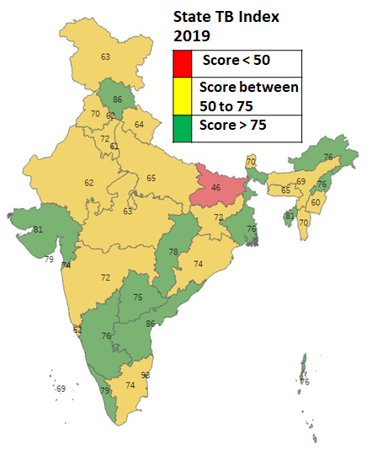State TB Index, a composite measure of the programme’s performance has been developed. It agglomerates nine key indicators of the programme which are provided scores based on the level of achievement. It is measured quarterly and presented annually.

The states/districts will be assessed on the following 8 parameters and its related key indicator:

1. Achievement of TB notification among the target identified.
2. HIV testing/ screening of TB notified patients.
3. UDST coverage among the TB notified patients.
4. Treatment Success Rate of TB notified patients.
5. Nikshay Poshan Yojana implementation.
6. DRTB treatment initiation among the diagnosed patients.
7. Utilization of the allotted budget.
8. Latent TB infection management

# **Chapter 16**

**NSP STRATEGIC AREA 1.9**

# **Research**

**16.1 INTRODUCTION**

The Country focuses on investing in TB research through the Department of Health Research and ICMR as well as on Operational/Implementation Research through vast network of medical colleges, partner organizations and NTEP programme managers. Over the past three years, the landscape of TB research has substantially shifted and Indian TB researchers have more funding opportunities than ever before.

**Table 13: An illustrative list sources for funding research.**

|  |  |
| --- | --- |
| **Government of India, State Governments and others** | **International or Private funding** |
| NTEP (CTD, State TB Cell, OR committees, NTI) | WHO |
| ICMR—India TB Research Consortium | Global Fund |
| ICMR— Task Force studies, Intra-mural funds | USAID |
| Dept. of Biotechnology/ BIRAC | Bill and Melinda Gates Foundation |
| Dept. of Science and Technology- CSIR | NIH |
| State Health Budgets | US-CDC |
| Intra-mural Funds of National Institutes (AIIMS, PGIMER etc.) | Stop TB Partnership (TB- REACH) |
| Indian Institute of Technology (Internal Funds) | The Union |
| Ministry of Tribal Affairs (MoTA) | FIND-India |
|  | UNITAID |
|  | India Health Fund (Tata Foundation) |
|  | Pharmaceutical Companies (J&J, Eli Lilly) |
|  | Wellcome Trust |

One of the most noteworthy changes in the Indian TB research landscape is the establishment of the India TB Research Consortium (ITRC) as an extramural program of the Indian Council of Medical Research (ICMR). This domestically-funded, extramural program was originally envisioned as an independent entity, but ultimately remained within the Department of Health Research in order to capitalize on institutional strengths. With a budget of more than Rs 120 Crore and multiple studies currently underway, the ITRC has been increasingly active since its inception. **Details of the ITRC are provided in Annex G.**

In order to effectively reach the diverse populations across the country, continued innovation and adaptation are key. This means moving beyond available NSP and technical guidelines. In other words, the program itself must remain fluid and dynamic at all levels. Flexibility and innovation have been encouraged at the national level, but appear to be lacking at the local level. While there have been some micro-level innovations as local programmes struggle to implement new policies and reach isolated and remote populations, these innovations have remained largely compartmentalized and hidden with very limited scale-up or uptake into broader policy and practice.

**16.2 THE PROGRESS SO FAR:**

1. **Institutional Structure and Capacity:**
2. Positive shift in TB Research landscape with an increase in potential funding sources.
3. NSP outlines specific research activities, with many of these initiated and are ongoing.
4. Some States (e.g. Gujarat and Karnataka) have been able to articulate state-level needs and target OR activities against them.
5. **Operational Research:**
6. National-level priorities have been identified and updated in 2017 by the ITRC for OR.
7. The National Anti-Tuberculosis Drug Resistance Survey (NDRS) presented the nature of anti-TB drug resistance in India, for first- and second-line drugs.
8. **Treatment:**
9. The NTEP has shifted to daily dosing for the basic TB regimen no longer insisting on universal use of labor-intensive DOT.
10. Some states (e.g., Kerala, Chennai) have completed vulnerability mapping as a baseline analysis for potential activities.
11. Interesting and promising studies on vaccines and prevention are currently underway.

* RATION study: a randomized control trial (RCT) that is using food as vaccine among household contacts; and
* Two multisite vaccine RCTs.

**16.3 CHALLENGES REMAIN**

1. **Institutional Structure and Capacity:**
   1. Innovations at the national level are difficult to recognize, capture and integrate into the program. At the local level innovations are not adequately scaled-up or included into broader policy and practice.
   2. While collaborations have been proposed with Brazil, Russia, India, China and South Africa (BRICS) and six meetings have been held in the last two years, no clear plan forward has been proposed or publicized as a result of these efforts.
   3. The inception of a National Research Cell within the National Technical Institute (NTI) is yet to be approved and launched. This Cell is intended as a solution to the perpetual challenge of securing operational research (OR) funding, lack of capacity for OR and dissemination and use of findings to inform updated evidence-based policies.
2. **Operational Research:**
   1. Lack of state-level OR focal points with the capacity for OR planning and training.
   2. Limited investments and progress made on the national-level OR priorities particularly in: NTEP management, addressing the socioeconomic impact and catastrophic costs of TB and integration into universal health coverage schemes (e.g., State insurance programs).
   3. Lack of state-level OR priorities.
   4. The incredible potential of the electronic data system, Nikshay, remains largely untapped. OR could help address the continued widespread gaps in data and its quality and lack of participation by general health staff.
      1. Secondary analysis of program data is limited to annual reporting.
      2. While vast data streams are converging into Nikshay, this wealth of information is largely inaccessible to researchers.
3. **Case Finding and Detection:**
   1. Inadequate tools and strategies in place to efficiently and effectively screen high-risk populations at scale. The diagnostics currently being developed and/or evaluated in India are not likely to meet the country’s needs.
   2. Lessons learned and best practices from the nationwide, large-scale ACF activities have not yet been synthesized, reviewed, or ultimately feed backed into policy recommendations.
   3. Detection of Isoniazid (INH, or H) resistance at the point-of-care level persists. As a result, only a small proportion of the total estimated INH-resistant TB has been detected and treated.
      1. Similarly, only a small portion of children and extrapulmonary TB patients have been successfully screened for drug resistance.
4. **Treatment:**
   1. Ongoing clinical trials offer promising pathways to incrementally improved treatment for extensively drug-resistant TB (XDR-TB) and rifampicin-resistant TB (RR-TB), but those trials will not yield a single transformative regimen for all patients detected with RR-TB. The NDRS articulated a denominator for different forms of anti-TB drug resistance.
   2. There is a gap in implementation research on the programmatic deployment of new regimens.
   3. There is a gap in implementation and health outcomes research on the impact of DAT-enabled differentiated care, as initially demonstrated and evaluated in the I-DAT evaluation in 2019.
5. **Prevention:**
6. TB prevention as a recognized and intentional programmatic activity is yet to be launched at scale.
7. Low uptake of chemoprophylaxis among the groups who are recommended for empiric treatment of latent TB infection (LTBI) (i.e., household contacts under 6 years of age and PLHIV).
8. Continued uncertainty on the strategy to use for any expansion (e.g., test and treat vs. just treat), and new globally approved regimens (e.g. 3HP) are pending additional clinical research in India which may further delay introduction.
9. AIC remains an issue in health care facilities despite the completion of several pilots and the roll out of national guidelines. The challenge is the intrinsic managerial nature of AIC interventions and the lack of suitable tools for scale-up.
10. Lack of linkage between vulnerability studies and surveys to prevention efforts.

**16.4 THE WAY FORWARD**

* + 1. **Improve the institutional structure and capacity for TB research**
       1. Improve ITRC-NTEP linkage
    2. Articulate India’s TB elimination needs with specific TPP to ITRC.
    3. Refresh the ITRC pipeline with NTEP-driven needs, including cessation of things that are not considered critical path to TB elimination.

Consider creating a dedicated technical cell and/or set of program officers to support researchers through administrative processes.

* + - 1. Leverage the Model Rural Health Research unit (MRHRU) for intensified TB surveillance. There are 18 such units across the country under the Department of Health Research. These units have dedicated staff who are engaged in research based on local needs. These MRHRUs can serve as surveillance centers for TB at no additional cost.
    1. **Address issues related to Operational Research and Implementation Science:**
       1. Update NTEP OR agenda with national priorities, and issue calls for proposals against the prioritized needs.
       2. Empower the NTI based National Research Cell to help manage the knowledge needs for TB elimination with an independent and fully-staffed secretariat equipped to:
    2. Conduct innovation identification evaluations and feedback into policy;
    3. Provide TA to States on OR needs and priorities and calls for proposals;
    4. Build OR capacity development for researchers; and
    5. Create an IT platform for transparent processes and funding flows.
    6. **Research in Case Finding and Detection**
       1. Make a concerted national effort to develop and deploy a TB triage and screening test by investing in both research and evaluation of already available global candidates.
       2. Conduct formative evaluation(s) of ACF campaigns, and develop differentiated guidelines.
       3. Optimize the diagnostic algorithm currently recommended by public sector providers across all sectors.
       4. Invest for research into new diagnostic tools
    7. **Research in TB Treatment:**
       1. Urgently fast-track trials for simpler, safer, shorter regimens for all forms of TB. Consider the following starting with RR-TB as the model and employing an adaptive and pragmatic design that includes pediatrics, patients with comorbidities etc.
       2. Develop and validate a non-sputum biologic marker of cure for use instead of time/dosing for clinical trials, and adapt for program use.
       3. Evaluate the reasons for low uptake of newer drugs/regimens and identify measures to rectify them.
       4. Identify and assess patient-centric approaches to improve treatment adherence by introducing new digital treatment support tools.
    8. **Research in TB Prevention:**
       1. Improve the utility of vulnerability mapping by researching best methods and then scaling up intervention efforts
       2. Implementation research on best models to reach adult household contacts and systematically provide TPT
       3. implementation research on models to provide TPT services among clinical risk populations such as patients having Silicosis, receiving Dialysis, preparing for transplantation or receiving anti-TNF treatment
       4. Establish an optimal ACF and preventive treatment strategy inclusive of efficacy/effectiveness of treatment, durability of protection and models on impact of intervention on TB disease and deaths at local level by developing surveillance sites in high transmission settings (large community cohorts) and then following them prospectively (without treatment) to identify profile(s) most predictive of disease. These cohorts may then also be used for intervention studies.
       5. Evaluate the predictive value of incipient disease (C-TB, signatures of risk and progression/ outcomes).
       6. Evaluate relative efficacy of AIC options, and develop better indigenous low cost UVGI fixtures.
       7. Research on potential TB vaccines
       8. Research on newer LTBI diagnostic tools
    9. **Research on socio-economic determinants of TB and impact of various patient support initiatives**

# **Chapter 17**

**NSP STRATEGIC AREA 1.10**

# **Strengthening procurement and supply chain**

**17.1 INTRODUCTION**

The NTEP strives to ensure a continuous supply of quality assured Anti TB Drugs and all related commodities to every TB patient diagnosed in the country. The procurement of Anti TB drugs, equipment and diagnostics is planned, coordinated and conducted centrally on an annual basis through a well-defined procurement mechanism. The financial support for procurement is provided by Domestic Budgetary Source (DBS), World Bank (WB) and The Global Fund (TGF). While procurement of consumables is decentralized to the states, drugs may be procured by the states during emergencies subsequent to proper authorization from CTD. The procurement, supply chain and logistics activities at the central level are administered by the Additional Deputy Director General (TB) with support from procurement and supply chain consultants. A procurement agency M/s Central Medical Services Society (CMSS), an independent and autonomous body under MoHFW is responsible for procurement and supply of anti TB drugs to the consignees in a timely manner following procurement procedures. These Procurement Agents also ensure that drugs procured are compliant with the quality policy of the NTEP, WB and TGF. The CTD also uses Government e-Marketplace (GeM) portal to procure and supply the items / services, which are available on GeM, for the use under NTEP.

**17.2 THE PROGRESS SO FAR:**

Several initiatives were undertaken during the previous NSP to enable an uninterrupted supply of good quality diagnostics and anti TB drugs to all TB patients. 2500 LED microscopes, 1512 TrueNat machines along with TrueNat chips, and 1000 CBNAAT machines and 3 million cartridges were procured to expand the reach of quality diagnostics across the country and strengthen sub-district level diagnostic capacities.

In addition to the first- and second-line drugs, newer formulations like the all oral regimen for adults and children, Bedaquiline and Delamanid were also successfully procured. More advanced tools for logistics and supply chain management were leveraged at the central and state level to ensure a more streamlined supply of drugs to prevent stock out situations and also support the daily regimen for Drug Sensitive TB patients for both adult and paediatric patients started in the month of October 2017. Nikshay Aushadhi enables real time visibility into stock status at all levels and enable forecasting and quantification for TB drugs and diagnostics. This is being implemented through Centre for Development of Advanced Computing (C-DAC), since December 2018.

**17.3 CHALLENGES REMAIN**

1. **Long lead time for procurement:** There has been a delay in the procurement of Anti TB Drugs, CBNAAT machines and other commodities in the past. These delays are generally due to procedural issues while ensuring the compliance of codal formalities. Long lead time of procurement leading to inadequate buffer stocks
2. **Inadequate infrastructure at state and district level stores:** Space is a major constraint in the Government Medical Warehouses. In addition, basic infrastructure like racks, temperature and humidity monitoring systems, firefighting equipment, computers with internet facility, manpower, communications, funds for transportation of commodities are sub-optimal. at SDS, DDS, TU and PHIs
3. **High turnover of contractual pharmacists** leading to vacancies, disruption in services and increased time to build capacities of new personnel.
4. **Packaging/repackaging of 2nd line drug boxes:** Following PMDT guidelines, boxes for 2nd Line drugs need to be re-packed at state drugs store and to be supplied to districts. However, there are also instances wherein loose drugs are re-packed in polythene bags or may be sent in loose forms only to districts. There is no uniformity in the packing and distributions of the Second Line Drugs.
5. **Lack of use of ICT platform** for capturing real time information on stock levels, expiry of batches and potential stock out situations resulting in increased operational strain on supply chain systems and also impact the forecasting and procurement planning given delays in reporting from the field.
6. **Disposal of expired Drugs:** Expired medicines continue to occupy the limited space in Central / State and District warehouse despite the 2% provision of write-off & disposal available at state level.
7. **Transportation**: Adhoc transportation mechanism from State to district / sub -district in some states resulting in delayed supply to end users at the PHI.
8. The thirty five (TIE-TB project) **Mobile Diagnostic Van** mounted with Microscopy and X-Ray Facilities for tribal population and forty five Mobile Medical Van fitted with CBNAAT Machine for early detection of MDR TB in high population areas through Active Case Finding are not being optimally used. In addition to above, undertaking of maintenance services of vans & Equipments are also being overlooked.
9. **Storage problems at National Warehouses (GMSDs)**: Time and again programme division has faced problems of storage of drugs at the national warehouse.

**17.4 THE WAY FORWARD**

**National Level**

* + 1. **Procurement agency –** To have an **alternative back-up mechanism to speed up procurement** of drugs and diagnostics to reduce the lag time for procurement from CMSS
    2. **e-Pharmacy / commerce platforms to enable door-step delivery of drugs need to be developed & implemented.**
    3. **Strengthening of procurement and supply chain management**
       1. Institutional learning: Training on Procurement and Drug Logistics Management for the all the personnel’s at National level involved in LSCM
       2. Capacity building of the PSM team in relation to the newer initiatives and artificial intelligence
    4. **Use Nikshay Aushadhi systems in PSM:** Procurement of barcode readers & printers, connectivity solutions for real time data exchange and for end to end visibility within the supply chain
    5. **NTEP drugs for Patients in Private sector: Voucher scheme, e-pharmacy & other** mechanisms for enabling the availability of NTEP drugs to patients in the private sector to be developed considering the focus on reaching out to patients diagnosed in the private sector.
    6. **Strengthening of Nikshay Aushadhi** – to incorporate supplier/testing laboratory interface, quantification tool, integration of LIMS etc.
    7. Improve **supply chain efficiency and effectiveness**, by moving toward standard, national specifications and consistent packaging for DS and DR-TB treatments.

**State Level**

* + 1. **Strengthening & Upgradation of Drug store infrastructure at state, district level and TU for storage of medical commodities and supplies including drugs.**
       1. Dedicated space for Anti TB drugs at the Government medical store depots.
       2. Upgrade store infrastructure to ensure Good Storage Practices and Good Distribution Practices
       3. Provision of ACs for 1st and 2nd line drugs store up to TU levels
    2. **Setting up state level PSM units- comprising of STO, Technical Officer, consultants for Procurement and supply chain management, with periodical support from central level:**
       1. A new position for inventory manager / PSM coordinator for district level proposed.
       2. Additional store assistant at SDS (>3000 boxes being packed per month) or hiring of a state level agency for providing packing material and subsequently packaging of monthly Patient wise boxes (2nd line)
    3. **Capacity building**
       1. Prepare guidelines for the following:
       - procurement of commodities at state level for Lab consumables, CBNAAT cartridges, packaging materials,
       - Local procurement of drugs in case of emergency (i.e. if the national level drug stock is less than 3 months or as may be directed)’
       - Transportation mechanism,
       - Quarterly validation of data.
       - Insurance policy for in-transit drugs and commodities
       - Annual Maintenance Contracts
       1. State Level trainings for new recruits and appointees under drug management, training and officials from Government Medical Stores Depots
    4. **LSCM solutions from District Drug Stores to PHI level –** Establishing / strengthening of transportation system **through third party logistics (3PL system)**
    5. **Mobile Vans -** Mechanism for thorough Upkeep & Uptime maintenance of Mobile Medical Vans & Equipment mounted on the van and maintaining Human Resource position to keep the Van in running state.
    6. **Supervision and M&E:** Monthly field visits by representatives of the central team covering SDS, at least 2 DTCs, 4 TUs and 4 PHIs in a state.
    7. **States mandatorily to write off up to 2% of cost of annual supply of expiry drugs & commodities** under intimation to CTD (annually) following waste management guidelines

As the country ramps up diagnostic services, the availability of drugs shall concomitantly increase to support the requirement of the program. With the planned strategies and its rapid implementation, the procurement and supply chain management which is the backbone of the NTEP would provide quality, sustainable and efficient services for the benefit of all TB patients.

# **Chapter 18**

**NSP STRATEGIC AREA 1.11**

# **digital information ecosystem for TB care**

**18.1 INTRODUCTION**

Data, information and knowledge has become the foundation on which an effective enterprise is built. The digital information era provides us with tremendous opportunities to collect and process large quantities of programme data, from numerous sources and locations to generate information in a near real time. This when translated to insights and knowledge, would lead to more agile, responsive, effective and efficient program management.

The digital technologies include information system (incl. web and mobile based applications and tools), the internet of things (IoT) with telecommunication networks; big-data analytics; and artificial intelligence (AI) that uses deep learning. Never has the need for translation of data into real-time insights for decision makers been so keenly felt as during the ongoing pandemic of COVD19. The pandemic has reinforced the need for high quality, and timely data and the use of digital technologies for making sense of it and respond at speed and scale. The COVID-19 pandemic is also potentially transforming the global health community’s acceptance and use of digital health technologies.

There has never been a better time to achieve impact with the data that is being produced by the NTEP. Programme data has not only increased in volume; it has also gained tremendous richness and diversity. More and more data is available, computing power is ever increasing, and mathematical techniques, and data science and analytics are getting more and more advanced

This NSP 2020 2025 will aggressively pursue the expansion of the digital information ecosystem over the next five years with the stated vision to create a **digital information ecosystem where information is captured in real time, processed and visualized, enabling efficient service delivery and responsive program management, driving TB Elimination in India and all over the world.** To realize the goal of END TB in India by 2025 it is imperative to leverage the strength of the digital information system complete with adopting and effectively applying Artificial Intelligence (AI), and analytics. This will result by:

1. Transitioning to a completely digital mode of operation where information is captured at the point of its generation on a real time basis and paper records are printed copies of electronic records.
2. Establishing ICT enabled state-of-art surveillance and program monitoring system, enabling users to data driven action and continuously improve service delivery, (including adherence monitoring and universal access to free drugs and diagnostics)
3. Enabling availability of information for general population at large for data driven transparency and accountability
4. Complying to EHR standards of Government of India, enabling interoperability and Integration with other ICT systems of MoHFW to contribute towards the creation of longitudinal health records of individuals.
5. Creating a scalable ICT ecosystem which can be replicated in other high TB burden countries or leveraged for management of other National health programs of similar scale in India.
6. Providing an enabling environment (mentoring, linkage with HTA, operational research support) to test and adopt newer digital solutions that may be used to solve the gaps across any part of the TB prevention, diagnosis and treatment cascade.
7. Periodically publishing NTEP’s digital pipeline and invite newer digital solution ideas using appropriate platforms. This will enable NTEP to take maximum advantage of digital technology solutions.

**18.2 THE PROGRESS SO FAR**

## **The Current Electronic information system in NTEP (Fig 19)**

In 2012, CTD launched Nikshay as its first web-based ICT System with the support of NIC and WHO, enabling case-based notification. Since then, immense progress has been made by NTEP to leverage information technology for improved management and implementation of the program across the country. In September 2018, CTD launched an enhanced version of Nikshay

**Figure 29: Diagrammatic representation of the current ICT Landscape for TB Care.**

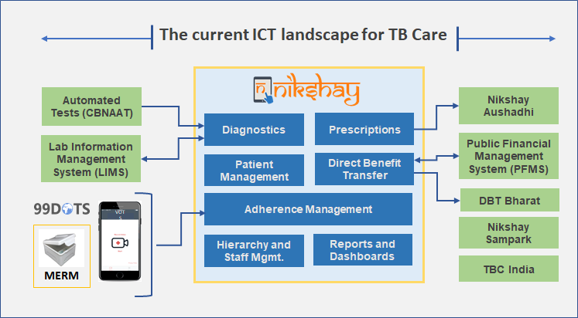  
**The broad functions that it currently serves are:**

* The National **TB Patient management tool** across public and private sectors and for all types of patients. Each user manages information of each patient throughout the patient lifecycle related to Testing  (Diagnosis and follow up), Treatment initiation, Public health action (Contact tracing, comorbidities), Adherence monitoring, Outcomes, Transfer and referral for testing and treatment across India, along with reporting of activities like Active Case Finding. For Adherence monitoring, Nikshay has an adherence toolkit integrated with the various Digital Adherence monitoring Technologies such as 99 DOTS, MERM and VOT.
* It acts as a **Surveillance and monitoring** tool: The entire TB care cascade from referral for testing and notification, to outcome declaration and all drop out events are tracked and monitored. With the wealth of data concerning each TB patient, a number of automated reports and data visualizations through dashboards are generated and they are available for further analysis to generate insights into TB epidemiology and actions for program management.
* **Direct Benefit Transfers**: Nikshay enables electronic transfer of benefits, direct to the bank account of beneficiaries, under four incentive schemes provisioned by Government of India. This is done through Nikshay PFMS (Public Financial Management System) interface, a continuously evolving system, unique to the NTEP of India.
* It helps in the management of information of **health facilities**, reporting hierarchy, staff and treatment supporters working for the programme.
* Additionally, there are three add on systems, in the Nikshay ecosystem, that perform specialized allied functions. These are:

1. Nikshay Aushadhi enables manage the supply chain of Anti TB drugs from Centre to the final dispensing to the patient, along with workflows of indent, drug request, procurement, forecasting, and reporting.
2. Laboratory Information Management System (LIMS) automates the processes at TB CDST Laboratories from specimen receipt, decontamination, sample preparation and performing additional test and specimen specific workflows
3. Nikshay Sampark Application manages the workflows and reporting needs of the Call Centre. It enables recording of the incoming/outgoing call details handled by the Agents and therefore, facilitates reporting on the type/volumes of calls handled and monitoring of the performance and quality of services delivered by the call centre.

### **Current scale of the system and stakeholders involved**

As India has a high burden of TB cases, the scale at which the NTEP operates is enormous. There are several stakeholders, across Public and Private Sectors who interact with the Nikshay ecosystem in their respective capacities. These include beneficiaries, public and private healthcare providers, policy makers, laboratories, chemists, informal healthcare providers and administrators. Thus, enabling a holistic patient management pathway. These stakeholders use the systems with different objectives and vary greatly in terms of time spent in the application to carry out their day to day activities. For e.g. policy makers and administrators would like to use the systems to review the program metrics for decision making whereas Public or PPSA health care staff use the systems on a day to day basis for patient management and care. Following is a pictorial representation of the various stakeholders involved.

**Figure 30: Stakeholders in the ICT Landscape for TB care:**

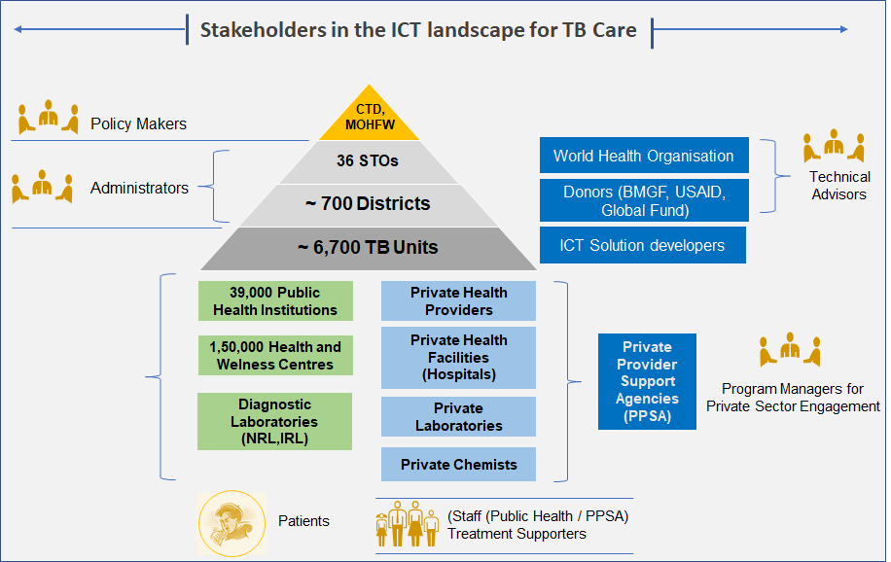

To be most effective, and inclusive, continuous active dialogues are conducted amongst stakeholders (at operational / management level) on a regular basis, to work as one cohesive unit to achieve common objective(s).

**18.3 THE WAY FORWARD (Interventions/ Activities)**

* + 1. **Establish the National Knowledge Cell under Central TB Division, equipped with resources to develop and maintain IT Systems, manage and use real time information for program management, study TB epidemiology, information dissemination, training, and manage the National TB Call Centre.**

### **The Proposed National Knowledge Cell**

There is a felt need to institutionalize and build inherent capacity to design, deploy and maintain all ICT related operations. All information and communication related activities in CTD needs to be organized into one functional and operational unit with the IT systems serving as the backbone. For this purpose, a knowledge division, led by a CTD officer, with various nodal persons or teams that are concerned with all means of information and communications services needs to be put in place.

The Cell will be primarily focusing on with six tracks of work, of which the first track of ICT system is the foundation on which deferent programme components can access, analyze and communicate TB service related feedback to the field. The ICT system will be supported by a Managed Service Provider (MSP) agency that will host all IT services, develop standards, WHO will provide the technical assistance at a central level to manage the various work tracks cohesively.

**Figure 31: Proposed Organizational structure**

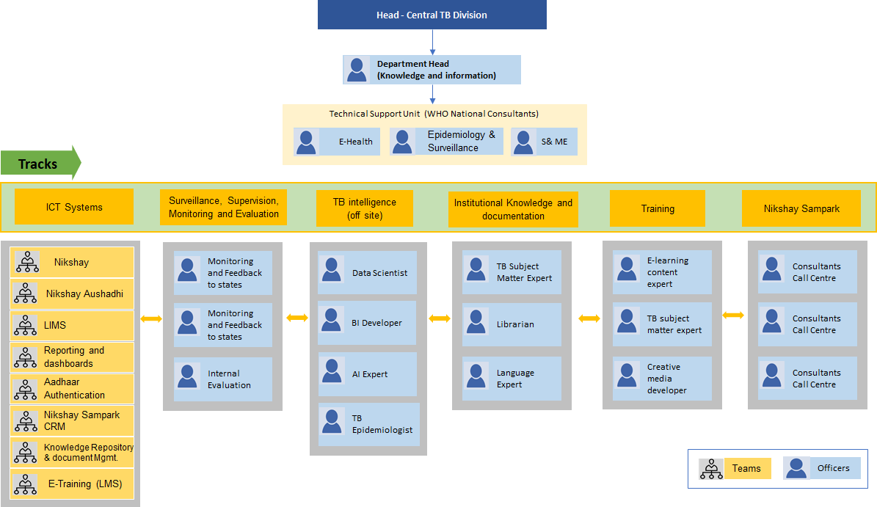

**Figure 32: Work tracks of the Technical Support Unit and the Roles and Responsibilities of each work track**

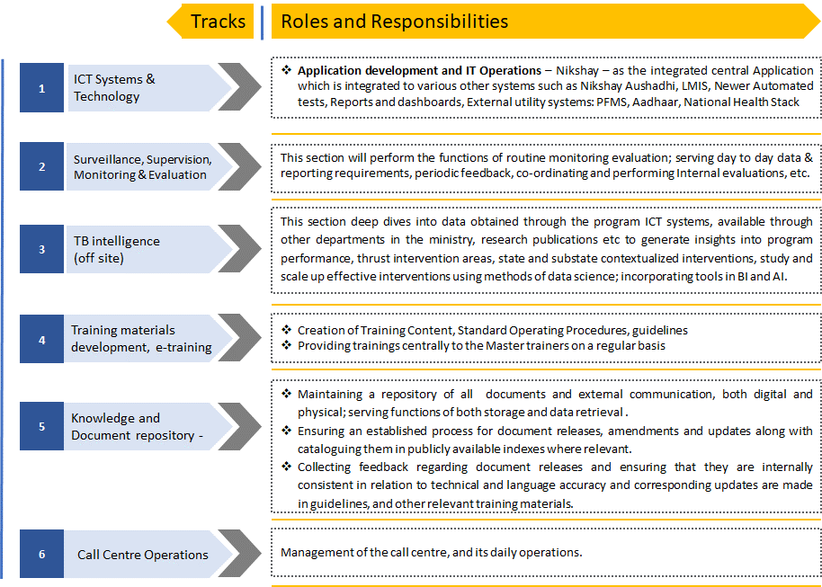

The first track, **ICT Systems and Technology** will be the foundation on which other tracks function, because the ICT application development and maintenance related to all other tracks will fall here. Various technology partner teams that build and maintain these ICT Systems will associate with CTD under this track and coordinate in such a way that they integrate with each other to form an ecosystem of applications within the NTEP. The roles and responsibilities of each technology partner is elaborated here:

1. Conduct needs assessment in consultation with CTD/ WHO, collate requirements received from all stakeholders, perform impact analysis, and effort estimation.
2. Conduct development sprint planning as per the priorities of the program and share the release plan.
3. Build the system functionalities, conduct testing and deploy these features on the field in the agreed upon timelines.
4. Provide technical support, track defects and incidences reported from the field and ensure that fixes are implemented.
5. Prepare and maintain updated (at all times), training documents, user manuals and system documentation and share the release documents with the stakeholders
6. Set up a process to obtain feedback from the Users

**Progress monitoring and review**

To successfully deliver a nationally implemented Ecosystem of application with a spectrum of stakeholders, a robust monitoring and review process needs to be institutionalized. This is vital to make sure that the program’s resources are optimally utilized to meet its priorities and objectives. An effective progress monitoring and review framework would ensure that the deliverables are of highest quality standards and as per the planned timelines. For this purpose a detailed project plan (covering all tracks) will be prepared, against which, progress will be monitored on an ongoing basis. Periodic reviews will be conducted with the relevant stakeholders to monitor progress. Risks would be identified and documented, mitigation measures to be taken as required.  The monitoring and review process would be led by the head of CTD, with technical support from the TSU along with the project partners.

* + 1. **Strengthen NTEP’s information systems further, to support the increasing demands of the program to accelerate India’s campaign to eliminate TB from India by 2025.**

**Figure 33: The proposed ICT system**

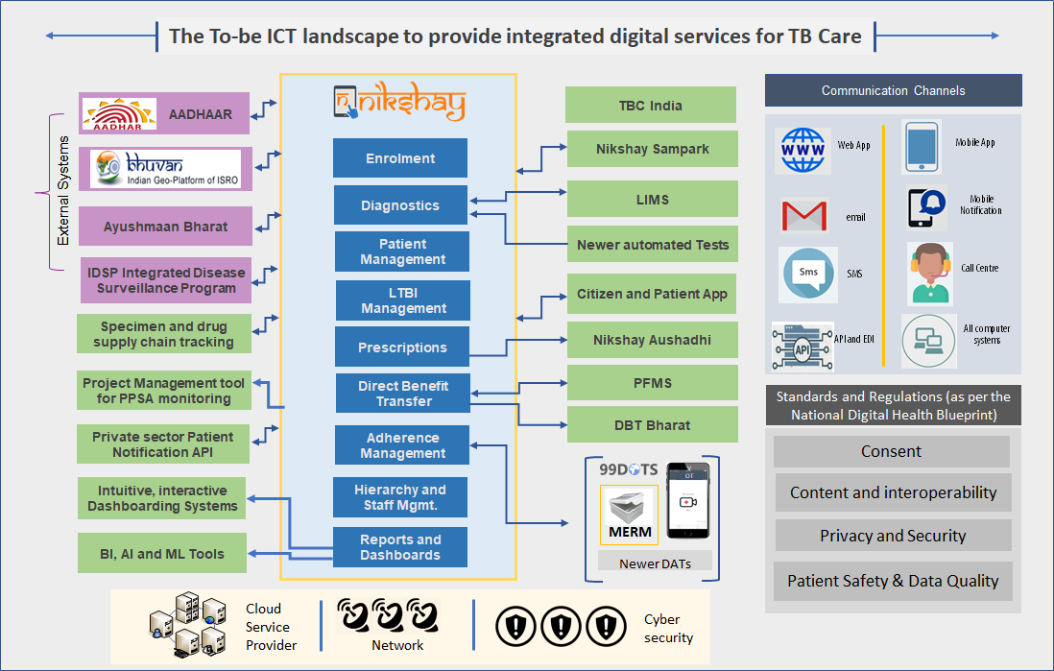

**The five focus areas for taking up the various ICT based development initiatives are as follows:**

* + - 1. **Focus Area 1: Maintenance of the existing systems at scale and sustenance**
    1. Optimizing for scale; Ability to efficiently manage the increasing volume of enrolments / transaction processing through the systems while maintaining high system availability and uptime.
    2. Ensure that the users can use the Nikshay eco-systems and its modules optimally and meet the objectives for which it was built.
    3. Continuous performance monitoring and improvements/optimizations
    4. Robust mechanism for Technical Support: A responsive technical support channel to resolve user’s issues in an effective and timely manner.
    5. Resolution of defects raised internally or reported by users and fine tuning the systems to ensure that the failures and errors are minimal

Owing to the sheer scale of the program operations of NTEP and its increasing momentum to pursue the 2025 goal, an estimation of volumes are depicted below:

**Figure 34: Scale up estimation**

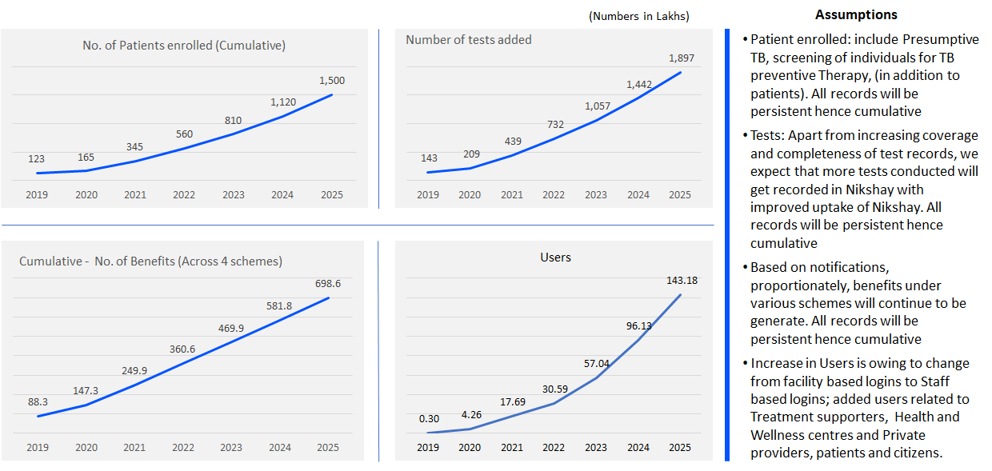

* + - 1. **Focus Area 2: Upgrades to achieve State-of-the-art technical solution design**
    1. In order to get best cost and performance advantages transition to open-source based technology stack, with no vendor lock-in and design for scale
    2. Develop a highly interoperable connected ecosystem with Open-API based data access capabilities
    3. Inculcate strong privacy controls across all the systems in the ecosystem p administer practices for data collection and sharing among authorized parties
    4. Fraud prevention, breach notification: Build the necessary checks and balances to minimize /eliminate fraudulent identity and transaction practices
    5. Common integration layer, with open standardized data interfaces semantic health coding libraries for standardization
    6. Ensure application modularity for rapid upgrades and scalability.
    7. Deploy Infrastructure hosting solutions with a ‘design-for-scale’ approach. The architecture of NTEP ICT Systems must be such that its components such as network, compute and storage scale horizontally so that additional resources can be added as-required to support the required scale.
    8. Security of data within the NTEP information systems need to be foundational keeping in view the sensitivity of data the critical nature of the infrastructure proposed to be built. Systems to ensure that access is available only to authorize users, Firewalls to prevent unauthorized access, password encryption policy etc. Security audit of the applications on a periodic basis need to be conducted and all the vulnerabilities fixed.
    9. To ensure reliability, while data transfer and data processing, the systems will ensure that there is zero loss of data, zero duplication of data processing. The APIs built will go through performance and security measures for reliability.
    10. Configurability: As NTEP’s program protocols undergo changes, for e.g. Diagnostic protocols, treatment protocols, it would be useful if some of the fast changing parameters, business rules are configurable while maintaining date-time stamp and audit trace for making such changes.
    11. The solution architecture of the ICT systems will offer high availability, minimum uptime of 98%. Disaster recovery and Business Continuity planning needs to be appropriately undertaken.
    12. Adopt emerging technologies such as Business Intelligence (BI), Artificial Intelligence (AI) and Machine Learning (ML) tools.
    13. Strong data management and harmonization designs, with vision for a national health data warehouse
        1. **Focus Area 3: Introduce greater automation portfolio and innovation**
    14. Today, the ICT Systems of NTEP are in various stages of maturity of implementation/ uptake across the country and are not yet comprehensive in terms of the functional coverage. There is a necessity to enrich the existing modules further, to achieve greater automation. A few examples are, strengthen the DR TB Patient management functions, ability to generate prints of Treatment Cards, Test Request forms and Test Reports, generation of newer task lists for staff for improved patient management, build insightful and actionable dashboards for users across the hierarchy.
    15. Improvements are also necessary to increase the user friendliness of the systems by simplification of the User Interface and workflows to make the systems more intuitive. This will also reduce the training needs significantly. For example, the DBT Approval screens may be improved to provide more information to users to enable easier search, simplify the process of review and approval.
    16. The systems should be able keep pace and cater to NTEP’s new intervention areas such as LTBI or revised protocols in the existing areas of functioning such as diagnosis.
    17. Improved integration between internal systems of NTEP (such as building two way integration between Nikshay Aushadhi and Nikshay)
    18. Integration with National systems such as Aadhar which would aid in beneficiary authentication.
    19. Integration with information systems built by MoHFW under other programs such as Ayushman Bharat. This would not only reduce duplicate data entry/ workload of the healthcare staff who are implementing multiple health programs on ground but also help create longitudinal health records for individuals.
        1. **Focus Area 4: Alignment with the National Digital Health Blueprint**
    20. **Identification**:
        1. **Personal Health Identifier (PHI):**  NTEP is in the process of developing Nikshay to enable Aadhar based identification of persons (patients, other beneficiaries such as private providers) and authentication for schemes (under section 7 of Aadhar Act)
        2. **Facility Registry:**  Presently, NTEP has common registries of health facilities built in Nikshay for those who provide TB care. As National Health Resources Repository (NHRR) is built, Nikshay would utilize it, integrate and exchange data.
    21. **Adoption of Minimum Viable Standards (MVS):** NTEP would strengthen its ICT Landscape by incorporation of the MVS. The recommended Standards for,
        1. Consent management, consent framework, Anonymizer
        2. Technical interoperability defined by IndEA Framework,
        3. Semantic and syntactic (content) interoperability-Fast Healthcare Interoperability Resources (FHIR) R4 Specification
    22. **Privacy and Security** Security (Digital Certificate, TLS / SSL, SHA-256, AES-256)
        1. Access Control (ISO 22600:2014 Health informatics-Privilege Management)
    23. **Adoption of Standards**
        1. MDDS and EHR Standards for India 2016
    24. **Service Access/ Delivery**
        1. Omni channel access/ delivery -  web, mobile based Apps and Call Centres for citizens/ patients (for Education and information)
        2. Patient level ownership of data
    25. **Federated architecture:** Nationally required functional blocks are built and maintained centrally, and provided as a service to the states; these would be interoperable with regional, state-level and institution level platforms in such a way that these systems may function independently provided that they achieve minimum requirements.

# **Chapter 19**

**NSP STRATEGIC AREA 1.12**

# **Technical assistance to NTEP**

**19.1 INTRODUCTION**

India is enriched with technical assistance from a large pool of TB experts, is evident from the fact that more than 60% of the countries across the world at least once have been provided TA for Tuberculosis program by an Indian. NTEP has a large pool of vivid experts in respective thematic area of the programme. The Technical committees on various thematic areas at National level provide the policy and operational guidance to NTEP. The National TB program is also receiving TA through National Institutions-ICMR, NITRD, NIRT, NTI, NRLs; Medical colleges; WHO-NTEPTA Project; USAID partners including Karnataka Health Promotion Trust, World Health Partners, REACH, SHOPS+, Union; BMGF partners including CHAI, CHRI, FIND, Everwell, Gramener, FIND; Stop-TB-Partnership-GDF-TBREACH; TB Association of India; GCAT-parliamentarian forum; TA for empowering community through GCTA,SATB, GHS etc.; Niti Aayog; CDC; Wadhwani AI; TISS; IIPH; etc. Similarly, the GF funded projects like JEET project, Axshaya, and Saksham has been providing TA at various levels of program implementation. The World Bank project starting in 2019 envisages Technical Support Units at National and State level to provide TA.

NSP 2017-25 envisages to continue the scale up of TA to NTEP. The WHO TSN assessment report recommendations have been implemented with expansion of the consultants network with additional recruitment (from 80 to 148 including 26 at CTD with 8 regional consultants), and transition of the funding support to domestic budget. Existing NSP has also envisaged the scale up and expansion of technical areas to cover priority thematic areas like private sector engagement, DRTB and TB surveillance with regional consultants in addition to the TA provided by other development partners.

**19.2 CHALLENGES REMAIN**

1. Multiple partners providing TA with duplication of efforts
2. Risk of thrust areas requiring TA being left out
3. Lack of evaluation of the TA provided, prioritization of areas and rationalizing efforts by the various partners.
4. TA for emerging areas of programme interventions with newer strategies remains underdeveloped.

**19.3 THE WAY FORWARD (partners TA)**

* + 1. **Strengthen the TSN and make TA responsive to the emerging TB landscape in India.** 
       1. Increase the present number of TA from WHO TSN considering the magnitude of the operations to End TB in India
       2. Equip the existing WHO-NTEP TSN with additional capacity to address some of the emerging themes such as Epi intelligence, Prevention, Urban TB, Tribal TB, Lab network services etc. as listed above.
       3. WHO is already providing TA across the large spectrum of programme priorities under agreement with GOI through its rich WHO-TSN of consultants. Its scope can be expanded to identifying areas of TA, prioritizing, routing TA provided by other experts/partners in those areas, evaluating and in rationalizing their efforts. This network is aptly suited to take on the additional responsibility owing to its widespread presence across the country, its involvement and familiarity with the program.
       4. Empower the WHO-TSN with enhanced capacities and resources and ensure retention of high quality TA in the programme.
       5. Provide the WHO Brand to the WHO-TSN even as the human resources and financial functions of the TSN maybe both supported by WHO and GoI.
       6. Synchronization, value addition and de-duplication of TA by different partners
       7. Development & utilization of better technologies and IT platforms for TA
    2. **Extend TA to other ministries** which address the contribution of social determinants of tuberculosis but needs intervention beyond NTEP/CTD[29].
    3. **Expedite the establishment of the planned TSU’s** with special focus on private sector provider engagement and contracting at National and State level, as per the World Bank supported project and expand their scope to other TA needs not covered by WHO-NTEP TSN such community mobilization, DBT, health financing/economics of TB control, human resources for health, health systems performance and efficiency analysis, multi-sectoral engagement etc.
    4. **Create a platform/mechanism to enlist and provide information on the available TA experts** (a pool of short term consultants of various international and national experts) which the program can utilize to have quick and timely access to specialized TA wherever and whenever required. Partners providing support for TA to the programme may facilitate this process.
    5. All partner organizations assisting the programme with TA in specialized areas like the TSUs, laboratory strengthening, health financing/ economics of TB control, digital health, other ministries etc. may be under one umbrella of GOI supported WHO-TSN consultants network. This will bring in accountability in prioritization starting from the subnational level, coordination
    6. Provide program units at central level with additional infrastructural support (e.g. space, communication tools, management support) to accommodate the expanded network.

# **Chapter 20**

**NSP STRATEGIC AREA 1.13**

# **ADDRESSING human rights and gender related barriers**

**20.1 INTRODUCTION**

In India, the Directive Principle of State Policy under the Article 47 of the Constitution of India considers that it is the primary duty of the State to improve public health, securing of justice, human condition of works, extension of sickness, old age, disablement and maternity benefits. Under this Article, the State is expected to raise the level of nutrition and standard of living of its people and improvement of public health among its primary duties. Providing adequate medical facilities for the people is an obligation undertaken by the government in a welfare state. The government discharges this obligation by providing medical care to the persons seeking care. India is a signatory to key international treaties and movements advocating for, and protecting human rights (The International Covenant on Economic, Social and Cultural Rights (ICESCR) in 1979, the UN Convention on the Rights of Children in 1992 and the Convention on the Elimination of all forms of Discrimination against Women in 1993, and the Convention on the Rights of the Disabled in 2007).

The country is committed to a response against TB that is people centered, rights-based and gender sensitive. Theoretically, an airborne disease such as TB should pose an equal biological risk to everyone, irrespective of who they are, where they live or work, or their gender. However, a higher proportion of the 2.69 million diagnosed with TB in India are men and the ratio is approximately 2:1 (Global TB Report 2019) between men and women. Multiple studies in the country also highlight that more men report microbiologically confirmed pulmonary TB and women are more likely to have clinically diagnosed pulmonary TB and extra-pulmonary forms of TB.

Although men in India experience higher incidence of TB, women are more socially vulnerable to the disease as they experience unique, gendered challenges such as stigma and social repercussions related to suffering from TB as well as others related to power dynamics and economic independence. Additionally, TB is one of the predominant causes of death for women in low income countries, especially among women of reproductive age. TB specifically increases a woman’s health risks: women living with HIV are highly susceptible to developing active TB during pregnancy or soon after delivery, making TB a leading cause of death during pregnancy and delivery. TB may also cause infertility, further compounding the stigma faced by women living with TB. Such stigma may create economic barriers for women with TB and therefore it may hinder the woman’s ability to access treatment and care. TB and infertility stigma can also put women at a greater risk for experiencing gender-based violence. Research also shows that the prevalence of HIV-TB co-infection is higher among women and among transgender persons who live in overcrowded houses and consume alcohol.

Traditionally, women tend to have better adherence and treatment outcomes as compared to men. The pressure to get back to work and lifestyle habits such as smoking or consumption of alcohol influence discontinuation of treatment in men. Migrant workers, mostly men, often face difficulties in adherence to treatment in the face of extreme poverty and issues of daily survival.

**Stigma and TB care:** Stigma is an important social determinant of TB. Stigma and discrimination are major impediments to treatment adherence, mainly among unmarried women, newly married women and the elderly. Access to care for HIV/AIDS, mental health, leprosy, TB and epilepsy are associated with stigma and the recent experiences related to COVID-19 pandemic response has raised more concern[30]. The institutional and community norms lead to stigmatization due to TB and are hindrance to TB elimination efforts. In a study in India, it has been found that perceived stigma among the patients is an important barrier for early diagnosis, initial patient lost to follow up and adherence to treatment.[31] [32] Lessons learnt from the National AIDS Control & Prevention Program (NACP) in India, provides examples on how to handle stigma attached to AIDS, for example maintaining confidentiality, safety network of PLHIV etc. In National TB Elimination Program (NTEP), out of 26 set of standards, there are 6 inclusion standards.[33] To make the NTEP more inclusive, stigma reduction interventions will address delay in access and non-adherence to care.

TB care is gradually moving to patient-centred approaches that emphasise community engagement, patient counselling, technology integration, adherence promotion, counselling; all of which adds value to stigma reduction efforts. TB survivors are raising awareness about TB that affirms the dignity of people with TB that may be insufficient.[34] [35] [36] The TB community needs social activism through survivor’s network, structural integration into system and through local informal community structures. These collective efforts and friendliness of health system can make a more enabling environment where TB affected people live in a stigma free environment[37].

Stigma and discrimination in the context of TB is not restricted along gender lines and an area that requires more attention for women, men, transgender people, and also among TB key populations such as those who live in urban slums or migrants. Stigma and discrimination can materialize in the home, the community, the workplace and in health care settings and this is a barrier to finding and missing people with TB. TB stigma must be recorded and measured in each of these contexts, and targeted interventions developed and implemented in response. Further challenges include those of privacy and confidentiality, as well as the ability to access services due to remoteness, operating hours etc. A rights based and gender sensitive TB response TB survivors and civil society have an important role in this aspect of the TB response.

**20.2 THE PROGRESS SO FAR**

The tuberculosis (TB) response needs a paradigm shift – to become people and community centered, gender sensitive and human rights based. In line with the National Strategic Plan for TB for 2017-2025, a **“National Framework for a Gender-Responsive Approach to TB”[38]** has been developed and adopted by the Government of India. This framework draws on the findings of the first ever Assessment of Gender and Tuberculosis in India in 2018 and aims to 1) Outline the influences and impact of gender on the TB burden and response, based on available literature and data; 2) Define actions which would help move towards a gender-responsive approach; and 3) Provide guidance to implement these actions. The need for gender responsive programme cuts across all the pillars of the NSP.

**Figure 35: National Framework for a gender responsive approach to TB in India**

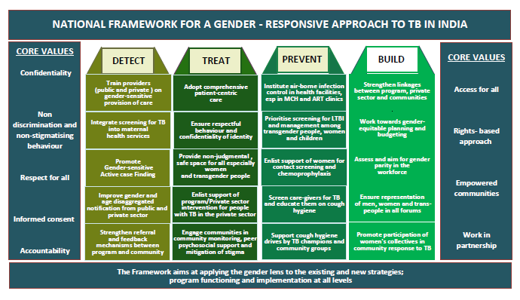

**20.3 CHALLENGES REMAIN**

1. Gendered roles, responsibilities and expected behaviors place women, men and transgender persons at increased risk for TB. Women are especially constrained by social norms which prevent prioritizing of their nutrition, health and well-being
2. Socio-economic and psycho-social impact of TB - high costs of diagnosis and treatment, expenditure on unnecessary tests and supplements, disruption in work and schooling, and stigma, harassment and rejection faced by those affected by TB, especially among women
3. Gendered health system resulting in gender inequities and barriers to provision of effective services.
4. While a Gender Sensitive Framework that has been developed, a costed action plan to overcome barriers to accessing services and responding to the recommendations of the TB Legal Environment Assessment has not yet commenced.
5. Among many TB stakeholders, but particularly TB survivors and civil society, there is a need for further sensitization and capacity building pertaining to TB, rights and gender.

**20.4 THE WAY FORWARD / Activities)**

**At its core the NTEP has crafted strategies that envisages to:**

1. Scale up services and interventions that reduce human rights, stigma and gender-related barriers and vulnerabilities to TB infection/disease;
2. decrease the burden of disease for those most at risk;
3. mitigate the impact of TB, and
4. address structural inequalities and discrimination
5. empower and engage TB affected communities

Being a cross cutting issue the interventions have been address in other thematic areas. However a few specific interventions are mentioned below.

**The specific interventions**

* + 1. **Provide equitable, rights-based TB services for women, men and transgender persons by adopting a gender-specific programmatic approach at all levels** 
       1. Undertake national level ToTs to create of a pool of trained manpower in each State/UT, for undertaking training on gender-responsive approach at State level and training of district level programme managers on gender- responsive programming through State level trainings.
       2. Build capacity of providers and peripheral health workers on the gender perspective and providing comprehensive person centric care through sensitization programme and refresher sessions.
       3. Conduct baseline assessment of facilities, infrastructure and linkages including assessment of provider knowledge on gender-responsive programming and existing gender-sensitive practices
       4. Utilize existing tools to analyze and publish gender-disaggregated data in periodic reports of the Division.
       5. Adopt and promote comprehensive person-centric care, in all steps of interacting with the person with TB guided by her/his/their preferences for people with TB of all genders including women and transgender people
       6. Ensure respectful behaviour towards people with TB, confidentiality of their diagnosis and personal health information, and anonymity of identities during and beyond the treatment period
       7. Aim for gender parity in the NTEP workforce.
    2. **Mobilize, empower and engage women, men and transgender persons in the TB response at the health system and community levels** 
       1. Empower communities and people with TB to understand their rights and responsibilities
       2. Promote active involvement of people affected by TB of all genders in all aspects of the design, planning and delivery of programmes through engaging with patients support groups and TB forums at all levels
       3. Involve community in all case finding activities and improving accessibility to diagnostic testing by establishing community monitoring systems
       4. Implement preventive actions including contact screening and chemoprophylaxis by enlisting the support of women and men in the family.
       5. Involve community influencers of all genders to improve cough hygiene in the community.
       6. Strengthen linkages between the programme, private sector and the community to synergize efforts towards provision of gender sensitive care and receive regular feedback.
    3. **Mobilize, empower and engage TB survivors, civil society and other TB stakeholders to reduce human rights and stigma related barriers to access TB services**
       1. Empower communities, TB survivors and people with TB to understand their rights and responsibilities
       2. Sensitize TB stakeholders, particularly those involved in TB service delivery, in rights based and gender sensitive TB responses.
       3. Conduct a TB Stigma Assessment to establish a baseline and measure TB stigma across various contexts, as well as strategically tailor interventions to respond to these findings.
       4. Build the capacity and coordination of networks of people affected by TB and TB survivors to actively engage in TB governance and decision making.
       5. Mobilize, empower and engage TB survivors, civil society and TB patients to monitor access and quality of TB services.
       6. Develop a costed enabling environment framework informed by the Legal Environment Assessment, in a similar way to the development of the Gender Assessment inspired to the Gender Responsive Framework
       7. Engage and sensitize the judiciary, including judges and magistrates, lawyers and law enforcement officers on TB and human rights.
    4. **Address Stigma in TB Care.**

**Figure 36: Framework for addressing stigma in NTEP incorporated in the NSP pillarss**

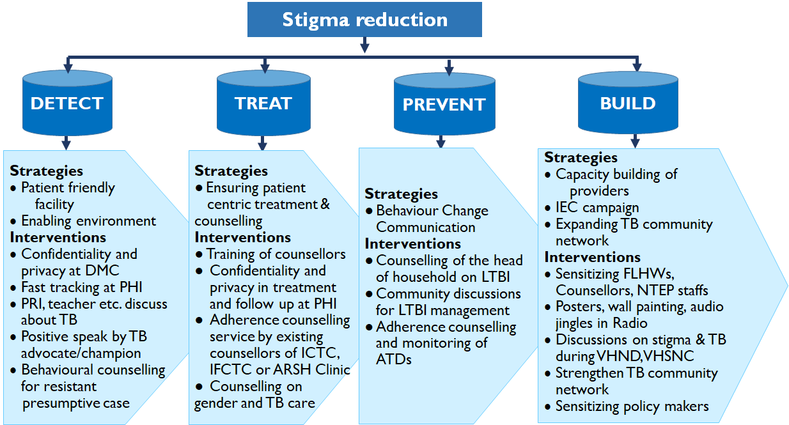

* + - 1. **Create patient friendly facilities at TDC:** At the TDC, establish minimum facilities to ensure confidentiality and privacy of a client and treat patients with respect.
      2. Engage TB survivors, panchayat, teacher and other community gatekeepers to do **community advocacy as “positive” speakers** on stigma.
      3. Undertake **counselling** of presumptive case who deny to attend DMC.
      4. Train FLHW’s in counselling skills to cover all aspects of gender and stigma in TB care.

# **Chapter 21**

**NSP STRATEGIC AREA 1.14**

# **TB CARE in the ERA of COVID**

# **Build a resilient, responsive and agile NTEP to respond to complex emergencies**

**21.1 INTRODUCTION**

Significant progress to END TB has been made since the Honourable Prime Minister gave a clarion call to End TB by 2025, five years ahead of Sustainable Development Goals target. Intensive measures have been undertaken over the last three years to improve TB case finding in public as well as private sector including active case finding, decentralizing molecular diagnostic and treatment services, enforcing mandatory TB notification, private sector engagement and extending public health actions. For a multi-sectoral response linkage have been established with other national health programs and other line ministries. Additionally, various enablers have been provisioned like incentives for TB notification, incentives for nutrition, support for patients in tribal areas and community engagement. However with the COVID 19 pandemic and its consequent public health actions including National and State specific lockdown since March 24th 2020; all the key strategic interventions have been affected resulting in almost 60% decline in TB notification during the lockdown period.

Further, evidence from previous epidemics that reduced access to care, medicines, and diagnostics for people with life-threatening conditions like TB can lead to an increase of deaths from these underlying conditions. In Guinea, one of the countries at the epicenter of the 2014–2016 Ebola outbreak in West Africa, reduced health services [led to a 53 percent decrease](https://www.ijidonline.com/article/S1201-9712(16)31194-8/fulltext)[39] in the diagnosis of TB—and a doubled mortality rate from it.

A recent modelling exercise to understand the potential impact of short-term lockdowns (2 month of lock down and 2 month of restoration) on TB incidence and mortality over the next 5 years, in high-burden countries estimates that an additional 514,370 cases and 151,120 deaths will be added in India between 2020-25 owing to the two month lock down and two month restoration periods. The estimates are much bleaker for protracted lockdowns and slower restoration period. It is clear now that **the pandemic will result in severe disruptions in NTEP service delivery, and presumptive TB cases and TB patient’s care seeking behaviour with profound consequences on NTPs trying to reach the END TB targets.**

**Specific risks for the National TB elimination programme’s response include:**

1. National TB programme staff being drafted into the COVID-19 response, creating staff shortages or increased workloads
2. TB facilities (hospitals, dispensaries) are being used for the COVID-19 response; with these being fully utilized if COVID-19 gets more widespread.
3. National laboratory and diagnostic services focusing on COVID-19 activities, such that TB laboratory tests like rapid molecular tests and cultures are delayed and there is limited access to chest X-rays,.
4. Disruptions in sputum transportation and on providing different types of treatment support.
5. People avoid going to or have no possibilities to reach hospitals and medical clinics due to lockdown and reduced transportation means.
6. A decrease in the number of people presenting/accessing services for TB.
7. Active TB Case Finding (ACF) activities stopped.
8. Physical/social distancing measures and national quarantine measures will interrupt treatment support and TB contact tracing measures.
9. Because of the vulnerability of people with TB and drug-resistant TB to COVID-19 and more aggravated COVID-19 forms with anticipated higher TB mortality; there are significant concerns on management of drug-resistant TB as hospitals are severely affected or moved to COVID-19 response; lack of Personal Protective Equipment for health care providers, with huge workload;
10. Drug stock-outs and procurement issues. As global transport networks are reduced and countries involved in the manufacture of TB medications are affected, there may be delays in the procurement chain. If health systems are overwhelmed or there are staff shortages, stock management may be de-prioritized. Disrupted importation processes of goods, In-country transportation, distribution and warehousing limitations also will create delays.
11. Domestic funding constraints for TB commodities procurement while allocating all available resources combating COVID-19.

**21.2 THE WAY FORWARD:**

**In the near future, the WHO and other international agencies will come up with guidance for addressing the challenges faced by the NTPs around the world owing to the pandemic, based on evidence and lessons learned. The national guidance will be updated based on these whenever available. In the meantime, NTEP has developed a strategy to aggressively counter the impact of the lock down and proposes steps to be undertaken during the upcoming months.**

|  |
| --- |
| 1. **Diagnostic Algorithm**    1. Inclusion of bi-directional TB-COVID screening: COVID screening for all diagnosed TB patients and TB screening for all COVID positive patients (detailed note placed at Annexure 1)    2. TB screening and testing for all presumptive ILI/SARI/COVID cases in all COVID Zones (detailed note placed at Annexure 1)    3. Integrated TB-COVID laboratory services including pretreatment evaluations for DR-TB and DS-TB for optimal utilization of platform technologies    4. Restore diagnostics capacity currently diverted for COVID-19 testing by provisioning additional equipments    5. Referral linkages to COVID Care Centres, COVID Health Centres and COVID dedicated hospitals    6. Introduce lung health concept providing diagnostic services for all priority acute / chronic respiratory diseases with the support of free diagnostic initiative    7. Biomedical Waste Management (BMWM): Adequate disposal of waste as per standard biomedical waste management guidelines |
| 1. **Case Finding - Public Sector**    1. Intensified case finding for TB & COVID in priority OPDs like Chest, Medicine, HIV, Paediatrics, Dialysis, NCD, Cancer, etc    2. Decentralized molecular diagnostics at block levels for TB & COVID screening – **Replacement of smear microscopy by NAAT testing** for all presumptive TB cases    3. Effective sample collection and transportation system from Sub Centre to PHC, PHC to CHC and from CHC to District /CDST/IRLs    4. **Home sample collection services** in Red Zones / Containment areas    5. Active TB case finding campaign in green zone and areas with no / minimal COVID cases    6. Hand washing facilities or corners may be established at the government health facilities and patients need to be educated for mandatory use of mask, physical distancing, and cough etiquette as per directives of the government.    7. SHC - Health & Wellness Centres (HWCs) through       1. CBAC and house to house survey       2. Population enumeration and enlisting vulnerable population (pre-designed checklist) and quarterly house to house systematic active case finding among vulnerable population       3. Ensuring follow-up of symptomatic but sputum negative cases for completion of diagnostic algorithm including X-ray       4. Tele-consultation and video-consultation for SHC-HWC with CHC/DH    8. **Contact tracing for close household and workplace contacts** for all infectious TB cases       1. Rule out active TB and initiate close contacts on TB preventive therapy (TPT)       2. Monitor and follow up contacts for quarterly screening and adherence to TPT    9. A systematic active TB case finding campaign to be initiated after mapping of those areas with rapid decline of TB case notification due to COVID-19 especially in the green and orange zone initially. While undertaking such activities, mass media should be judiciously utilized, and all relevant local stakeholders should be taken into confidence to avoid unnecessary gathering of the patients or healthcare workers    10. **Special strategy for Urban Slums** – In collaboration with NUHM and Urban Local Bodies; mobile vans, doorstep screening, sample collection & transportation, referral linkages for diagnosis & treatment    11. **Migrants Strategy**– migrants mapping, camp-based approach, active case finding, patient tracking and patient support |
| 1. **Case Finding - Private Sector**    1. Directive through local administration for reopening private clinics / hospitals / laboratories    2. IMA, IAP, ICS, FOGSI and other professional medical bodies may be issued instructions from state administration for provision of TB care and should be informed about mandatory notification and availability of provision for free drugs and diagnostics from NTEP    3. Personalized outreach through JEET / PPSA / Other NGO / NTEP staff to private providers for reopening facilities – Focus on high volume private practitioners / hospitals / facilities    4. During physical visit to private provider physical distancing norms, wearing of masks, cough etiquettes, hand washing, etc should be followed. Advice the private provider that notification can also be made by calling Nikshay Sampark at 1800-11-6666 and providing patient details.    5. Patient support to existing private sector TB patients through JEET / PPSA / Other NGO / NTEP staff physically    6. E-pharmacy, doorstep sample collection and inclusion of private courier services/postal services    7. Focused enforcement of mandatory notification and Schedule H1 implementation – monitoring drug sales in private sector    8. Utilization of call centre (NIKSHAY SAMPARK) and other state level call numbers for follow up, drug refills, treatment outcomes |
| 1. **Sample collection and transportation services**    1. **Collecting of sputum samples:**       1. Collection of sputum is to be carried out in open well-ventilated area in public as well as private labs. Health Care Workers (HCWS) should observe Standard Operational Procedures (SOPs) for sample collection and handling.       2. Until specimen transport mechanism is completely restored, only priority specimens (including specimens from People Living with HIV/ AIDS, Paediatric, Extra-pulmonary) to be sent to the linked laboratory for diagnosis.       3. These specimens are to be stored in the refrigerator (2-8 degree Celsius) with appropriate labelling (including patient name, NIKSHAY-ID and date of specimen collection) for subsequent testing.    2. **Reception and unpacking in the laboratory:**       1. Washing hands with soap and water after collecting, receiving and testing specimens.       2. Not eating/ drinking in the laboratory area       3. Restricting access to the laboratory premises. In laboratories with more than one technician posted, adequate distance between the personnel must be maintained.       4. Universal safety precautions including appropriate disposal of biomedical waste and repeated hand washing must be strictly followed while receiving and testing samples along with social distancing advisory implementation. |
| 1. **Treatment Services**    1. **Modified DOT modalities** – through CHO SHC/HWC, digital adherence technologies, call centre, treatment supporter – family DOTS    2. Provide at least **monthly supply of drugs** with the option of **home delivery**    3. State / District program managers and field functionaries should ensure there is adequate stock of anti-tubercular drugs available with the programme as well as the private chemists to cater to the patients currently on treatment in their respective geographical area.    4. Decentralized drug refills through home visits by SHC-HWC and through JEET/PPSA/NGOs in urban areas/intervention areas    5. Monitoring of Adverse Drug Reactions through call centre, tele-consultation    6. Universal DST and Pre-treatment evaluations for DR-TB to bridge gap between diagnosed and initiated on treatment    7. Utilization of **isolation facility for infectious DS-TB / DR-TB patients**    8. Intensified co-morbidity management – HIV, DM, other NCDs including TB-COVID. Cross referrals and linkages for diagnosis, co-morbidity management and continuum of care    9. **Management of other priority acute / chronic respiratory illnesses** with support of free drugs initiative    10. **Airborne Infection Control** in all public health facilities in OPD/IPD, patient registration/waiting areas etc to ensure infection control, adequate social distancing, and staff safety (e.g. disinfection protocols, patient appointment system etc.)    11. **Consultation / Treatment in an OPD setting**        1. Opening of OPD should be based on directions as per orders of the local administration. Clear timings of the clinical practice to be mentioned        2. For individuals showing up at facilities providing non COVID essential services in exceptional cases, **triaging** should be carried out.        3. Entry point screening during triaging would help minimize contact between probable COVID and non COVID cases. If possible, temporary structures outside the public facilities could be set up to facilitate triaging.        4. Establish a triage area to pre-screen the patients for symptoms for COVID. Temperature readings as part of the routine assessment of patients should be taken before initiating any consultation. Temperature should be recorded at every visit preferably through an infrared thermometer. Physical distancing should be maintained in clinical and triage areas.        5. Prepare the waiting area, bathrooms, and patient consultation rooms to ensure availability of proper supplies like:        6. Tissues, alcohol-based hand rub / soap at wash basin / sinks        7. Place chairs 6 feet apart, when possible. Install physical barriers (e.g. glass or plastic window/curtain) at reception/triage areas to limit close contact with any potentially infectious patients.        8. Any TV, takeaway IEC materials, toys, reading materials, remote controls or other communal objects in the clinic may be removed or regularly cleaned        9. On a regular schedule, wipe all touchable surface areas with an approved surface cleaner.           1. Remember to include tables, chair arms, doorknobs, light switches, hangers, and anything else with which people come in contact           2. If surfaces are dirty, they should be cleaned using a detergent or soap and water prior to disinfection        10. Use appropriate PPEs and ask the patient and patient's attendant to wear mask. Maintain a distance of at least one metre unless examining the patient. Physically examine patients only if absolutely essential. Discard gloves carefully post examination.        11. Once the Staff reaches home, it is recommended to:            1. Leave bags, keys, and other personal objects in a box at the entrance of house and do not touch anything without washing hands first.            2. Take off shoes, sanitize phones, remove clothes and put them in a bag inside the dirty clothes basket. Bleach.            3. Shower and wash the most exposed areas, like hands, fists, neck, and face, really well.        12. All frontline health workers should be trained in protocols for COVID screening, isolation and triage which are to be followed for anyone arriving with acute onset of cough, fever, and breathlessness within the last 14 days. Protocols are evolving and therefore the most updated provided on websites of            1. MoHFW/ICMR/ NCDC/CTD must be used.            2. Fever clinics should be established at CHC/UCHC to which patients could be referred from peripheral facilities. The scheduling of visits to fever clinics could be managed through staggered appointments facilitated through telephone calls to the clinic or through centralized helplines. |
| 1. **Patient Support Services**    1. **Each district needs to identify a person who can handle TB patient/public related calls** and assist them for required service uptake (Sample collection, drug delivery, linkage with treatment supporter or nearby HWC or PHI providing treatment)    2. All confirmed TB patients need to be provided with **TB ID cards** which should allow unrestricted mobility and assist TB patients for availing the TB diagnosis, treatment and follow up or DBT scheme    3. Efforts to be made to reduce patient visit to the healthcare facilities and all services to be offered under one roof / **single window system** (TB, HIV, DM testing, sample collection for UDST, bank detail collection and treatment initiation with one month medicine provision to each TB patients with linkage of the patient to nearest health facility and treatment supporter in the closest locality)    4. Nutritional counselling support and home-based counselling through ANM/ASHAs    5. Call centre support for reporting adverse drug reactions, drug refills, DBT, any other social support    6. Offer tele-consultation & video-consultation for interaction with doctors    7. Peer counsellors through Community Engagement NGOs / partners    8. All health facilities (including private health facilities and PHIs), treatment support centers need to ensure prompt initiation of all diagnosed TB patients on TB treatment and counselling of TB patients for Infection prevention of contacts and reporting of any symptomatic in family or in surrounding.    9. **For program / PPSA /NGO partner staff:**        1. List of all TB patients should be maintained at the PHC/ SHC level.       2. Delivery of DOTS to TB patients through ASHAs/ ANM/ volunteers to be ensured, closer to the community, with minimum or no travel.       3. Routine screening for presumptive TB cases to continue at primary level facilities with diagnostic services to be provided uninterrupted at designated facilities as per advisories issued by National Tuberculosis Elimination Programme.       4. In case those TB patients already diagnosed do not turn up for treatment initiation / continuation due to lockdown or any other ‘administrative / psychological / social barrier’ STS / CHO / ANM / ASHA / Treatment supporter should contact the patient at the earliest, in his household (if necessary) and initiate on TB treatment.       5. In case of Private notified TB patients, private healthcare providers need to contact local NTEP / JEET / PPSA / NGO project staff who may be requested to contact the said private TB patient at the earliest for treatment and other service linkages to avoid initial loss to follow up.       6. Use of digital health technologies should be intensified to support patients and programmes through improved communication, counselling, care, and information management, among other benefits. |
| 1. **Provider Support Services**    1. Guidelines for Standard precautionary measures for healthcare workers in all health facilities including healthcare workers surveillance for communicable / non-communicable diseases    2. Ensure adequate PPE for NTEP and NGO staff along with trainings    3. Timely pay out of salaries, performance-based incentives, incentives to informants, incentives to private providers    4. Sensitization of universal safety precautions for all medical and para medical staff including private sector    5. Training of outreach workers governmental and non-governmental in personal protection along with provision of adequate PPEs    6. Graded plan for relieving NTEP staff from COVID duties    7. Transition from paper-based reporting to 100% digital recording and reporting |
| 1. **Direct Benefit Transfers (DBT) Services**    1. All districts to list scheme wise beneficiaries like patients whose Nikshay Poshan Yojana (NPY) benefits are pending at various levels and clear the backlog within a month. All pending payments for NPY, Treatment supporter, tribal patients, private provider and informants should be cleared within a month.    2. Patients who were diagnosed but whose bank details were not available, need to be contacted by CHO / SHC-HWC / peripheral healthcare workers and NGO / partner agencies for collection and submission of bank account details in Nikshay and ensure prompt payments    3. Treatment providers play a crucial role in assisting TB patients for treatment adherence and completion for successful treatment outcome. All STS, DPC and District PPM coordinator need to complete the NIKSHAY portal data either through visit to health facilities, contacting TB patients whose follow up were due during lockdown and couldn't happen, facilitate patient sample collection from their home/patient visit to nearest healthcare facilities from where sample can collected and dispatched for testing    4. JEET / PPSA / other NGO partners also need to be involved in beneficiary identification, bank account details collection, etc |
| 1. **Demand Generation activities**     1. Intensive local IEC on TB & COVID    2. Address stigma due to COVID and improve health seeking behaviour    3. IEC for sustaining social distancing, personal hygiene, ban in spitting, wearing of masks, etc    4. Targeted IEC activities for key populations like migrants, urban slums, HIV vulnerable populations, miners, labourers, etc    5. Community engagement activities for local advocacy, reduce stigma, improve health seeking behaviour, peer support, etc |
| 1. **Rationale use of Personal Protective Equipments (PPEs)**     1. **General Guidance** (Rationale use of Personal Protective Equipment guidelines issued by MoHFW)       1. Standard precaution always needs to be followed       2. PPEs are not alternative to basic preventive public health measures such as hand hygiene, respiratory etiquettes which must always be followed       3. Always follow the laid down protocol for disposing off PPEs as detailed in infection prevention and control guideline available on website of MoHFW    2. **Doctors chamber/physical consultation (MO, Specialists, Nurses)**       1. Triple layer medical mask       2. Latex examination gloves       3. No aerosol generating procedures should be allowed    3. **Handling specimens (Microbiologists, Bacteriologists, STLS, Sr. / Lab technician, Lab Attendants, Sputum Collection and Transportation Agents)**       1. Disposable N95 respirators (mask)       2. Disposable apron/ Surgical Gown / Normal Apron covered with plastic sheet (disposable/autoclavable /disinfected with hypochlorite)       3. Gloves (Vinyl or Latex)       4. Disposable Head gear (cap)    4. **Outreach Staff (District level supervisory staff, STS, TB HV, NGO Supervisors / Field Officer, Treatment Coordinators)**       1. triple layer medical mask       2. latex examination gloves    5. **Radio-diagnosis / Pharmacy counter / Stores / Laundry Help desk / Registration counter (X-ray techs, Radio techs, Pharmacists, Store Officer, Store Asst, Volunteers)**       1. triple layer medical mask       2. latex examination gloves |
| 1. **Monitoring and Evaluation**     1. 100% transition to NIKSHAY including laboratory services and supply chain management    2. Quarterly NIKSHAY based feedback to all States on State TB Index and Quality Index    3. Strengthened support to districts through WHO NTEP Consultants – monthly visit to all districts    4. Utilization of Medical College Faculty (Community Medicine Dept.) in conducting State Internal Evaluations (SIE) – once in a quarter to each district; ensure adequate budgetary support to Medical Colleges    5. Data entry, data management and data driven decision to be taken at local level for specific intervention for overcoming the challenge and documentation of best practices with periodic feedback to state and centre |
| 1. **Surveillance**     1. Sub-national disease certification through third party agency    2. Annual district level under-reporting survey and 50 district sentinel surveillance    3. Completion of National TB Prevalence Survey through ICMR    4. Commissioned Operational / Implementation research on priority research topics |
| 1. **Program Management, Staff and Administrative Support**    1. All respective States and Districts should report issues to competent authorities/ respective administration for urgent resolution of matters pertaining to drug supply, transportation of samples, patient mobility etc. Chief Secy / Principal Secy (Health) should send advisories to all district administrative and health functionaries for immediate operationalization of transportation services for samples/drugs and patient mobility even in containment zones as a measure for essential services.    2. In Green Zone District, NTEP activities will resume normally with complete utilisation of the human resources, with immediate effect. In Orange Zone District, baring few officials, who are directed / involved by the local administration for COVID-19 related containment zone duties, the rest of the human resource shall function and cater to TB Services fully.    3. In Red Zone District, human resources who are involved in both NTEP/COVID activities should play a more active role and will have to put extra effort to restore routine NTEP activities. They must ensure that routine activities under NTEP go unabated.    4. TB programme managers of States and Districts must motivate, orient, counsel and perform periodic reviews of peripheral health care workers / TB workers, over the phone and video conference and to contribute to improving the service standards and optimal functioning of the NTEP program. Peripheral health workers (ANM/ASHA etc.) should ensure the adherence to treatment of TB patients, over regular phone calls if not possible by physical visits.    5. Ensure proper transport facilities and passes for staff of NTEP along the partner organizations like JEET, PPSA personnel.    6. Expedite the filling of vacancies and release of funds to districts / contracted NGO partners    7. Incentives and other rewards and recognition to motivate State/District staff    8. Provide flexibility to districts to implement local level solutions and support scale-up of innovative ideas    9. Strengthen supply chain monitoring through NIKSHAY AUSHADI and ensure uninterrupted drug supplies, including adequate buffer stock    10. Utilize NHM flexibility for local procurements of anti TB drugs by ensuring rate contracts for 25% quantities of all anti TB drugs and inclusion in essential drug list of States    11. Logistic and consumables: Provision of sufficient lab consumables, sputum cups, reagents, falcon tubes, recording and reporting formats, CBNAAT cartridges, Truenat chips, PPE kits and soap/sanitizer provision to NTEP staff / partner NGO staff    12. NTEP field workers will need complete orientation on basic program activities (SOP, IPC, TB case finding, TB case holding, all 4 DBT scheme, tele-consultation, use of TB call center by general public and patients, new incentives to be rolled out, special package in COVID-19 containment areas)    13. Civil Society Representatives and Community Based Organizations (CBOs) will also facilitate training for community representatives with the help of their network across the country.    14. Partner agencies will support all NTEP related activities in community engagement, training of healthcare workers, capacity building of private healthcare providers as well as medical officers for handling TB patients, active TB case finding campaign, drug and logistics management, mission mode active TB case finding campaign and monitoring/identification of gap areas at local/district/state level and feedback to health system |

# **NSP PILLAR 2**

# **PREVENT TB**

# **Chapter 22**

**NSP STRATEGIC AREA 2.1**

# **Tb preventive treatment (TPT) and programmatic management of TPT**

**22.1 INTRODUCTION**

It is now well established that focus on TB disease alone has a limited impact on the reduction in future incidence without the additive effect of TB preventive treatment for people with latent TB infection (LTBI).[40] Current estimates for the estimated number of persons with LTBI in India is substantial.[41] Assuming a conservative average of four household contacts per notified patient and 50 percent tuberculosis infection rate among them, an estimated 4 million new tuberculosis household infections occur in India every year..[42],[43],[44] Without further action and investment, 24 million new tuberculosis household infections will occur by 2025[45].Clearly, addressing LTBI is a programme imperative in India.

India’s TB program has moved forward on the LTBI front by adapting the international guidelines. In 2020 and onward NTEP plans saturation of LTBI treatment in two groups (i.e. PLHIV and paediatric contact of active TB patient) with the additional inclusion of asymptomatic contact all ages, patient with silicosis and children/adult on immunosuppressive therapy, Anti-TNF treatment, Dialysis and transplantation.

**22.2 THE PROGRESS SO FAR**

1. The program has taken significant strides in ramping up TB prevention services, including aligning its targets with UNHLM goals and rolling out of TPT to PLHIV and child household contacts. In order to reach a TB free India by 2025, an increase in funding and resources with specific attention to support the scale-up is required for TPT activities to meet these ambitious targets.
2. Since 2017, and particularly in 2019, there has been a marked increase in coverage of TB preventive services among child household contacts of TB patients (see Graph 37). Some progress has also been noted in household contact investigation to reach child contacts of TB patients for TPT provision. In 2019, close to 47 percent of households of notified TB patients were visited with 540,013 child contacts identified and 417,643 (78 percent) child contacts received TPT (see Figure 37).

**Figure 37: Preventive therapy**

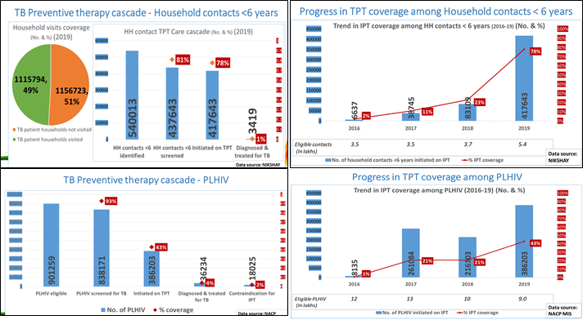

1. Since 2017, National TB and HIV programmes have also demonstrated momentum in improving the coverage of TPT for PLHIV (Fig 37). Close to 65 percent of PLHIV on treatment have received TPT till December 2019.
2. NTEP is also currently testing operational feasibility of the WHO mobile application to strengthen recording and reporting of cascade of care for TB preventive treatment.

**22.3 CHALLENGES REMAIN**

1. While important first steps have been taken by NTEP to start TPT interventions, the challenges primarily relate to strategy and execution of the strategy.
   1. Strategy related
      1. Low priority accorded to TB preventive treatment by national TB and HIV programmes
      2. Restrictive eligibility criteria for TB preventive treatment
      3. Shorter regimen of TB preventive treatment yet to be implemented
   2. Operational
      1. Low coverage of household contact investigation
      2. TPT coverage in identified key populations (Children <5 years and PLHIV) is sub-optimal in most of the states.
      3. Low coverage of TPT among PLHIV newly enrolled in care
      4. Contact investigation non-existent for TB patients detected and notified from private sector
      5. Missing cascade data (Nikshay/patient records)
      6. Limited TPT adherence real time digital monitoring and support system

**22.4 THE WAY FORWARD (Interventions / Activities)**

**2.1.1 Saturation of TPT and monitoring in PLHIV and paediatric contact of active TB patient (expansion to other age group of contacts and selected groups including health care workers in stages) – use contact investigation as entry point for provision of TPT for eligible contacts.**

2.1.1.1 Secure the funding and resources to support the planned rapid scale-up of TB preventive services to reach 5 million per year and cover all eligible individuals by 2025 with TPT.

2.1.1.2 Establish a TB prevention cellat national- and state-level

2.1.1.3 Integrate TB preventive services in all ACF efforts at health facilities, in communities and among vulnerable populations and public private initiatives

2.1.1.4 Strengthen household contact screening and evaluation by developing and providing a package of financial incentives for service providers (public and private) to ensure complete coverage of household contact investigation, initiation of TB preventive treatment and follow-up to complete the course of preventive treatment and providing additional human resources at district- and state-level to support, supervise and monitor implementation.

2.1.1.5 Start a nationwide scale up-up campaign to achieve universal TPT coverage for all PLHIV in care and child (under five-years of age) household contacts of notified TB patients with the goal to achieve universal coverage among these two eligible groups by 2021.

2.1.1.6 Strengthen monitoring and evaluation by ensuring capture of data on cascade of care for TPT in the Nikshay platform as well as scaling up digital tools such as LTBI mobile application/contact register for systematic recording of cascade data. These efforts should also include establishment of mechanism to assess TPT completion and monitoring of TB among health care workers. Appropriate preventive treatment regimen for health care workers to be instituted.

**2.1.2 Fast track approvals and phase wise capacity augmentation for detection of latent TB infection: TST, 4th gen IGRA, POC to detect infection (CTB)**

**2.1.3 Rapidly adopt and scale-up use of newer and effective TPT diagnostics and shorter rifamycin-based TB preventive treatment regimen (3HP, 1HP, 3HR, 4R)**

2.1.3.1 Considering the rapid scale-up of molecular diagnostics, the National programme will explore TPT for contacts of DR-TB patients based on drug susceptibility patterns of index cases.

2.1.3.2 Establish mechanisms for TPT adherence support and adverse events monitoring to ensure prompt action and management of the rare adverse events

2.1.3.2 The National programme will consider procurement of technology-based tools for adherence support to support the shorter regimen treatment (e.g., ICT, IDAT).

**2.1.4 Research and fast tracking adoption of new products and innovations**

2.1.4.1 India TB Research consortium (ITRC) involved in designing and validating new vaccine candidates. Several potential vaccines candidates are identified and work is progressing- VPM1002 (Live recombinant vaccine from the Serum Institute), ID93/ GLA-SE (recombinant protein vaccine, discovered by Infectious Disease Research Institute, Seattle), M72/ AS01 (recombinant protein vaccine by GSK, Belgium), MIP (whole cell inactivated vaccine, Cadila Pharmaceuticals in collaboration with the Department of Biotechnology, DAR 901. Two the candidates (VPM1002 and MIP) are now in Phase III trials.

2.1.4.2 Government of India to continue to support vaccine research and fast-track clinical trials and necessary regulatory approvals so the products could progress to next stage of validation.

2.1.4.3 Ministry of health to fast-track validation and roll out of LTBI diagnostic tests e.g. C-Tb, next generation IGRA

2.1.4.4 To address concerns around high background INH resistance, the national programme may consider use of shorter rifamycin based regimen (e.g. 4R), enhance coverage of drug sensitivity testing of index cases (including patients notified from private) and generate evidence around use of index case DST guided preventive treatment regimen among eligible contacts of DRTB. These data may inform global guidance for management of contacts of drug resistant TB cases.

# **Chapter 23**

**NSP STRATEGIC AREA 2.2**

# **AIrborne infection control**

**23.1 INTRODUCTION**

Infection prevention and control (IPC) measures in health-care settings are of central importance to the safety of patients, health-care workers and the environment, and to the management of communicable disease threats to the global and local community. Application of basic IPC precautions, such as Standard Precautions, is a cornerstone for providing safe health care. In an era of emerging and re-emerging infectious diseases and the recent COVID-19 pandemic, IPC in health care is a critical step now. It is hoped that with the enhanced awareness about Acute respiratory infections (ARIs), modes of transmission through droplets, infectious respiratory aerosols, or contact will change the way of living of Indian’s which will be more oriented towards precautionary and preventive measures; as has been the case with COVID 19. Face masks, indiscriminate spitting, cough hygiene practices, and other civic responsibilities during the pandemic is expected to continue, given the exhortation by the Prime Minister and heightened awareness about disease transmission and safety measures during the pandemic.

**23.2 PROGRESS MADE SO FAR**

1. National guidelines on airborne infection control in all health settings including HIV care settings were developed that included a combination of simple managerial, administrative, environmental and personal protection measures.
2. Good practice with regards to Airborne Infection Control (AIC) in states can be scaled up. This included TB screening among healthcare worker using CBNAAT, vulnerability mapping, cough corners, AIC awareness campaigns and distribution of home AIC kits.

**23.3 CHALLENGES REMAIN**

1. AIC measures are yet to be included in Indian Public Health Standards (IPHS)
2. Low priority given to AIC by national TB and HIV programmes and overall general health system
3. Lack of implementation of AIC interventions at majority of health facilities (Public as well as Private)
4. Triage and fast tracking of symptomatic persons limited to HIV care sites only
5. Absence of consistent supply and use of personal protective equipment (e.g., N95 particulate respirator masks) (only seen in DR-TB treatment centres)
6. Inadequacyof health care workers (HCWs) screening practice and lack of data on TB among HCWs

**23.4 THE WAY FORWARD**

**2.2.1 Enhanced policy support and financial human and financial resources to mainstream AIC**

2.2.1.1. Revise the AIC Guidelines in line with the National TB Elimination programme vision and objective so as to be inclusive of community, general settings and all healthcare facilities

2.2.1.2 Advocate with the Ministry of Health/National Health Mission to approve and make available increased budget allocation that will be required to support implementation of all components of AIC as suggested in the AIC guidelines

2.2.1.3 Work with other departments for mandatory AIC measures implementation and AIC to be included as a necessary clause in NABL/NABH Accreditation of all Health care establishments in Private sector

2.2.1.4 Provide additional dedicated staff at TB unit level to coordinate, supervise and monitor systematic implementation and monitoring of AIC measures along with the expansion of TB preventive treatment services.

**2.2.2 Strengthen Airborne Infection Control (AIC) through effective implementation of administrative and environmental measures.**

2.2.2.1 Leverage ongoing initiatives e.g. scale up of health and wellness centres under the Ayushman Bharat scheme, initiatives by the NHM such as Kayakalp (promote inclusion of AIC as a criterion for awards).

2.2.2.2 Roll out a sustained national campaign for cough hygiene using e.g. mass media, awareness programmes in education institutions.

2.2.2.3 Promote AIC practices/new AIC mechanisms in public transport, promote policy for mandatory/voluntary leave for those patients who are smear or culture positive in workplaces schools and colleges.

2.2.2.4 Provide updated implementation guide and standard operating procedures (SoPs) e.g. patient flow, engineering measures at health facilities.

2.2.2.5 Promote innovations such as AIC helpdesk to identify presumptive TB and fast-track

NTEP staff to ensure compliance with national AIC guidelines mandatorily at the NTEP supported laboratories/ MDR-TB wards, leverage infection control committee meetings

2.2.2.6 Develop and disseminate IEC specific for AIC and TPT (cough hygiene/ fast tracking)

2.2.2.7 Ensure adequate supply of personal protection equipment and monitor their usage amongst health care workers and at risk groups. Supply mandatory masks to all patients with respiratory infections in hospital settings.

2.2.2.8 Provide AIC Kits to all TB patients

# **NSP PILLAR 3**

# **DETECT ALL**

# **Chapter 24**

**NSP STRATEGIC AREA 3.1**

# **Laboratory and Diagnostic systems**

**24.1 INTRODUCTION**

Reaching the goal of END TB requires putting in place models and methods to provide prompt and quality assured diagnosis to populations at par. The interventions to be undertaken are as follows. As India intensifies its efforts to improve diagnosis and treatment and close the incidence–notification gap, the proportion of notified cases, that are bacteriologically confirmed, needs to be monitored and improved to ensure that people are correctly diagnosed and started on the most effective treatment regimen as early as possible. Closing the incidence-treatment enrolment gap for MDR/RR-TB requires increasing one or more of the following: the proportion of TB cases detected; the proportion of TB cases bacteriologically confirmed; the proportion of bacteriologically confirmed cases tested for drug resistance; and the proportion of detected cases of MDR/RR-TB started on appropriate treatment.[46]

**24.2 PROGRESS MADE SO FAR**

Prompt diagnosis of active pulmonary TB is a priority for ending TB, both for treating the individual and also as a public health intervention to reduce transmission.

1. All diagnostic tests are available free of direct cost at all TB service delivery points in public sector.
2. Sputum collection and transport system have been developed and rolled out, esp. for presumptive MDR TB. GOI signed an MOU with Indian Postal Services to facilitate sputum collection and transport mechanisms from periphery to CBNAAT sites/CDST labs under strict biohazard precautions.
3. With the expansion of diagnostic tests available at Designated Microscopy Centres (DMCs) – (not just limited to sputum microscopy) - the term DMC is replaced with **Tuberculosis Diagnostic Centres (TDCs).**
4. The decentralization of TB and DRTB diagnostic services, with ‘Nucleic Acid Amplification Test (NAAT) and other rapid diagnostic tests’, will continue in NSP 2020-25 period so that the NTEP offers DST guided treatment to all TB patients.
5. In 2019, NTEP screened ~12 million symptomatic using microscopy and / rapid molecular test. Framed policies and implemented strategies like U-DST, introduction of INH mono/poly regimen, shorter MDR-TB regimen and all oral longer regimen. 56% of notified patients were provided U-DST. 338000 FL-LPA and 72000 SL-LPA. LC-DST for Moxifloxacin was offered to 16600 patients to aid clinical judgement.
6. To ensure complete diagnostic coverage, laboratory network has been scaled up and will be further expanded based on requirement.
7. Expansion of diagnostic facilities coverage over the last 2 years has been significant as is seen in the information below.

**Table 14: Diagnostic facilities under NTEP**

|  |  |  |
| --- | --- | --- |
| **Diagnostic unit** | **2017** | **2019** |
| TDC (formerly called DMC) | 13,008 | 20,356 |
| NAAT – (TrueNat) | -- | 350 (Orders for an additional 1512 machines placed and to be delivered in 2020) |
| NAAT- CBNAAT | 628 | 1230 |
| LPA | 54 | 64 |
| LC-DST | 33 | 50 |
| Private Sector / NGO | 15 | 19 |

1. First National Drug Resistance Survey (NDRS) conducted in 2015-16 has provided new insights on various drug resistance patterns. It is the first step towards building capacity for setting up continuous surveillance systems in the country.
2. National TB prevalence survey is currently underway which will provide state specific prevalence of TB.

**24.3 CHALLENGES REMAIN**

1. Implementation of algorithm for DSTB due to lack of X-Ray facilities in the periphery as all presumptive TB requires up-front Microscopy as well as X-Ray in the algorithm for DSTB diagnosis. Similarly, for the DR-TB algorithm, challenge remains with sample collection and transportation as the starting point is NAAT tests for all notified TB patients, presumptive TB among the key and vulnerable population and non-responders to anti-TB treatment.
2. Specimen collection and transportation for diagnosis is sub optimal.
3. Ensuring last mile access to quality diagnostics for the presumptive TB cases in the remote corners of the country.
4. Diagnostic coverage for patients availing services from the private sector remains a challenge
5. NAAT / other modern diagnostics facilities in the private sector yet to be completely harnessed by the program.
6. Review of Laboratory work loads, network optimization and technology landscaping are lacking
7. Non availability and / or underutilization of X-ray facilities at periphery adversely affects screening as well as diagnosis.
8. Turnaround time from TB/DRTB diagnosis to test result reporting is delayed (high sample loads and improper interpretation and application of the prescribed diagnostic algorithm).
9. Potential for compromised biosafety within the TB laboratory network continues (space constraints, delays in maintenance of TB containment unit and timely procurement of spare parts).
10. Rapid expansion of the Lab network led to sub optimal supervision and monitoring for Quality Assurance, especially at peripheral level.
11. Retention of skilled human resource (transition from FIND) and requirement of additional work force.

**24.4 THE** **WAY FORWARD**

The way forward is for the NTEP to ensure provision of diagnostic services with a focus on revised laboratory expansion plan, planning for scale-up of new diagnostics within the revised TOG, promotion of rapid detection of TB (all forms) in both adults and children and public-private partnerships for laboratory testing and specimen transport. Specifically minimize patient-important TATs (time from diagnosis to taking action on a test result) to avoid delays in diagnosis and initiation of appropriate therapy as well as loss to follow. Use a systems approach to develop a robust, patient-centric diagnostic system that emphasizes access to quality-assured rapid molecular tests and ensures the timely flow of specimens and information.

**3.1.1. Enhance the use of novel and improved strategies to enable diagnosis of latent as well as active TB (including DR TB)**

**3.1.1.1** Rapid / prioritized transition of TB diagnosis from smear microscopy to molecular testing using NAAT right up to the Block level. AFB-smear microscopy will continue to have an important role in treatment monitoring and screening for NTM.

**3.1.1.2** Expedite evaluation, approvals, and implementation of new WHO/GoI endorsed technology into the diagnostic algorithm so as to enable testing for both first as well as second line resistance at the block and district level itself.

**3.1.1.3** Introduction of Point of Care (POC) sequencing platform when available (expected within 1 – 2 years), to support lineage determination and prediction of drug resistance at the district level to help guide treatment decisions accurately.

**3.1.1.4** Roll out the use of approved tests (IGRA, C-Tb, etc.) for LTBI detection, initially for LTBI among high risk groups like contacts and progressively other populations.

**3.1.1.5** Roll out the use of novel skin tests like C-Tb to support the diagnosis of pediatric TB as a replacement for the conventional PPD based TST.

**3.1.1.6** Scale up culture follow ups for TB patients (DS, H mono poly and DR TB) by need based augmentation of capacity by provision of MGIT 320 machines to identified high burden districts.

**3.1.1.7** Enable access to digital X-Ray for screening presumptive TB cases at the PHI level. Leverage Artificial Intelligence based tools to increase access to radiology services. Use innovative approaches like linkages with existing private Labs, use of portable (vehicle or back mounted) X-Ray machines, prioritized repair / procurement of digital X-Ray machines, linkages to free diagnostic schemes etc.

3.1.1.8 Introduction of next generation whole genome sequencing to evaluate resistance associated mutations and heteroresistance.

**3.1.2. Strengthen the laboratory and diagnostic systems**

**3.1.2.1.** Update the National TB Laboratory Policy and develop documents for TB Lab Biosafety, Preventive Maintenance and Laboratory Management

**3.1.2.2.** Conduct a nation-wide Laboratory network utilization and optimization assessment to understand the work load and rationally deploy appropriate, need based technologies.

**3.1.2.3.** Build capacity of existing network for detection of Zoonotic TB, LTBI and NTM using conventional and molecular technologies and establish collaborations with national institutes with expertise in these areas.

**3.1.2.4.** Identify sustainable measures and models for timely, effective and eco-friendly specimen transport mechanisms.

**3.1.2.5.** Urgently identify and enable ICT based solutions for seamless connectivity of all peripherally placed diagnostic technologies to Nikshay. Initiate steps to harness available and upcoming telemedicine and artificial intelligence (AI) based tools.

**3.1.2.6.** Establishment of one Nodal Centre for analytics for Whole Genome Sequencing (WGS), therapeutic drug monitoring and a central repository for Mycobacteria.

**3.1.2.7.** Expanding coverage of NABL accreditation and certification for the entire Lab network in India.

**3.1.2.8.** Expansion of EQA to cover all NAAT technologies to be scaled up.

**3.1.2.9.** Capacity building of the programme/lab staff for in house equipment Calibration and maintenance activities

**3.1.2.10.** Make provision for an in-house Bio Medical Engineer for the C-DST Labs

**3.1.3 Strengthen efficient specimen transport to improve TB detection**

3.1.3.1 Monitor and document key performance indicators for specimen referral and results reporting, especially turnaround times. Initiate corrective actions to minimize TATs for referral for NAAT, LPA, culture, and DST

3.1.3.2 Perform a network optimization study of the specimen referral and results reporting system

* Use network planning, simulation or optimization tools for design and planning with an emphasis on access to services and patient flow through the diagnostics cascade
* The optimal specimen referral pathway may vary by geography and local epidemiology and infrastructure

3.1.3.3 Explore the use of the PPSA model to facilitate specimen collection and transport for NAAT and other testing (e.g., LPA, culture, DST)

3.1.3.4 Streamline the specimen collection process to ensure that there is minimal number of visits needed to get the diagnosis and NAAT. This will involve collecting specimens for smear microscopy; storing all specimens while smear testing is done and sending the stored specimen to the CBNAAT site for any newly diagnosed smear-positive patient. Conduct training to ensure capacity and competency for collection of quality sputum specimens and specimens from children and presumptive EP-TB

**3.1.4. Enhance biosafety and biosecurity in TB diagnostic labs-** **Biosafety audit to be undertaken in all TB diagnostic labs**

# **Chapter 25**

**NSP STRATEGIC AREA 3.2**

# **TB CASE finding**

**25.1 INTRODUCTION**

Early identification of people with a high probability of having active TB (presumptive TB) is the most important activity of the case finding strategy. Passive case finding has been the mainstay of case finding under NTEP for a considerable time. However passive case finding alone leads to missed cases or delayed diagnosis. Enhanced outreach activities to detect more TB cases are critical to universal access. An active case finding (ACF) campaign is a proven effective way to achieve this. Screening for TB has also to be undertaken at every point of contact with health care workers among key population including clinically and socially vulnerable group of people.

**25.2 PROGRESS MADE SO FAR**

1. To improve the integration with general health system, 5082 TB Units (TUs) were aligned and reporting as on March 2016.
2. Decentralization of Tuberculosis Diagnostic Centres (TDCs) to PHI levels where a binocular microscope and trained LTs are available.
3. By virtue of every district having access to at-least one rapid molecular diagnostic facility, it is possible to test all the vulnerable populations of Pediatric, Extra Pulmonary and PLHIV including smear negative for TB.
4. Also, all the diagnosed TB patients, including non-responders to treatment, are now offered Universal Drug susceptibility testing
5. NTEP has conducted an analysis of the burden of TB amongst the vulnerable populations who were reached out to using active case finding methods in the year 2019. Twenty eight subset of the vulnerable populations (Table 13) are being systematically screened for TB. A total of 71,366,938 were screened for TB symptoms out of which 7692 (2%) were diagnosed as TB. The analysis of data from the last 3 years highlights the yield (numbers needed to be screened) for prioritizing case detection activities amongst the vulnerable population. The analysis reiterates the focus of the programmes on congregate setting including orphanages/ institutional Homes, and prisons inmates.

**Table 15: Yield from case finding activities amongst vulnerable population**

|  |  |  |
| --- | --- | --- |
| **Type of population** | **Screened population** | **NNS** |
| Orphanages/ Institutional Homes | 146083 | 1316 |
| Prisons inmates | 205674 | 1390 |
| Night shelters/ Home less/ Street Children | 63345 | 1980 |
| Tribal | 1783562 | 2509 |
| Populations/ areas groups with known high malnutrition | 3770404 | 2517 |
| Labourers | 7282005 | 2735 |
| Villages with special criteria | 30127350 | 2794 |
| NACO/SACS identified HRG for HIV | 1456548 | 3333 |
| Other | 46347899 | 3937 |
| Refugee camps | 50255 | 4188 |
| Slum | 36881250 | 4670 |

NNS = Number Needed to Screen (numerator = population screen, denominator = patients diagnosed)

**25.3 CHALLENGES REMAIN**

1. Lack of awareness in the community on TB diagnostic facilities in the programme (patient pathway - largely multiple consultations leading to delays)
2. Case finding is still largely passive
3. Lack of proper and adequate screening of presumptive cases due to limited access to X-Ray facilities.
4. Lack of access to the latest NAAT based tests, which are more sensitive than the currently used sputum microscopy, at the peripheral health institutions.
5. The yield of Active Case Finding (ACF) and Intensive Case Finding (ICF) is low and the screening is resource intensive.
6. Lack of adequate sample collection and transport mechanisms at all service delivery points (Public as well as Private) for prompt diagnosis.
7. Active case finding in at-risk groups and repeating the activity periodically has been a challenge.
8. Although rapid strides have been made in engaging with the private sector, the coverage isn’t commensurate with the size of the sector. Awareness in the private sector on correctly diagnosing TB still remains a challenge.
9. Non availability of an accurate, economical and standardized test to rapidly diagnose LTBI.

**25.4 THE WAY FORWARD**

To ensure the early and complete detection of all TB patients the NTEP will continue to implement intensified case finding strategies and addressing high risk populations. In addition, it will prioritize conducting, documenting and monitoring systematic contact tracing while holding the program accountable for completeness and quality of contact tracing, perhaps, by including contact tracing in state scoring system.

An enhanced focus on ACF/ICF on vulnerable populations and individuals and use sensitive tests to improve yield will be undertaken. It is also important to make ACF more efficient and less resource consuming.

**3.2.1 Integrated diagnostic algorithm to detect all forms of TB (latent, active, and DR-TB):** Design and implement an integrated diagnostic algorithm to detect and manage all forms of TB (active, latent, DR, Sub Clinical, Zoonotic, NTM) and also to enable testing for both first as well as second line resistance at the block and district level itself. Adopting a diagnostic algorithm in which, post screening by X-Ray, a NAAT based WRD is the initial diagnostic test offered to all people with signs or symptoms of TB is the first step towards better case finding.

**3.2.2. Integration of TB diagnosis within the existing health system for extensive outreach** **for public awareness, TB service demand generation, early detection and referral to nearest TB service delivery point**

**3.3.3. Predictive analytics use for hot spot identification, vulnerability mapping**

**3.3.4 Systematic screening of high-risk groups through outreach and community-based approaches using digital x-rays and rapid and more sensitive diagnostic tools**

**Active case finding (ACF)** activity in vulnerable groups is a focus over the next five years. The prioritization of vulnerable groups for screening and ACF is as follows:

**Table 16: Prioritization of vulnerable groups**

|  |  |  |  |
| --- | --- | --- | --- |
| **Priority** | **Urban area** | **Rural area** | **Tribal area** |
| 1 | Slum | Difficult to reach villages | Difficult to reach villages and hamlets |
| 2 | Prisons inmates | Mine workers | Villages with known  higher case load |
| 3 | Old Age homes | Stone crusher workers | Tribal school hostels |
| 4 | Construction site workers | Populations groups with high malnutrition | Areas with high malnutrition |
| 5 | Refugee camps | NACO/SACS identified high risk group for HIV | Villages seeking care from traditional healers |
| 6 | Night shelters | Weaving and Glass industrial workers | Tribal areas with little ventilated huts |
| 7 | NACO/SACS  identified high risk group for HIV | Cotton mill workers |  |
| 8 | Homeless | Unorganized labour |  |
| 9 | Street children | Tea garden workers |  |
| 10 | Orphanages | Villages largely seeking care from traditional healers |  |
| 11 | Homes for destitute |  |  |
| 12 | Asylums |  |  |

3.3.4.1 Sensitization of the political and administrative leadership in the states.

3.3.4.2 Identify and map high risk / vulnerable population in local area.

3.3.4.3 Active case finding in a campaign mode conducted in 3 rounds during the year.

3.3.4.4 Large scale IEC through print and electronic mass media and local channels about the campaign

**3.3.5 Systematic screening for symptoms in health care institutions/ OPDs**

3.3.5.1 Put in place administrative measures to identify and fast track the chest symptomatic attending OPDs and other clinical set ups to enable rapid consultations and investigations, thus minimizing transmission rates in hospital OPDs

**3.3.6 Intensified contact tracing/investigation: to cover baseline and follow up**

3.3.6.1 Monitor and supervise quality and completeness of contact tracing

3.3.6.2 Hold the program accountable for completeness and quality of contact tracing, by including in state scoring system.

3.3.6.3 Ensure that reverse contact tracing of pediatric TB patients to identify the index case is done for all pediatric TB patients

3.3.6.4 Repeat contact tracing at end of treatment and during follow-up to detect newly developed cases and document treatment outcome

3.3.6.5 Ensure availability **of testing (TST, IGRA, etc.) and follow-up (TPT) for contacts** and link to appropriate TB treatment or TB preventive treatment.

# **NSP PILLAR 4**

# **TREAT ALL**

# **Chapter 26**

**NSP STRATEGIC AREA 4.1**

# **treatment of DSTB**

**26.1 INTRODUCTION**

Universal access to free, standard treatment services for all TB patients in the country encompass an ambit of services in and around each patient’s care cascade. Strengthening of these patient centered treatment services in NTEP with enhanced capacity to rapidly accommodate new drugs and treatment modalities will be the cornerstone of the NSP 2020-25 .

**26.2 THE PROGRESS SO FAR**

1. Pan country roll-out of Injection free regimen (FDCs) for DS-TB
2. Increase in the proportion of patient put on treatment is 92%
3. Access to free drugs for private sector - 8% of private notified patients
4. With rapid expansion of molecular diagnostics in last 3 years, India now has decentralized the molecular test for DR TB detection and subsequent linkage for treatment initiation at district level
5. Post treatment follow up till 2 years after completion of the anti-TB treatment (follow-up policy at 6, 12, 18 and 24 months post-treatment) for ensuring relapse free cure
6. Treatment success rate – DS TB (80%)
7. More than 500,000 treatment supporter for patient centric treatment provision
8. India has developed, deployed, and evaluated the worlds only integrated digital adherence technology solution, providing patients and providers with choices of adherence support and monitoring technologies.
9. Leveraging NIKSHAY, India has developed escalation protocols based on information from digital adherence technologies, to inform and enable more differentiated patient care

**26.3 CHALLENGES REMAIN**

1. DST services in many states are sub-optimal leading to a compromise in initiating the patients on appropriate treatment regimen.
2. Quality issues such as delay in obtaining laboratory results and consequent delay in initiation of treatment.
3. Sub-optimal implementation of ADR management and aDSM.
4. Uptake of Digital Adherence Technologies (DAT) for adherence monitoring is insufficient and is not being uniformly implemented in all the states.
5. Lack of information on the long-term outcomes of treatments which makes it difficult to establish efficacy of long term follow-up as envisaged in the NSP 2017 2025.
6. Measuring the quality of care in private sector is a challenge as PPs have no means to ensure treatment adherence/compliance.
7. TPT coverage in identified key populations (Children <5 years and PLHIV) is sub-optimal in most of the states.
8. Inadequate provision of palliative care and rehabilitation services for the difficult to manage cases

**26.4 THE WAY FORWARD**

* + 1. **Continue with the current modalities for treatment that include regimens for DSTB using daily** FDCs as per patient’s weight band (5 weight bands) with augmented continuation phase and intensified treatment support systems using ICT.
    2. **Implement activities for the prevention of relapse and development of drug resistance in pan** sensitive patients during first line standard treatment:
       1. Concurrent baseline investigation along with treatment initiation
       2. Therapeutic drug monitoring services for patients to be available on demand from the provider
       3. Option of regular and long-term post-treatment follow-up of TB patients to identify relapse early and detection and management of post TB sequels explaining the role of health care workers at different levels and linkages.
       4. Ensure linkages for management of co-morbid conditions
       5. Engage patient support system to improve patient compliance
       6. Address issues of migration and patient transfer on real-time basis utilizing the NIKSHAY platform ensuring linkage for un-interrupted treatment for the patients.
       7. aDSM toolkit to be implemented to improve ADR management, timely reporting and monitoring through NIKSHAY.
    3. **Care cascade monitoring:** system issues in the care cascade of a TB patient need to be addressed through regular good-quality trainings
       1. Utilization of e-platforms such as ECHO, Swasthya Gurukul or e-samikhsha portal for conducting e-trainings to augment the efforts of modular trainings.
       2. Institute mechanisms to measure the quality of trainings.
    4. **Expanding options for adherence monitoring and supervision**
       1. Combination of DAT with traditional adherence support mechanisms will be utilized as suited for individual patients. This will include 1) Digital adherence technology (**99DOTS for DSTB/ MERM for DRTB and Paediatric TB**) in addition to **family members as treatment supporters**; 2) Community based (involving **ASHA or other community member)/Institutional treatment supporte**r; 3) In cases like sick and bed ridden patients or children, a family member to be the treatment supporter; and 4) **Refill monitoring:** Digitized prescription refill information in Nikshay will be used to estimate the number of days the patient missed doses based on subsequent refill dates, indicating a proxy for medication possession.
       2. **Automated reminders** on treatment initiation, interruption and follow up through the Nikshay platform.
       3. **Offline app for patient education**. Information regarding TB diagnostic and treatment services, enablers, grievance through call center support will be linked on the app through e-Nikshay.
       4. NIKSHAY Aushadi and NIKSHAY will be placed on the same platform with direct bridge for understanding drug stock for notified TB patients, forecast of needed drugs and available stock out if any.
    5. **Improving Clinical support**
       1. Utilization of updated and appropriately located Ready Reckoners, pamphlets, job-aids for easy reference for all health care providers at all levels for prompt clinical decision
       2. Develop and incorporate **‘Clinical Decision Support’ (CDS) Tool** into Nikshay.
       3. Establish a **Tuberculosis Warm-Line** through which Physicians, para-medical staffs and other health professionals dealing with TB patients can seek support and consultations from a group of dedicated teams of experts consisting of physicians and para-medics.
    6. **Enhanced Care:** TB patients will be assessed on parameters like Body Mass Index (BMI), severity of illness, alcohol and substance abuse, depression, and stigma. NTEP staff will screen for various risk criteria that meet a critical threshold for requiring “Enhanced Care” and link to appropriate care described in chapter 28 on Priority Populations.

# **Chapter 27**

**NSP STRATEGIC AREA 4.2**

# **TReatment of Drug resistant tb**

**27.1 INTRODUCTION**

With the rapid expansion of molecular diagnostics in the last three years, India now has each district offering molecular tests and subsequent linkage with CDST lab. The NSP 2017-25 achieved rapid decentralization of DRTB diagnosis and treatment centres and developed innovative models for treatment adherence monitoring e.g. Integrated Digital Adherence Technology (IDAT). The NTEP will further explore patient-friendly adherence monitoring mechanisms to improve success rates in line with WHO’s End TB Strategy.

**27.2 THE PROGRESS SO FAR:**

1. The NTEP has progressed from establishment of TDCs and treatment support centres in medical college to arriving at a policy decision to have Nodal DRTB ward in all medical colleges along with Antiretroviral Therapy (ART) centre. This will strengthen the capacity of the country to fight DRTB epidemic as well as HIV TB epidemic
2. Based on WHOs recommendations, drug resistance TB guidelines have been modified and 10 states have launched all oral regimen in 2019. India in 2020 and onwards will implement all oral regimen for all DRTB patients to reduce loss to follow up and adverse drug reactions. Pan country roll-out of all oral longer regimen for DR TB patients’. Newer drugs like Bedaquiline and Delamanid are also introduced for drug resistant TB patients
3. NTEP will strive to keep national guidelines simplified for ease of understanding and implementation on the ground, achieving a higher treatment completion rate and ultimately >90% success rates for all TB patients.
4. To address the menace of Drug Resistance TB and to substantially reduce the catastrophic cost to TB patient, program has not only initiated Universal Drug Susceptibility Testing (UDST) with expanded molecular diagnostics like CBNAAT (1180) and TrueNat (350) but has also taken a decision to offer first line and second line probe assay for additional drug resistance detection (H, E, Z, FQ and SLI) for all notified TB patients.
5. This NSP 2020-25 aims to offer Linezolid, Bedaquiline, Delamanid and Pretomanid drug susceptibility tests once endorsed by WHO so that all TB patients get appropriate DSTB and DRTB regimen based on their DST patterns which in turn will yield better success rates.
6. Apart from measurement of weight for deciding the weight band criteria for first-line and second-line drugs, NTEP will incorporate Body Mass Index (BMI) calculation for all TB patients and will strategize for nutritional counseling and other social support schemes to address component of malnutrition apart from ongoing NIKSHAY Poshan Yojana (NPY)
7. NIKSHAY and other IT-based analytics will boost the data compilation on a real-time basis and expedite the local level action for ensuring diagnosed all TB patient’s appropriate follow up till the end of TB treatment and thereafter using life cycle approach.
8. NTEP will be open to new proven healthcare worker-friendly new diagnostic tests for early detection of TB and novel adherence mechanism for establishing more than 90% success rate for all TB patients.
9. The country now has nationwide coverage of the Bedaquiline based regimen and has also introduced Delamanid based regimen for improving the treatment outcome among DRTB patients. The utilization of these drugs is dependent on the utilization of extended second-line DST services and can’t be improved rapidly without addressing the health system challenges, rapid laboratory expansion and shorter turnaround time using digital technology to expedite rational evidence-based decision making for regimen change or switching to a new drug regimen for the TB patient.
10. People-centric planning, research framework for addressing challenges in uptake of DST as well as new drug regimen will be few of the priorities for program in period 2020-25 to address the missing 1/2 MDRTB patients out of the estimated 130000 MDRTB cases. Treatment success rate – MDR RR TB Shorter MDR TB – 59%, MDR RR TB longer regimen 48%, H mono/poly regimen – 75%
11. Private sector TB patients can be linked to NTEP new drug regimen post notification in NIKSHAY system free of cost but operational challenges, barriers to access of new drugs from NTP by private-sector TB patients and concrete evidence-based solutions are yet to yield results in the form of rapid improvement in private sector DRTB patient treatment linkage.
12. With current efforts, the country could detect 66255(51%) MDRTB patients (2019) and 49% of estimated 130000 MDRTB patients are yet to be reached out for appropriate TB treatment linkage.
13. 54 Districts in the country without district DRTB treatment center out of which 2 districts are among the aspirational districts and offer challenging conditions with inadequate health infrastructure and accessibility issues.
14. A smart DR-TB Medication Event Reminder Monitor (MERM) which organizes a patient’s medication, provides dosing instructions, and monitors medication adherence has been developed and preliminarily evaluated by India’s NIRT Chennai for patient and provider acceptability.

**27.3 CHALLENGES REMAIN**

1. There has been frequent updates in the WHO guidelines which makes it challenging for programme staffs to adapt
2. Quality issues such as delay in obtaining laboratory results and consequent delay in initiation of treatment.
3. Currently multiple regimens for DRTB makes it challenging for uptake of these regimens.
4. Uptake of these Digital Adherence Technologies (DAT) for adherence monitoring is insufficient and is not being uniformly implemented in all the states.
5. Lack of information on the long-term outcomes of treatments which makes it difficult to establish efficacy on long term follow-up as envisaged in the previous NSP.
6. Sub-optimal implementation of ADR management and Active Drug Safety Monitoring (aDSM).
7. DST services in many states is sub-optimal leading to compromise in initiating the patients on appropriate treatment regimen.
8. Measuring the quality of care in private sector is a challenge as PPs have no means to ensure treatment adherence/compliance.
9. Inadequate provision of palliative care and rehabilitation services for the difficult to manage cases

**27.4 THE WAY FORWARD**

**4.2.1 Introduction of effective regimens with shorter duration for both adults and paediatric patients**

4.2.1.1 Rapid approval of national technical expert committee; simultaneously, procurement of required drugs based on the forecasting and quantification

4.2.1.2 Conduct trainings starting from National, state, district level including private sectors within public health system with the support of partners wherever required.

4.2.1.3 Implementation and intensive monitoring till the achievement of nationwide coverage of all oral injection free shorter MDR regimen and also new regimens that may keep emerging (E.g.: BPaL)

4.2.1.4 Introduction of supportive system of e-trainings, Decision Support System, ADR management tool, etc.

4.2.1.5 Tracking timely follow up of all patient initiated on treatment

Extensive monitoring at state and district level through monthly/quarterly coordination meetings among NAAT sites and N/DDR TBC

4.2.1.6 Introduction of child friendly formulations for DR-TB.

4.2.1.6 Strengthen the network of specimen collection centers for paediatric TB and EPTB.

**4.2.2 Estimate the burden of Non-tuberculous Mycobacteria (NTM) and establish a protocol to address the problem**

Nontuberculous mycobacterial (NTM) compared to TB is more challenging to manage, beginning with diagnosis and extending through treatment. Factors peculiar to NTM disease such as extensive microbial resistance mechanisms and difficult to interpret, in vitro drug susceptibility patterns are common clinical management challenges. Because the prevalence of NTM is rising, it is increasingly necessary to understand those unique aspects of NTM lung disease diagnosis and treatment that differ from tuberculosis and there is a need to incorporate the protocol to understand the NTM situation in India.

4.2.2.1 Develop protocol for diagnosis and management of NTM under programmatic condition

4.2.2.2 Upgradation of laboratory network to improve the access to diagnosis of NTM

4.2.2.3 Phase wise implementation of services under programmatic condition Ensuring availability of drugs and establishment of treatment initiating facility

4.2.2.4 Promote research to generate evidences for effective diagnostic tool, treatment regimens and other supportive mechanism to improve the outcome.

**4.2.3 Surgical, Palliative care and rehabilitation: Build capacity and linkages to existing programs for palliative care and rehabilitation.**

 Even though surgical option is rarely offered along with treatment of DS TB, it can be an important intervention. Selection of ideal patient for surgical intervention and linking the patient to quality surgical services is essential to obtain the benefit of surgical intervention. A very small proportion of patient may require hospitalization during initial or terminal stage. Model of care will be established to provide end-of-life care and proper TB infection control to patients who have no effective treatment alternatives.

**4.2.3.1** Country wide mapping of availability of services including private/ NGO/other sectors.

Development of patient selection protocol and escalation protocol for appropriate referral of patients; capacity building of field staff and medical officer

**4.2.3.2** Establishment of geographical linkages between institutions and coverage areas.

**4.2.3.3** Resource allocation and capacity building of health institutes to enhance coverage and type of surgical services provided.

**4.2.3.4** Initial pilot in selected health facilities followed by evidence based expansion of services through various modalities including partnership options.

**4.2.3.5** Operational research to understand the cost effectiveness and cost-benefit analysis of palliative and rehabilitation services.

**4.2.3.6 Put in place robust systems for post-treatment rehabilitation:**

1. Peer to peer counselling can be a low-cost high-impact strategy to address some of these issues. Institutional provisions, must be put in place if individuals are to successfully complete treatment, and return to their normal lives.
2. Work out mechanisms to address “returning to jobs” or to their education, as many workplaces and educational institutions do not provide leave for extended periods. Moreover, physiological challenges like constant stigma and discrimination that individuals face from friends, family and even healthcare workers will be addressed in the strategy.
3. Provide nutritional support in the post treatment period.

**4.2.4 aDSM (Adverse Drug Safety Monitoring):**

**4.2.4.1** aDSM toolkit to be implemented to improve ADR management, timely reporting and monitoring through NIKSHAY which becomes more relevant considering the use of new drugs and regimens for DR-TB patients.

**4.2.4.2** Develop and incorporate the “Clinical Decision Tool (CDS)” into NIKSHAY

**4.2.5 Establish a Centre of Excellence for DRTB**

The National TB Elimination Programme (NTEP) is implementing a decentralized model of care for universal access to quality DR TB services. Nucleic Acid Amplification Test (NAAT) has been adopted as the first-choice diagnostic to diagnose DR TB. The country has introduced new drugs i.e., Bedaquiline and Delamanid, shorter treatment regimen (STR) and DST guided treatment regimen. Decentralised C&DST laboratory network and two-tier treatment network comprising both nodal and District DR TBC have been established in the country for DR TB diagnostic and follow up services. The institutional linkages for the referral, treatment, reporting, mentoring and monitoring in DRTB space need to be effectuated as those within the tiered diagnostic network. Therefore, NTEP is putting a lot of efforts towards **institutional strengthening** to ensure high quality patient centric DRTB services across all institutions and states and further improve detection and treatment outcomes of DRTB patients.

The NSP for TB Elimination 2020-2025, envisages expanded scope of activities of medical colleges with increasing diagnostic and treatment services in newer areas of TB control efforts. This will include establishing Centres of excellence (COEs) as a mechanism for institutional strengthening for DR-TB care. Plans are underway to establish at least five CoE in different regions of India.

Developing **Centres of excellence (CoEs)** for innovating, executing, and establishing excellence in DR-TB care and building the capacities of other institution that provide TB services will help in improving case detection and treatment success rate among DR-TB patients. CoEs will play a critical role in diffusing skills and expertise across the public and private healthcare facilities, to increase efficiencies across clinics, hospitals, laboratories and pharmacies, and enable successful treatment outcomes. The CoEs can work on a Hub and Spoke model to allow for the rapid spread of state-of-the-art tools and evidence, while simultaneously providing guidance and mentoring to spoke institution to offer standards of excellence across every state. The concept of centre of excellence may be priorities for specialized clinical services like ADR management, surgical interventions, Palliative care, Pulmonary Rehabilitation etc., As well as for the programmatic components like Monitoring and evaluation, Analytical excellence, social determinants, advocacy strategies etc.

# **Chapter 28**

**NSP STRATEGIC AREA 4.3**

# **Addressing TB in priority populations**

**28.1 INTRODUCTION**

The National Strategic Plan (2017-25) identified “Priority populations” as a disadvantaged group of people as compared to others, due to their reduced access to health services and the underlying determinants of health, posing challenges for TB control. With a higher disease burden than the general population, it is pertinent that TB burden in these special populations is adequately addressed and appropriate linkages to TB services to End TB. The current updated NSP 2020-25 continues with the same classification.

**Source: Stop TB Partnership, Global Plan to End TB – Paradigm Shift, 2015. Some groups added to match the Indian context**

**28.2 THE PROGRESS SO FAR:**

Since 2017 several new initiatives have been undertaken to expand programme reach to cover more vulnerable and affected populations.

1. In order to address the TB burden in all the priority populations in a holistic manner, TB comorbidity **collaborative mechanisms** have been put in place at the National, State and District levels, leveraging on the TB-HIV coordination mechanisms already in place. This mechanism would involve NACP, NPCDCS, NTCP, MCH, and HWC.
2. The **nodal person** for TB-comorbidities has been identified at all levels, with clear definition of the roles and responsibilities. To further strengthen the TB-HIV collaboration, District TB officers have also been nominated as District AIDS control officers.
3. **Collaborative frameworks** for TB and priority comorbidities (TB/DM, TB/tobacco, TB/nutrition, and TB/Gender) have been rolled out in addition to the existing TB-HIV collaborative framework. Scope of TB-HIV collaborative activities has been expanded to include addressing TB and HIV burden in congregate settings, vulnerable populations for HIV and pregnant women.
4. **Centres of excellence** for Pediatric TB have been established as model centers for care, support and treatment and support the programme in capacity building activities and TB elimination activities among Pediatric cases. Engagement with **Indian Academy of Pediatrics** has been strengthened through a formal MoU for engagement with private practitioners as well as expertise has been roped in for updating Pediatric TB guidelines. Mainstreaming with Child Health services has been carried out through incorporating TB screening under **Rashtriya BAL Swasthya Karyakram** (RBSK).
5. TB screening has been incorporated as an integral part of Population Based screening in Health and wellness centres along with other-comorbidities. Nutritional support being provided to all TB patients through financial support of 500 INR per month for all notified TB patient
6. **Supervision and monitoring** for TB comorbidity has been strengthened through establishing joint reporting systems, periodic data sharing with respective programmes and feedback to States, standardizing supervisory tools, undertaking joint review meetings and joint visits with respective programmes.
7. Joint **awareness** campaigns have been undertaken with respective health programmes to address HIV, Diabetes, Tobacco usage, and malnutrition burden among TB patients. Awareness activities on Nikshay Poshan Yojana has been included in Poshan Maah/Poshan Pakhwada campaigns of the Poshan Abhiyaan under the Ministry of Women and Child Development.
8. **Co-location/linkage** of TB and co-morbidity screening services have been scaled up with 87% and 73% of the tuberculosis diagnostic centres co-located with HIV and Blood sugar screening facilities and ~90% of ART centres linked to CBNAAT facilities.
9. **Coverage** of comorbidity screening among the priority population has been increasing with 81%, 64%, 57% and 46% of TB patients knowing their HIV, Blood sugar, Tobacco usage and alcohol consumption status in 2019. Among those with TB-HIV, TB-Diabetes, TB-Tobacco and TB-Alcohol usage co-morbidity, 94%/96%, 52%, 24% and 31% were linked to Anti-Retroviral/Co-trimoxazole therapy, anti-diabetic treatment, tobacco cessation centres and deaddiction services.

**28.3 CHALLENGES REMAIN**

1. Inadequate local knowledge of distribution and spread of priority population. Lack of comprehensive district specific action plan for TB elimination in priority population.
2. Wide differences in adoption of the frameworks for collaborative activities across the States, with lower priority accorded to TB elimination in priority population.
3. Knowledge gaps in health personnel involved in implementation of health programmes related to comorbidities.
4. Varying levels of decentralization/coverage of services related to comorbidities resulting in non-existent/weak linkages to comorbidity services in certain areas, resulting in challenges to the patient in accessing comorbidity care.
5. Gaps in care cascade in TB-comorbidity management resulting in suboptimal TB treatment outcomes.
6. Sub-optimal coverage/documentation of TB-comorbidity related services among TB patients notified in the private sector.
7. Existence of parallel MIS for each programme with different levels of implementation/sophistication of the data systems weakening the monitoring component and issues in data quality. Challenges in data sharing due to confidentiality issues in certain settings.
8. Minimal awareness among TB patients on role of comorbidities in risk for TB or treatment outcomes.

**28.4 THE WAY FORWARD**

**4.3.1 Common strategic interventions for strengthening TB care services in priority populations:**

**4.3.1.1** Develop district specific action plans to address TB among priority populations through identification of vulnerable populations, exhaustive dynamic mapping, prioritizing population for intervention and developing strategies/activities through a consultative/collaborative process with all stakeholders, especially affected communities.

**4.3.1.2** Enhance priority to ensure uniform country-wide adoption of frameworks for collaborative activities with oversight/review of same at highest levels

**4.3.1.3** Develop concise need-based, cadre-specific and comprehensive training materials, counseling tools including adoption of e-learning tools for implementation

**4.3.1.4** Advocacy at highest levels to ensure availability/convenient linkage of comorbidity related services at all TB care facilities to provide services to all TB patients. Effectively utilizing multi-disease testing platforms in addressing the burden of comorbidities. Leveraging IT services, including Call centre, IVRS, SMS etc. provide comorbidity counselling, early linkage to appropriate health facility and periodic follow-up. Establishing coordination with respective Ministry/Department/sector for ensuring prompt and uninterrupted service delivery. Leveraging/integrating with existing campaigns or plan new campaigns to reach priority populations based on needs and leveraging IT and IT enabled tools, screening tools and rapid diagnostics.

**4.3.1.5** Periodic review of care cascade of TB management among priority population and systematic measures to address gaps in care to improve treatment outcomes

**4.3.1.6** Leverage partnership options in expanding TB-comorbidity screening/service provision to all TB patients notified from private sector

**4.3.1.7** Develop platforms/mechanisms to inter-link information management systems across different programmes including strengthening recording and reporting of collaborative activities through data reconciliation and data driven action at all levels

**4.3.1.8** Joint, need-based and customized advocacy and communication activities for awareness of inter-relationship of TB and comorbidities

**4.3.1.9** Develop novel strategies and innovative approaches for comprehensive TB care to priority population through partnering with NGOs, civil society etc. and rapid scale up of successful interventions.

**4.3.1.10** Undertake research to enhance understanding of inter-relationship of TB and comorbidities, determine burden of TB among priority population in local settings, identify gaps in services, KAP/health seeking behaviour/feasibility studies

**4.3.2 Pediatric TB** - **strategic interventions**

**4.3.2.1** Determine burden of Pediatric TB through appropriate methodologies including inventory studies etc.

**4.3.2.2** Increase prioritization of Pediatric TB elimination activities through setting National age-disaggregated targets for TB notification.

**4.3.2.3** Expansion of Systematic screening at entry points - NRC, MCH/school health programmes

**4.3.2.4** Ensure linkage to radiography and rapid tests for TB through appropriate mechanisms, including tele-radiology

**4.3.2.5** Specimen collection methods in children, (e.g. sputum induction, naso-pharyngeal aspirate, gastric aspirate) needs to be linked to the identified centres undertaking referral activities. Stool has now been recommended as a specimen for the diagnosis of PTB in children using Xpert and with the upcoming guidance from WHO, will be rolled out accordingly.

**4.3.2.6** Address the implementation challenges of making clinical diagnosis (DS-TB and DR-TB) using the existing algorithms for paediatric TB population which included non-responders.

**4.3.2.7** Including differentiated service delivery models considering the different needs of age groups/ population groups and rolling out child friendly TB formulations for pediatric DRTB and TPT

**4.3.2.8** Enhance surveillance through monitoring of age-disaggregated numbers, strengthening contact/reverse contact tracing, ensuring linkage of child and family index case

**4.3.2.9** Scale up Centre of excellence for Pediatric TB and expand scope of activities

**4.3.2.10** Capacity building activities using all methodologies, including e-learning platforms.

**4.3.2.11 l**everaging the engagement of Indian Academy of Pediatricians for notifying all diagnosed TB patients to NTEP

**4.3.2.12** Strengthen collaboration with Child health programme and Rashtriya BAL Suraksha Karyakarm (RBSK) Programme to reach the paediatric population, spread awareness regarding TB and ensure the instant referral of symptomatic cases to nearest health facilities.

**4.3.2.13** Engage with Rashtriya Kishor Swasthya Karyakram - RKSK (Adolescent Health Programme) to address TB burden among adolescent population and ensuring psychosocial support including education for school age children and adolescent with TB

**4.3.2.14** Ensure adequate representation of the Pediatric population in operational research under the programme. Priority research areas to include sensitive point of care diagnostics (non-sputum based), validation of newer drugs/regimens and vaccines, Paediatric TB care models and effect of TB–related stigma and discrimination of children and adolescents with TB and reviewing implementation of the paediatric guidelines and evaluation of the impact of the guidelines

**4.3.2.15** Partner with the Ministry of Women and Child Development to address the missing cases in the community

**4.3.3 Malnutrition and TB** - **strategic interventions**

**4.3.3.1** Strengthen nutritional assessment and counseling of TB patients through adequate capacity building of treatment supporters/Community Health Officers, leveraging IT tools and ensuring linkages to hospitals for cases requiring admission. Empowering patients for self-assessment of nutritional status and guidance on locally available nutritious food through Nikshay mobile application.

**4.3.3.2** Scale up community based nutrition interventions and expand linkage to social support schemes/vocational training

**4.3.3.3** Intensify the linkage between NTEP and Nutrition Rehabilitation centres for TB screening among malnourished

**4.3.3.4** Research on impact of social support/assistance initiatives in Ending TB

**4.3.3.5** Expand scope of engagement under Poshan Abhiyan of Ministry of Women and Child Development

**4.3.3.6** Engage with Department of Food and Public Distribution for enhancing food security

**4.3.4 Alcohol dependence/substance use** - **strategic interventions**

**4.3.4.1** Develop of framework for TB associated with Alcohol consumption

**4.3.4.2** Roll out the framework for bi-directional screen of TB and alcohol consumption/ substance use and vice versa in De-addiction centres, Integrated Rehabilitation Centre for Addicts (IRCA) etc.

**4.3.4 .3** Ensure adequate linkage to de-addiction services

**4.3.4.4** Placement of Treatment support counsellors/Capacity building of existing counsellors/leveraging call centre support to effectively counsel TB patients

**4.3.4.5** Develop and roll-out of joint awareness campaigns to disseminate information on harmful effect of alcohol dependence/substance abuse on TB

**4.3.4.6** Involve NGOs (including Alcoholics Anonymous and networks of people using drugs) to implement, monitor and track progress on these interventions

**4.3.4.7** Establish collaboration with Ministry of Social Justice and Empowerment and National Drug Deaddiction Programme under MoHFW

**4.3.5 Tobacco use** - **strategic interventions**

**4.3.5.1** Effective involvement of NTCP in comorbidity collaborative mechanism established at all levels

**4.3.5.2** Leverage Tobacco Quit line and m-cessation initiatives of NTCP to link patients for appropriate counseling and cessation

**4.3.5.3** Expand scope of linkage to tobacco cessation services to cover Dental colleges/clinics

**4.3.5.4** Undertake research on interrelationships of Smokeless Tobacco usage and Tuberculosis.

**4.3.5.5** Engagement with National Oral Health Programme/Indian Dental Association for TB screening as part of Tobacco Intervention Initiative

**4.3.6 TB - Diabetes** - **strategic interventions**

**4.3.6.1** Expand scope and improve effectiveness of joint DM and TB screening campaigns, including Population Based screening

**4.3.6.2** Linkage of ICT based platforms of NTEP and NPCDCS – Messaging to provide effective linkage to TB and DM management services

**4.3.6.3** Engagement with Indian Diabetic Association in screening for TB/increasing awareness of risk of TB among diabetics

**4.3.7 TB-HIV** - **strategic interventions**

**4.3.7.1** Strengthen intensified case finding activities in HIV care settings, especially in Targeted Intervention sites. Saturate coverage of Provider Initiated Testing and counselling among presumptive TB cases and TB patients in private sector as well as rollout of *Single window services" in public health facilities in low burden districts.

**4.3.7.2** Ensure access of all PLHIV to rapid molecular diagnostics with prioritization. Rapid adoption of newer diagnostic technology - Urine TB-LAM etc. for fast-tracking diagnosis, improving quality of care, and reducing mortality.

**4.3.7.3** Adoption of community led models and provision of patient-centric services to ensure prompt initiation of ATT/ART/CPT, counseling, adequate follow-up, ensuing highest quality of care

**4.3.7.4** Saturation of PLHIV with TB prevention therapy and rapid adoption of newer shorter regimens. Increase focus on prevention activities, including training on AIC activities, institutionalizing Health care worker surveillance and AIC assessment of all ART/FIRAT centres with recommendations

**4.3.7.5** Expand scope of collaboration to include newer initiatives of community-based HIV testing

**4.3.8 TB-Gender** – **refer to chapter on Gender and rights**

**4.3.9 TB-Pregnancy** - **strategic interventions**

**4.3.9.1** Develop collaborative mechanism between NTEP and MCH for addressing TB among pregnant women

**4.3.9.2** Ensure screening and detection of active TB cases among pregnant and postpartum women

**4.3.9.3** Providing appropriate counselling to address nutrition and lifestyle aspects

**4.3.9.4** Strengthen referral linkages between NTEP and MCH program

**4.3.9.5** Augment treatment of TB among pregnant women

**4.3.9.6** Address TB and obstetric complications

1. Ensure screening for active TB, vaccination and chemoprophylaxis/TB treatment to newborn of pregnant mothers affected by active TB
2. Establish surveillance, and monitoring and evaluation (M&E) mechanism for collaborative activities
3. Promote research and training in issues related to TB in pregnancy
4. Engage with RMNCHA+ to effectively implement the collaborative framework

**4.3.10 TB in Congregate settings/incarcerated population** - **strategic interventions**

**4.3.10.1** Ensure collaborative efforts through the constitution of working committees on between the prison and general health services.

**4.3.10.2** Strengthen screening of new inmates and periodic screening of prisoners and penitentiary services staff to detect active TB and HIV in a timely manner.

**4.3.10.3** Provision of adequate prevention through airborne infection elimination, including protective measures for staff and preventive therapy for individuals with LTBI.

**4.3.10.4** Ensure continuity of care for released prisoners who are on treatment for TB and for individuals who are on treatment before entering the prisons.

**4.3.10.5** Provide psychological counselling and support for prisoners to improve TB treatment adherence.

**4.3.10.6** Strengthen TB elimination in prison-based programmes by raising awareness about TB among inmates and prison medical and non-medical staff. Avoid transfer of TB patients, but, in the case of transfer, improve communications between prisons to ensure treatment follow-up after transfer and facilitate transfer to community clinics for released prisoners.

**4.3.10.7** Link scientific research, including Operational Research to the development of specific knowledge about treating TB in the prison environment.

**4.3.10.8** Engaging with Ministry of Home Affairs, Ministry of Women and Child Development in effectively addressing TB burden in Prison, Swadhar/Ujjwala homes respectively, apart from other related Ministries.

**4.3.11 TB-Geriatrics**

**4.3.11.1** Develop framework to address TB among geriatric population and address special needs among the population

**4.3.11.2** Institute effective screening for TB in Old age homes and other settings and ensuring continuity of care

**4.3.11.3** Establish collaboration with National Programme for Healthcare of the Elderly (MoHFW) and Integrated Programme for senior citizens (Ministry of Social Justice and Empowerment)

**4.3.11.4** Engage with Geriatric Society of India/Indian Academy of Geriatrics/Association of Gerontology in increasing awareness on TB burden and information on availability of services

**4.3.11.5** Partner with NGOs already working with the geriatric population – HelpAge India, Manavlok, Abhoy Mission, Asha Kiran, Shraddhanand Mahilashram etc. in screening of TB and linkage to appropriate care

**4.3.12 TB-Mental Health**

**4.3.12.1** Incorporate mental health counseling component for all TB patients

**4.3.12.2** Building capacity of health personnel/counsellors at all levels in identifying TB among patients with mental disorders

**4.3.12.3** Screening of all TB patients for mental health issues and linkage to services

**4.3.12.4** Screening of inmates of Institutions for mental disorders for TB and linkage to services

**4.3.12.5** Leverage wellness component of Health and Wellness centres to provide support

**4.3.12.6** Undertake research on burden of TB among those with mental disorders and operational research on modalities for screening/ensuring continuum of care.

**4.3.12.7** Establish linkage with National Mental Health programme for linkage to mental health support services among TB patients

**4.3.13 TB-Hepatitis**

**4.3.13.1** Develop framework to address TB and Hepatitis comorbidity and issues related to the same

**4.3.13.2** Roll out services for screening and management for viral hepatitis among TB patients

**4.3.13.3** Undertake research on the burden of TB among those with Hepatitis and operational research on linkage to appropriate care.

**4.3.13.4** Establish linkage with National Viral Hepatitis Control Programme, Centre for Excellence in Mental Health

**4.3.13.5** Roping in support of NGOs - Manas, Snehi, Roshini, MNGO, ISSS, Prayas etc. in screening of TB and linkage to appropriate care

**4.3.14 TB-Silicosis**

**4.3.14.1** Conduct periodic screening of workers in high risk settings for Silicosis for Tuberculosis

**4.3.14.2** Capacity building of health personnel in high-risk areas for ensure early diagnosis and detection of silicosis and sensitization on occupational history documentation

**4.3.14.3** Appropriate follow-up and counselling to be provided to patients affected by silicosis

**4.3.14.4** Engage with Ministry of Labour and Employment to address burden of TB among Silicosis patients, ensuring appropriate dust control measures in workplace and payment of compensation to all those affected by Silicosis

**4.3.15 Tribal TB**

**4.3.15.1** Mobilize political will and involvement at local levels through involvement of local elected representatives, and PRIs

**4.3.15.2** Use community meetings of PRIs as a forum to initiate community-based activities like early detection, sputum collection, facilitate treatment, monitoring and social support for needy patients

**4.3.15.3** Involve primary school teachers in disseminating IEC material

**4.3.15.4** Use chemists, grocers’ shops and other places frequented by tribals to disseminate information

**4.3.15.5** Increase uptake of incentives for Tribal TB patients for transport support

**4.3.15.6** Engage with Ministry of Tribal Affairs

**4.3.16 TB in urban slums**

**4.3.16.1** Constitute a committee under the chairmanship of City Commissioner with all the inter-sectoral department heads as members. It will design short term objectives and review on action taken once in three months. It will also direct that TB agenda is included in all the ward corporators meetings to garner necessary support

**4.3.16.2** Ensure that coordinated action plans are prepared while making PIPs by NUHM and NTEP to secure budgets in NUHM PIPS specifically for TB control activities under specific line items over and above NTEP budget

**4.3.16.3** Promote Inter departmental coordination for a systematic approach to “Urban TB Campaign” in Urban Slums. Focus on greater coordination between the Department of Health (NUHM, NTEP and the Medical Colleges) and the Department of Urban Development and Administration; for unorganized Sectors (taxi association, construction Workers, workers in MSME; etc.)

**4.3.16.4** Use IT tools for identification of hot spots

**4.3.16.5** Advocate for ‘TB free slums’ initiative on the lines of TB free blocks and districts.

**4.3.17 TB among migrants**

**4.3.17.1** Develop guidelines on Programmatic Management of TB among Mobile Populations and define as well as implement essential TB service package for migrant population.

**4.3.17.2** Identify and line list all the areas in Panchayats and wards where migratory labors come and work and do not stay back, for e.g. farm laborers, brick kilns etc.

**4.3.17.3** Maintain surveillance data separately for migrant population for periodic review to create a data base to work on improving service delivery especially outcome.

**4.3.17.4** Institute activities to detect and treat LTBI at the beginning of a migration season for laborers who stay / work at the same place for six months. This will help in bringing down the infection pool.

**4.3.17.5** Create, publish and provide customized IEC materials for advocacy and public education to inform about TB (transmission and care) and also to raise health service providers’ and professionals’ cultural and gender sensitivity to migrants’ health issues. Also conduct IEC activities at places of stay and work for migrants.

**4.3.17.6** Arrange for on-site sample collection and provision of treatment as far as practicable, keeping in mind that the migrants are usually daily laborers and cannot afford to lose daily wages.

# 

# **Chapter 29**

**NSP STRATEGIC AREA 4.4**

# **Patient support systems**

**29.1 INTRODUCTION**

Enabling patient/people-centered care and prevention is an enormous challenge as India seeks to eliminate TB by 2025 but also offers tremendous opportunities to improve outcomes for patients, their families and communities. Patient support systems are fundamental to integrated patient-centered care. A disproportionate burden of the disease incidence, mortality and the costs of care are borne by the poor in India. Among the poor, those from marginalized communities like tribals who often live in remote and inaccessible locations, and migrant workers who often develop the disease working in locations distant from home require special attention.

**29.2 THE PROGRESS SO FAR:**

1. The progress in the last three years underscores the importance of social protection interventions in ending tuberculosis. The interventions represent a critical investment in the pathway to elimination of TB.
2. In 2017, the NTEP released a Guidance Document for Nutritional Care and Support for patients with active tuberculosis in India, which recommended that a nutritious diet adequate in calories and proteins is required as an adjunct to the therapy of TB patients in India.
3. In 2018, the Government of India launched a direct benefit transfer scheme – the Nikshay Poshan Yojana, and provided a monthly benefit of Rs. 500 to enable a nutritious diet for TB patients for both patients in the public and private sector. In the first year, more than 2 million patients received at least one instalment of incentives worth US$ 55 million.
4. A basic deduplication module, and all four payment modules for Nikshay Poshan Yojana (NPY), Tribal Scheme, Treatment supporter, and payment to private providers were developed and deployed in Nikshay. These have been since verified by the Independent Verification Agency (IVA) as a part of the Bank credit to the TB program.
5. In 2018, the NTEP also released the results of a study on “ State Initiatives on Patient Support Systems for TB elimination in India, “which documented the various initiatives of cash assistance, nutritional support, livelihood assistance being implemented in different states.

**29.3 CHALLENGES**

1. Patients with drug-susceptible tuberculosis, who comprise the vast majority of patients in India do not have an assured system of patient education supplemented by patient information material which addresses the varying information needs related to the disease, treatment and prevention during the course of treatment
2. Patient support by DBT via NPY
3. **Timeliness and coverage:** There are differences in initial and subsequent payments across public and private sector. Timeliness needs to be improved too.
4. **Equity:** Access to benefits in remote/ tribal areas is a challenge (no bank accounts, cooperative banks etc.)
5. **Impact on core function of patient supervision in NTEP:** The STS is unable to spend adequate time to focus on core patient supervision functions due to responsibilities on supporting enrolment for DBT.

**29.4 THE WAY FORWARD**

* + 1. **Expand the coverage of treatment adherence support mechanisms for all TB patients.** 
       1. **Provide TB prevention and treatment literacy support:** (in local languages) to all patients and families at the point of diagnosis and in the continuum of care which covers disease, treatment and adherence, TPT, and social benefits including DBT.
       2. **Strengthen community-based patient support** by the health system (ASHA, MPW and STS) supplemented with **Digital adherence tools (DAT). This also includes various patient support groups formed at local levels, leveraging existing community structures for improved TB case management.**
    2. **Provide social benefits to patients** 
       1. **States are encouraged to provide social benefits and nutritional support beyond NPY (Hybrid model)** in keeping with the current best practice document on “State Initiatives on Patient Support Systems for TB in India”. Also explore options for delivery of nutritional support including public distribution system
       2. **The Ministry of Health and Family Welfare need to provide access to comprehensive inpatient care without cost for all TB patients** under Ayushman Bharat, and continue its work towards outpatient packages.
    3. **Initial Screening and review of data**
       1. Implement **a triage tool for severity assessment** to identify severely ill patients and support their access to care. A triage tool based on nutritional status, vital signs and presence of anemia has been suggested in the NTEP document on nutritional care and support.
       2. **Implement a differentiated care approach** for patients with comorbidities and complications to improve treatment outcomes.
       3. **Assess disability at the end of treatment** and link those identified with disabilities to rehabilitation schemes (provided by government and/or others).
       4. **Implement simple systematic relapse surveillance via phone calls made to patient cohorts at regular intervals to** ascertain if relapse has taken place over a 2 year period.
    4. **Nikshay improvements:**
       1. **Develop patient transfer module** to ensure initiation and tracking of patients who move from one TU to another. This is particularly important in the case of migrant workers who require to be transferred quickly. The NTEP will consider a patient transfer module which will provide seamless access to initiation
       2. **Develop Task lists in Nikshay** for linking, and tracking pediatric contacts.

Section 3

CHAPTER 30: BUDGETING AND COSTING THE NSP

# **Chapter 30**

# **Costing and Financing the NSP**

**Budget and Funding for National Strategic Plan for TB**

To achieve Government of India’s ambitious targets of ending TB, the National TB programme require an escalated resource envelope to ensure uninterrupted and timely implementation of the programme activities. Political commitment demonstrated with more than doubling the investment over last three years needs further continuation with much more investments for TB care and control. An estimated budget of **₹24,091.54** crores will be required over next four years to transform TB control and move towards the national goal of ending TB as a major public health problem by 2025. This resource envelope envisages to cover the following activities as has been detailed in the prior chapters.

1. Large scale strengthening of the existing programme activities
2. Strengthening of activities to reach patients seeking care from private providers
3. Increase case detection by expanding systematic screening in key populations with rapid molecular diagnostics
4. Strengthen the national surveillance and tracking system for TB patients
5. Provide patient support via DBT to address catastrophic costs and improve nutrition with scale-up expansion to private sector patients
6. Further strengthening of supply chain management and financial management systems using ICT tools
7. Large-scale implementation of the management of the Latent TB Infection

Detecting and treating all TB, DRTB and Latent TB patients will require wide spread use of newer diagnostic tools, newer treatment regiments and innovative methods to manage TB patients using information technology. This will require large scale investments. The details of the resources required are given below in the tables.

**Summary of the funding for TB Control in India:**



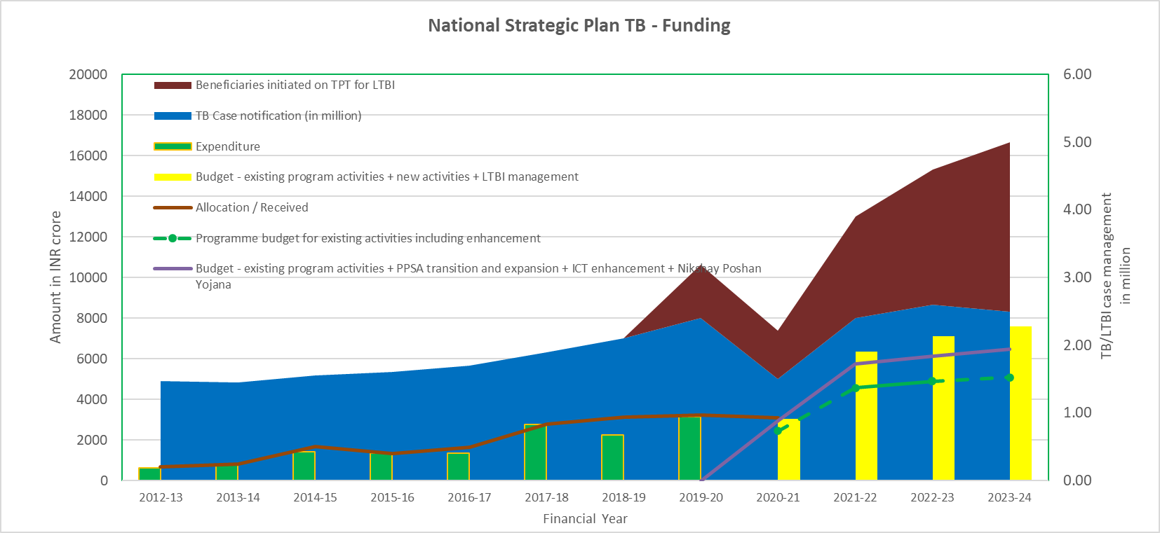

1. **Existing activities including enhancement:**

NSP includes management of the 9 M DSTB patients with 60.78 M presumptive TB / TB patients examination. 46.52 M diagnostic smear microscopy, ~16.08 M CBNAAT tests for diagnosis of TB/DRTB through the existing 1530 CBNAAT machines to expand to ~7942 sites and additional 372 digital X-ray units expecting notification of 273,898 DRTB patients including 10,142 X-DRTB patients and 319,596 H-mono/poly resistant TB patients. Sustenance of existing C&DST laboratory network to perform 5 million cultures, ~50,000 LC-SLD, 3.36 M LPA-FLD, 806,000 LPA-SLD with coverage of EQA for all CBNAAT machines/sites and accredited C&DST laboratories. ACF with 7 rounds of ACF campaigns apart from the routine and active screening of key population in prioritized districts for early case detection.

1. **Private sector engagement – transition of PPSA and scale up:**

Implementation of the partnership guidelines with transition and scale-up of the externally funded JEET project with decentralized mechanism through the STSU at state level with mentoring by NTSU under NTEP. Intended to reach 4.6 million TB patients from private sector with increase in coverage of districts from 130 to 350 with support linkages for remaining districts across the country through PPSA. Quality of care improvement envisaged with improving proportion of bacteriologically confirmed cases and testing status for HIV and Blood sugar for appropriate linkages with respective programs. Includes availability of the drugs supported by program for 2.52 million TB patients through social marketing / e-logistics / PPSA mechanism. Private providers incentivized for 4.38 million TB notifications and providing treatment outcome for 3.68 million TB patients using the Nikshay platform for ensuring timely public health action.

1. **Digital Information Ecosystem for TB Care:**

It includes all aspects related to the development and maintenance of all current and future ICT interventions/projects (LTBI, TB patient management, TB labs, supply chain management, adherence technologies, automated reports and dashboards, contracting and project management, institutional repository, program website, etc), purchased services (such as hosting, domains, BI tools and related software licenses, AI platforms, security services, PRI lines, SMS, call centre) in NTEP.

1. **Latent TB Infection management:**

NSP Includes TPT management for 6.71 million (M) person which includes 4.89 M household contacts of pulmonary TB, 1.64 M PLHIV and 0.17M at risk other population to be covered. It includes 2.14 Million tests for LTBI over four years of implementation after evidence generation in initial years. It includes provision for the patient support for diagnostics and treatment adherence through the DOT Provider. It also includes the cost of additional HR at sub-district level to manage 6.71 million patients and additional HR at field, state and central level for supervision and monitoring. It includes the cost of the designing, development, implementation and upgradation of the Nikshay LTBI modules / system with capacity to manage 10-20 Million patients’ data over period of time. It includes the additional support for supervision and monitoring for the specific staff including provision of hand held devises for real time monitoring of the patients. It includes the cost for training, advocacy and communication related to LTBI till the level of 150,000 Health & Wellness centres across the country by end of 2023-24.

1. **Patient Social & Nutritional support:**

Includes sustenance of Rs.500 per month during treatment of TB via DBT to the patient as nutritional support for the notified TB and DRTB patients. Projected to reach to 90% of the patients by end 2023-24 with an intent to cover at least 7.81 Million patients. Support provided in installments of Rs. 1000 at notification and thereafter every 2 months via direct benefit transfer (DBT) in beneficiary bank account for nutritional support.

**National Strategic Plan for Tuberculosis - Budget for Financial year - 2020-21 to 2023-24**



|  |  |  |  |  |  |  |  |
| --- | --- | --- | --- | --- | --- | --- | --- |
| **Sr. No.** | **Particulars** | ***Amount in* ₹ */ INR crore*** | | | | | |
| **2020-21** | **2021-22** | **2022-23** | **2023-24** | **Total** | **%** |
| A | Programme budget for existing activities including enhancement | 2457.00 | 4576.17 | 4872.47 | 5093.06 | 16998.69 | *71%* |
| B | Private sector patient management - transition and scale up of private sector engagement | 127.28 | 501.80 | 586.61 | 698.19 | 1913.88 | *8%* |
| C | Digital Information Ecosystem for TB Care | 37.27 | 82.17 | 49.34 | 53.92 | 222.68 | *1%* |
| D | Latent TB Infection management | 79.52 | 610.60 | 968.36 | 1134.31 | 2792.79 | *12%* |
| E | Patient social, adherence & nutritional support - Nikshay Phoshan Yojana | 332.99 | 576.80 | 628.64 | 625.06 | 2163.49 | *9%* |
| TOTAL | | 3034.06 | 6347.54 | 7105.41 | 7604.53 | 24091.54 | *100%* |

**Implementing the financial aspect of NSP**

NTEP will be implemented in line with National Strategic Plan with effect from 01st April 2020 with the proposed allocation as given in annexure.

The Procedures for the financial management are being followed as per the manuals and guidelines available on the program website (Financial Manual for National TB Elimination Programme.).The financial management arrangements to account for and report on program funds, includes both Domestic Budgetary Support (DBS) and External Aided Component (EAC). The arrangements are as follows:

**Institutional arrangements:** Central TB Division (CTD), being a part of the National Health Mission (NHM) holds the overall responsibility of the financial management of the program. Similarly, at the state and district level, the State TB Cell and the District TB Centre are responsible respectively.

There is adequate experience at the central and state level for the disbursement and financial management of the project funds. The project has provided training to the finance staff at state level in maintenance of the records and forwarding the necessary reports. The Finance staff at central level has also provided training to staff at state/district level during their visits to the states and conducting group training. The programme has scaled-up to cover all the districts for the use of the Public Financial Management System (PFMS) for financial reporting. The states have sufficient capacity to plan and utilize the funds for project activities as also maintain requisite records and generate the required reports to be provided to the CTD, MOHF&W and other agencies. The project at the central level has a Finance Unit (staffed by Finance consultants, Finance Manager, Jr. Consultant - Accounts, Consultant - Accounts) at the Central TB Division. At the state level, there is an Accounts Officer/Accountant (Two accountants in larger states) and the districts to have a full time accountant. The CTD will continue to make efforts to enhance the capacity for financial management at state and district level by visits by central staff for internal reviews, identifying training needs and providing the necessary training.

The project has been making financial performance-based disbursements to the states in the earlier phase. Releases of funds to the states has been based on the expenditures incurred, balances held in the states and districts and expected expenditures in the next two quarters. There has been however no direct linkage between the budgets of the states, action plans, programmatic progress, records of proceedings (ROP) and releases of funds to the states. These linkages will be developed and states will be encouraged to prepare budgets related to action plans every year. The states will also be required to monitor their performance regularly based on the budgets versus expenditures.

TB programme will be implemented in mission mode and adequate structural changes will be adopted at central, state and district level for local resource generation to implement the local solution to the local challenges being faced by TB programme. Necessary registrations with appropriate authorities will be acquired and fund management systems with transparency would be established at all the necessary levels to enable acceptance of the resources, through banking channel or in kind, for investments in TB programme activities. All efforts will be made to ensure to prevent duplication of funding for same activities.

**Budgeting and flow of funds**

Program expenditures are budgeted under the Demand for Grants of the MoHFW Flexible Pool for Communicable Diseases funding arrangement. These are reflected in two separate budget lines- General Component (GC) and Externally Aided Component (EAC).

The fund flow remains within the existing financial management system of the MoHFW, which operates through the centralized Pay and Accounts office. Release of funds to states is done in installments through State Treasury. Flow of funds from Central to state are in two to three instalments. The initial allocation will be based on cash flow forecasts based on their action plan and budgets and approved ROP. Subsequent funds will be released based on expenditures and projected requirement for release of funds.

The budgets will be prepared by the states. These will be compiled from the district budgets that have been examined and consolidated at state level. Budgetary norms have been specified for planning of activities. The budgets will be supported by state and District annual action plans. These will be approved by the Executive Committee of the state NHM, followed by the final approvals of the National Programme Coordination Committee (NPCC) Meeting under the MoHFW and will form the basis of release of funds and monitoring project implementation by state and CTD.

**Accounting, Internal Controls and Finance Indicators**

**Sanctions & Approvals:** All procurements of commodities are processed by the Central Medical Services Society (CMSS), an autonomous society under MoHFW, Govt. of India approved by the Cabinet and in line with it, all decisions on procurement will be taken by the CMSS without any reference to the MoHFW. All fund releases for commodity advances for approved contracts are routed through the Integrated Finance Division (IFD) and processed by the Drawing and Disbursing office (DDO) and Pay and Accounts Office (PAO).All the program expenditures follow the standard government systems of the PAO and are subject to control as per the General Financial Rules (GFR) of the Government of India. Payments are made through electronic funds transfer through treasury since the financial year 2014-2015

**Accounting:** The accounting records for all payments are made against approved budget. Budget lines are maintained by the Principal Accounts Officer and compiled by the Controller General of Accounts (CGA). The compiled monthly accounts are reconciled with the CTD record of transactions. Similarly the state and districts follows the NHM guidelines for accounting and finance reporting.

**Financial indicators:** A financial report is submitted by CTD to MoHFW and the donors like The Global Fund and World Bank on periodic intervals based on the compiled monthly accounts and CTD’s own record of expenditures. Similarly the state and district follows the NHM guidelines for the financial reporting.

The financial records will be reviewed periodically by Finance staff at CTD and state to identify weaknesses and take measures for capacity building.

The following financial indicators shall be used to review the key financial activities in the states/districts:

|  |  |  |  |
| --- | --- | --- | --- |
|  | **Activities** | **Indicator** | **Source (s) of Verification** |
| 1 | Key Financial personnel in place in centre and states | Staff in position | Appointment orders |
| 2 | Disseminate “Financial Manual” containing set of accounting procedures and policies for all levels. | Manual disseminated | Dissemination Report on the Manual |
| 3 | Undertake financial management performance evaluation of entities based on agreed criteria and methodology | Quarterly / Annual Financial Monitoring Reports | * Report on variance between estimated date of fund receipt and actual date of release. * Financial management proforma |
| 4 | Ensure streamlined system of funds-flow (centre to state and state to District) | * Action plans and Budgets prepared and forwarded by states/districts to state and CTD respectively in time * Audit reports of previous FY of acceptable quality submitted by 30 September every year * Consolidated SOEs forwarded by states to CTD within 30 days of end of quarter | * Action Plan and Budget of State and District * Audit reports / Consolidated SOEs |

Internal control system will include the following:

1. Establishment of appropriate budgeting systems and regular monitoring of actual financial performance with budgets and targets;
2. Adoption of simple, clear and transparent financial and accounting policies. These policies will include identification of expenditures that can be charged to the project and the categories under which it can be charged; policies and procedures for transfer of funds and accounting of expenditures
3. Establishment of standard controls such as verification of expenditures, levels of authorization, reconciliation and physical verification.

**Financial reporting**

The financial reporting will commence at districts that will provide SOE to the state TB cell with an electronic copy to State NHM. The state in turn will consolidate the SOE and forward to CTD. CTD will compile the SOEs from all entities and claim reimbursement, if any from the **external funding agencies**. With streamlined PFMS, the process of submission of SOE will be withdrawn. After audited statements are received the balances at STCS and DTCS will be revised. The reports will include comparison of budgeted and actual expenditures and analysis of major variances. The release of first installment will be based on consolidated SOEs, Provisional Utilization Certificate of state duly countersigned by Secretary/Chief Secretary of the State and their State Share/ matching contribution of State as on 31st March. The second and third installment will be released on receipt of consolidated audit report, utilization certificate, SOE of the latest quarter and their State Share/ matching contribution of State as on 30th September

**Integration with NHM:** Integration of NTEP with the NHM has presented two major advantages. On the one hand, States are required to contribute the required NTEP budget as below:-

|  |  |  |  |
| --- | --- | --- | --- |
| Sl. No. | States | Contribution by States/UTs | Contribution by Ministry (NHM) |
| 1 | States | 40% | 60% |
| 2 | Hilly States (Himachal Pradesh, Uttrakhand) and NE States | 10% | 90% |
| 3 | UTs (including Jammu & Kashmir and Ladakh) | 0% | 100% |

On other hand, access to the larger pool of NHM resources has allowed States to smooth the flow of funds to districts through a mechanism by which NHM makes short term loans to NTEP to bridge any time gaps in receipt of resources from the Centre.

**Auditing arrangements**

**The Director General of Audit (Central Expenditure) (DGACE) under** Comptroller and Auditor General (CAG) will audit the accounts of CTD. Local Chartered Accountant firms on the panel of CAG/state AG appointed by state/NHM will audit the state and district societies will be audited as per state NHM Manual and guidance for audit by empaneled chartered accountancy firms of the state on annual basis.

The auditors will carry out such tests and controls as deemed necessary by them. This may include visits to districts, verification of bank accounts, physical inspection etc. as per the Terms of Reference which will be forwarded by CTD as per Operational Policies of **funding agencies/NHM**. The Audit reports will be forwarded to CTD within **four** months of close of financial year (as per external funding agencies, if any, Operational Policies). All SHS, DPMUs, CHCs, PHCs along with other implementing agencies are responsible to make compliance of audit observations made in the audit report within the timeline prescribed by the controlling authority. CTD will compile these and forward to appropriate authorities in Government/External Funding Agencies, if any

**Innovative mechanisms for resourcing the NSP**

Innovative mechanisms will be the openness and creative thinking of the programme. It also emphasizes the willingness of the programme to think ‘’out of the box’’ for devising solutions to difficult challenges in TB elimination.

1. Mandal S, Chadha VK, Laxminarayan R, *et al*. Counting the lives saved by DOTS in India: a model-based approach. **BMC Med** 2017;15:47
2. World Health Organization. Global tuberculosis report, 2019. WHO: Geneva, 2019. (WHO/CDS/TB/2019.15).
3. Chadha VK. Tuberculosis epidemiology in India: a review. **Int J Tuberc Lung Dis.** 2005;9:1072–82
4. Goodchild M, et al. A cost-benefit analysis of scaling up tuberculosis control in India. 2011;15(3):358-62.
5. Government of India (2020), India TB Report 2020: National Tuberculosis Elimination Programme – Annual Report, Central TB Division, Ministry of Health and Family Welfare, New Delhi.
6. <https://www.who.int/tb/publications/2020/rapid-communications-molecular-assays/en/>
7. https://www.theglobalfund.org/media/5885/psm_qadiagnostics_policy_en.pdf
8. <http://www.stoptb.org/assets/documents/global/plan/GPR_2018-2022_Digital.pdf>
9. <http://statisticstimes.com/demographics/population-of-india.php>
10. Bihar, Chattisgarh, Jharkhand, Madhya Pradesh, Odisha, Rajasthan, Uttar Pradesh, and Uttarakhand.
11. ICMR and IHME, Health of the Nation’s States, 2018. Available at http://www.healthdata.org/policy-report/india-healthnation’s- states
12. National Health Profile 2019, Central Bureau of Health Intelligence, DGHS, MOHFW
13. [https://databank.worldbank.org/views/reports/reportwidget.aspx?Report_Name=CountryProfile&Id=b450fd57&tbar= y&dd=y&inf= n&zm =n&country=IND](https://databank.worldbank.org/views/reports/reportwidget.aspx?Report_Name=CountryProfile&Id=b450fd57&tbar=y&dd=y&inf=n&zm=n&country=IND)
14. Census Women and Men in India (A statistical compilation of Gender related Indicators in India). 20th Issue. 2018. Central Statistics Office. Ministry of Statistics and Programme Implementation.
15. National Health Accounts (NHA) 2014-2015
16. Gupta I, Chowdhury S, Prinja S, Trivedi M (2016) Out-of-Pocket Spending on Out-Patient Care in India: Assessment and Options Based on Results from a District Level Survey. PLoS ONE 11 (11): e0166775. doi:10.1371/journal.
17. Office of Registrar General & Census Commissioner India. CensusInfo. Ministry of Home Affairs, Government of India. 2011. Available from: http://www.censusindia.gov.in/2011census/HLO/HH14.html
18. Thomas BE, Adinarayanan S, Manogaran C, Swaminathan S. Pulmonary tuberculosis among tribals in India: A systematic review & meta-analysis. Indian J Med Res. 2015;141:614–23.
19. National Health Profile 2019, Central Bureau Of Health Intelligence, Directorate General of Health Services, Ministry of Health & Family Welfare, 401 & 404-A Wing, Nirman Bhawan, Maulana Azad Road, New Delhi-110108
20. Health system for a new India; Building blocks – Potential pathways to reform; Niti Aayog, Sept 2019 <https://niti.gov.in/sites/default/files/2019-11/NitiAayogBook_compressed.pdf>
21. <https://economictimes.indiatimes.com/news/economy/policy/india-to-increase-public-health-spending-to-2-5-of-gdp-pm-modi/articleshow/67055735.cms?from=mdr>
22. O’Connell T, Rasanathan K, Chopra M. What does universal health coverage mean? Lancet. 2014;383:277–9. doi: 10.1016/S0140-6736(13)60955-1
23. Pettigrew LM, De Maeseneer J, Anderson MI, Essuman A, Kidd MR, Haines A. Primary health care and the Sustainable Development Goals. Lancet. 2015;386:2119–21
24. Hone T, Macinko J, Millett C. Revisiting Alma-Ata: what is the role of primary health care in achieving the Sustainable Development Goals? Lancet. 2018;392:1461–72. doi: 10.1016/S0140-6736(18)31829-4
25. term developed by Merrill Singer in 1990s to describe the aggregation of two or more concurrent or sequential epidemics or disease clusters in a population with biological interactions, which exacerbate the prognosis and burden of disease
26. Lonnroth K, Glaziou P, Weil D, Floyd K, Uplekar M, Raviglione M. Beyond UHC: monitoring health and social protection coverage in the context of tuberculosis care and prevention. PLoS Med 2014; 11 (9): e1001693.
27. The projections are based on scenario II (pragmatic approach) of the NTEP impact modelling, Table 6, 7, Page 33, 34 and 35 Chapter 6
28. <http://www.ima-india.org/ima/free-way-page.php?pid=2>
29. Examples include Ministry of information technology, planning, urban development, rural development, women and child development, social justice and empowerment, human resource development, information and broadcasting, tribal affairs, minority affairs, skill development and entrepreneurship, heavy industries and public enterprises, science and technology, mining, statistics, Railways etc.
30. Dewa L. Social distancing in covid -19: what are the mental health implications? BMJ. 369 DOI: https://doi.org/10.1136/bmj.m1379
31. Chakrabartty A, Basu P, Ali KM, *et al*. Tuberculosis related stigma and its effect on the delay for sputum examination under the Revised National Tuberculosis Control Program in India. IJRTB; 65 (2018) 145–151
32. Chakrabartty A, Basu P, Ali KM, *et al*. Tuberculosis related stigma attached to the adherence of Directly Observed Treatment Short Course (DOTS) in West Bengal, India. IJRTB; 66 (2019): 259-265
33. Ministry of Health with Family Welfare (2017). National Strategic Plan for Tuberculosis 2017-25
34. Courtwright A, Turner AN. Tuberculosis and stigmatization: pathways and interventions. Public Health Rep 2010;125(Suppl 4):34–42.
35. Stangl AL, Lloyd JK, Brady LM, et al. A systematic review of interventions to reduce HIV-related stigma and discrimination from 2002 to 2013: how far have we come? J Int AIDS Soc 2013;16(3 Suppl 2):18734.
36. Sommerland N, Wouters E, Mitchell EMH, et al. Evidence-based interventions to reduce tuberculosis stigma: a systematic review. Int J Tuberc Lung Dis 2017;21:81–6.
37. Sharpe L, Ginsburg G, Gordon G, et al. Trying to make the personal political: feminism and consciousness-raising - a reprint of consciousness raising guidelines (1975). Chicago: Women's Action Alliance, Half Letter Press, 2017.
38. <https://tbcindia.gov.in/WriteReadData/l892s/388838054811%20NTEP%20Gender%20Responsive%20Framework_311219.pdf>
39. impact of infectious disease epidemics on tuberculosis diagnostic, management, and prevention services: experiences and lessons from the 2014–2015 Ebola virus disease outbreak in West Africa Rashid AnsumanaDOI:https://doi.org/10.1016/j.ijid.2016.10.010
40. Houben R, Menzies NA, Sumner T, *et al*. Feasibility of achieving the 2025 WHO global tuberculosis targets in South Africa, China, and India: a combined analysis of 11 mathematical models. **Lancet Glob Health.** 2016;4:e806–e815.
41. Cohen A, Mathiasen VD, Schön T, Wejse C. The global prevalence of latent tuberculosis: a systematic review and meta-analysis. **Eur Respir J.** 2019;54(3):1900655.
42. Narasimhan P, MacIntyre CR, Mathai D, *et al.* High rates of latent TB infection in contacts and the wider community in South India. **Trans R Soc Trop Med Hyg.** 2017;111:55–61.
43. Office of the Registrar General and Census Commissioner, India, 2018. HH-01. Normal households by household size*. Available from:* [*http://www.censusindia.gov.in/2011census/hh-series/hh01.html*](http://www.censusindia.gov.in/2011census/hh-series/hh01.html)*.* 
44. Khaparde K, Jethani P, Dewan PK, *et al.* Evaluation of TB Case Finding through Systematic Contact Investigation, Chhattisgarh, India. **Tuberc Res Treat**. 2015; 670167.
45. Moonan PK, Nair SA, Chadha VK, et al. Tuberculosis preventive treatment: the next chapter of tuberculosis elimination in India. BMJ Glob Health. 2018; 3(5):e001135.
46. Global TB Report 2019